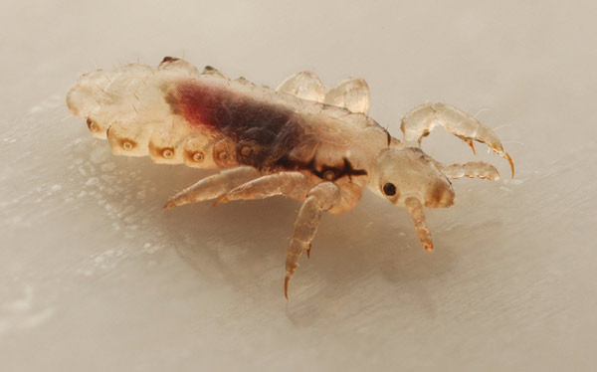
Head Lice – Information for Parents

This leaflet aims to help parents to:

- Learn about head lice.
- Reduce anxiety about head lice.
- Discover how to detect and treat them

Head lice are not dangerous and do not spread disease, but they do cause anxiety and distress amongst parents.

Head lice are a wide societal problem and contrary to popular belief, research shows that the transmission of lice within the classroom is relatively rare. When it does occur, it is usually from a ‘best friend’. We know that you can only get head lice from direct head-to-head contact with a person who has them. Head lice cannot jump, hop or swim and there is no evidence that head lice have a preference for either clean or dirty hair. It is extremely rare to get head lice by sharing hats, combs or pillows.

The role of families:
What we expect from you
- Check for head lice, ideally using detection combing on wet hair, once a week;
- If live lice are discovered, treat the infestation as soon as possible;
- Inform school that your child has had head lice.

The role of the school:
What you can expect from us:
- Advise parents on the nature of head lice infestations and the means of controlling them (this leaflet).
- If staff suspect that a child has head lice, we will telephone parents to ask them to assess the child and confirm whether or not there is a head lice infestation.
- Individual reports will be kept confidential.
- We will refer families to the School Nurse for further support, if required.
- Staff are vigilant for un-treated/persistent cases of head lice infestation, as this is acknowledged to be an indication of neglect (NB Staff are unlikely to notice lice in the hair unless there is a very heavy infestation).
- Children will not be excluded because of head lice. We feel such measures are extreme and unjustifiable, except possibly as a last resort, in very exceptional circumstances

What are head lice?
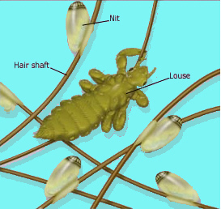
A head louse is a tiny, wingless insect that can attach itself to a person’s hair, where it feeds on extremely small amounts of blood from the scalp. They can only move to another head by crawling from hair to hair when the heads physically touch.
Head lice lay eggs around the roots and on the hair – it is the eggs that are more commonly seen in children than the lice.

Some head lice facts…
- Head lice have nothing to do with cleanliness. Anyone can have lice. Lice love everyone!
- If a person is carrying 20 lice, those lice could lay 2,652 eggs during their reproductive life.
- The eggs take 7 to 10 days to hatch.
- “Nits” are the empty egg of a head louse after hatching.
- “Nymphs” are immature head lice, reaching maturity between 7-13 days. Before this they are unable to lay eggs, or move to another head.
- They can live for up to 40 days.
- Lice are programmed to want to move to another head and can move quickly when disturbed – a louse can travel up to 23cm in a minute.
- They cannot jump, swim or fly, only crawl from head to head, so they are not quite the all action heroes we might think.
- After mating, a female louse can store the sperm in a container in her body, so she does not need to mate again to continue producing eggs.
- Head lice only live on human beings, not on other animals.

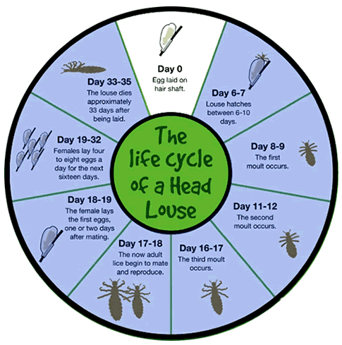

Signs and symptoms
- Surprisingly, the symptoms of a head lice infestation are often difficult to identify, particularly in adults.
- Itching is an allergic reaction which only occurs in about a third of cases. Itching can take 2-3 months to develop and can continue for some time after effective treatment. In subsequent infestations, itching is likely to occur sooner.
- Small white egg cases glued to the base of the hair are the most obvious signs of an infestation, but other things to look out for are black powdery deposits on pillows and clothing, damaged lice floating on the surface of the water after hair is washed, or the appearance of a rash at the back of the neck.
- NB – You only have a head lice infestation if LIVE lice are found in the hair. Empty egg shells from a previous infestation may remain in the hair. They can be picked or combed out, or left to grow out.

Prevention and detection
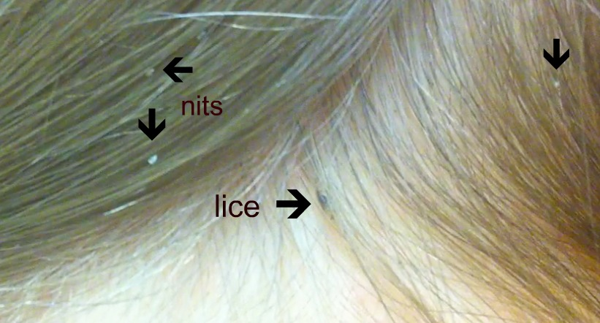
- All families are asked to check their children’s hair for lice once a week, ideally by wet-combing, as this is acknowledged to be the best method of identifying an infestation.
- The School Nurse does not routinely examine children for head lice, as this has been proved to be an ineffective policy – it is hard to accurately detect lice in dry hair.
- The use of louse-repellents is not deemed to be a good way to deal with lice in the community, as they do not treat existing infestations. Anecdotal evidence from parents is that they may be helpful as a preventative measure.
- Children should be encouraged to adopt good hair grooming habits and to use their own brushes and combs. If you have had an infestation, soak combs and brushes for 5-10 minutes in a pan of water at 60ºC.
- Launder clothing and bed-linen immediately before lice treatment on a 60ºC wash or higher. (Caution – do not bathe or shampoo in water this hot!) Dry cleaning also kills lice and eggs.
- Sealing clothes, soft toys pillows or blankets for two weeks in tightly closed plastic bags will kill lice and eggs.

Treatment
We recommend 2 methods of treating head lice:

Wet combing
- Wash the hair using ordinary shampoo and apply plenty of conditioner, before using a wide-toothed comb to straighten and untangle the hair.
- Once the comb moves freely through the hair without dragging, switch to the louse detection comb. Make sure the teeth of the comb slot into the hair at the roots, with the bevel-edge of the teeth lightly touching the scalp.
- Draw the comb down to the ends of the hair with every stroke, and check the comb for lice.
- Remove lice by wiping or rinsing the comb.
- Work methodically through the hair, section by section, so that the whole head is combed through.
- Rinse out conditioner and repeat the combing procedure.
- Repeat the procedure on days three, six, nine, 12 and 15, so that you clear young lice as they hatch, before they have time to reach maturity.

How long it will take to comb your child's hair will depend on the type of hair they have and its length. For example, short, straight hair can be quickly prepared and can be fine-toothed combed in a few minutes. Longer, curlier hair will take longer to comb.

Lotions and Sprays
- Using a lotion or spray is an alternative method of treating head lice. However, to be effective they need to be used correctly. Your pharmacist will be able to recommend an over-the-counter lotion or spray and advise you about how to use it correctly.
- A lotion or spray should only be used if a living (moving) head louse is found. Crème rinses and shampoos aren't thought to be effective and therefore aren't recommended.
- Ensure you have enough lotion or spray to treat everyone in your family who's affected. Use enough to coat the scalp and the length of the hair during each application.
- Follow the instructions that come with the lotion or spray when applying it. Depending on the product you're using, the length of time it will need to be left on the head may vary from 10 minutes to eight hours.
- The normal advice is to treat the hair and repeat the treatment after seven days. Some products also supply a comb for removing dead lice and eggs.
- Some products may be capable of killing eggs as well as lice, although there's no certainty of this. Check for baby lice hatching from eggs three to five days after using a product and again 10-12 days afterwards.
- At least two applications of lotion are needed to kill lice over the hatching period because the lotions don't always kill louse eggs.
- If the lice appear unaffected by the product, or if the problem persists, seek advice from your school nurse, health visitor, pharmacist or GP.

Contact tracing
- This is essential to treat the likely source of the infestation and to prevent re-infestation.
- Contact anyone who has had head to head contact with the case and tell them that they need to undertake detection combing and treat the infestation if live lice are found.
- Possible contacts: Parents, siblings, grandparents, other relatives, friends, school, after school clubs/activities, child minders.

Further support and information can be found at http://www.nhs.uk/conditions/Head-lice/Pages/Treatment.aspx

