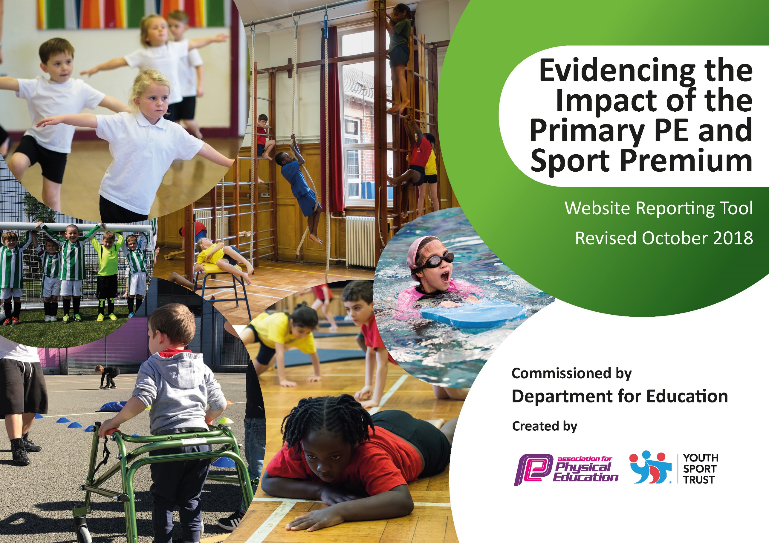
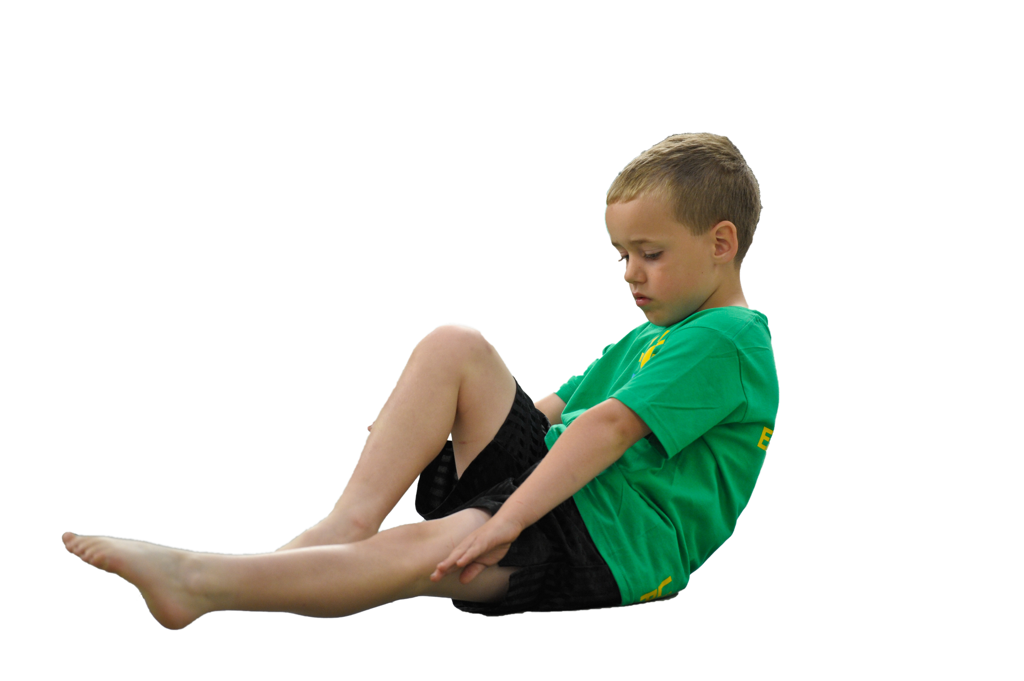
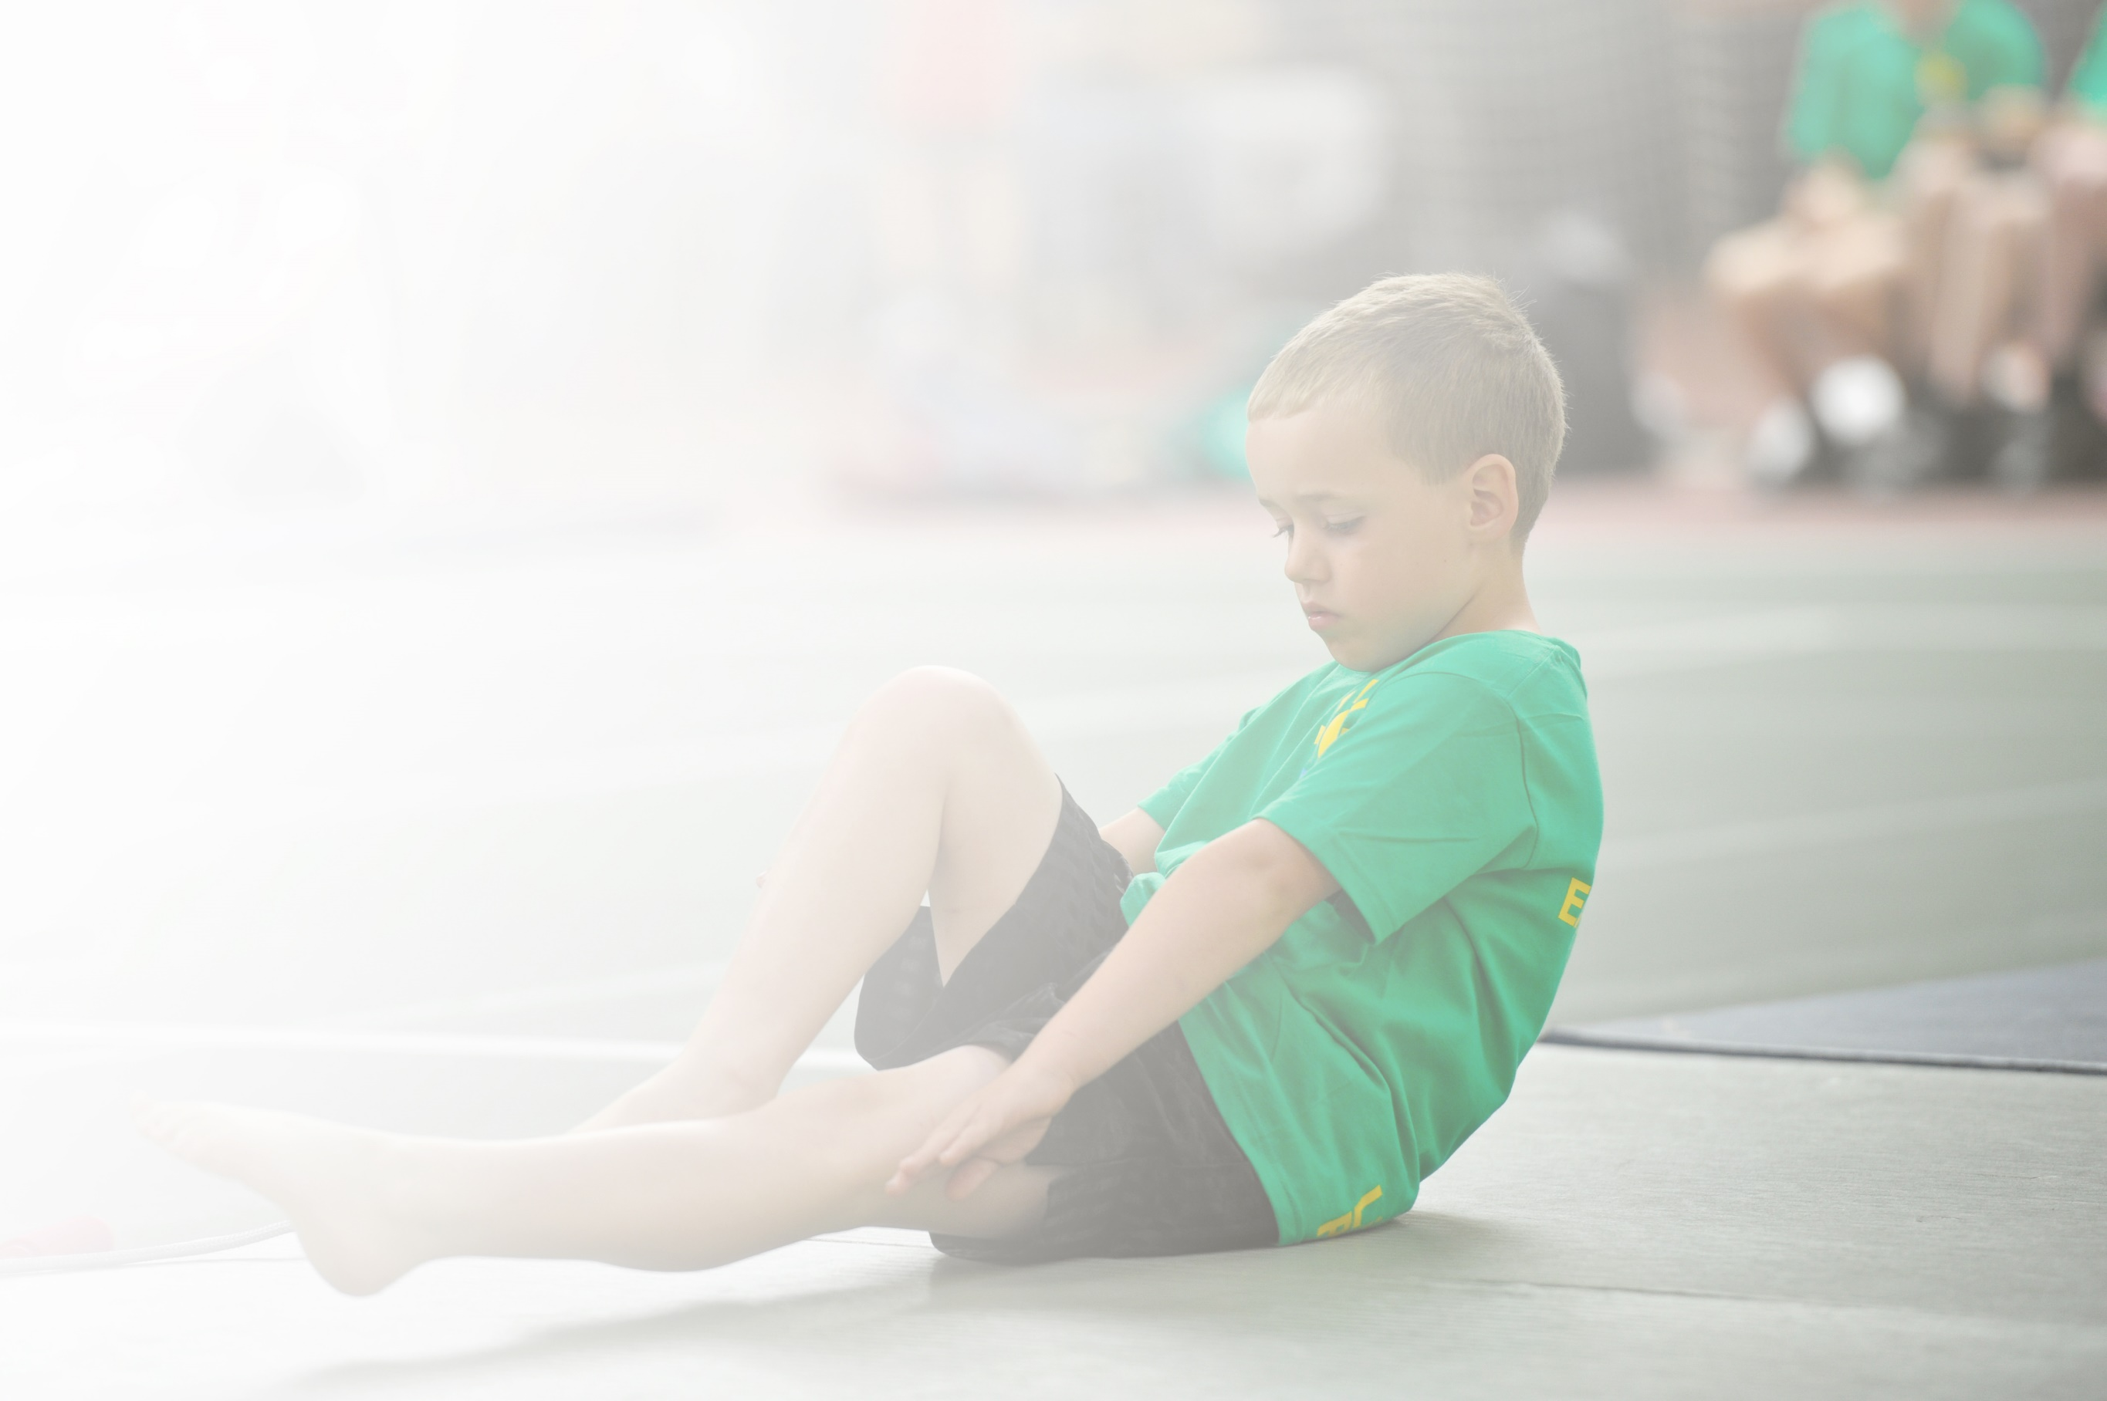
Schools must use the funding to make additional and sustainable improvements to the quality of Physical Education, Sport and Physical Activity (PESPA) they offer. This means that you should use the Primary PE and Sport Premium to:

- Develop or add to the PESPA activities that your school already offer
- Build capacity and capability within the school to ensure that improvements made now will benefit pupils joining the school in future years

Please visit gov.uk for the revised DfE guidance including the 5 key indicators across which schools should demonstrate an improvement. This document will help you to review your provision and to report
your spend. DfE encourages schools to use this template as an effective way of meeting the reporting requirements of the Primary PE and Sport Premium.

We recommend you start by reflecting on the impact of current provision and reviewing the previous
spend. Under the Ofsted Schools Inspection Framework, inspectors will assess how effectively leaders use the Primary PE and Sport Premium and measure its impact on outcomes for pupils, and how effectively governors hold them to account for this.

Schools are required to publish details of how they spend this funding as well as on the impact it has on pupils’ PE and sport participation and attainment by the end of the summer term or by 31 July 2019 at the
latest.
We recommend regularly updating the table and publishing it
on your website throughout the year, as evidence of your
ongoing review into how you are using the money to
secure maximum, sustainable impact. To see an
example of how to complete the table please
click HERE.

Support for review and reflection - considering the 5 key indicators from DfE, what development needs are a priority for your setting and your students now and why? Use the space below to reflect on previous spend, identify current need and priorities for the future.

Key achievements to date: | Areas for further improvement and baseline evidence of need:
- Increased participation in competitive sport across KS2 linked to Cluster and LA competition.  - Increased percentages of attendance at PE festivals/activities linked to key skills – racket skills, dance, etc.  - Use of coaches to enrich aspects of PE curriculum and provide CPD for staff.  - Introduction of Early Movement into Early Years PE curriculum.  - Provision of sports equipment to meet growing needs of large school.  - Installation of daily mile track and active playtimes promoted | - Review and revision of PE curriculum objectives to ensure continuity and progress. This includes a review and resourcing at LTP, MTP and STP units.  - Revision of assessment practices in PE from Y1- Y6  - Development of sports leader roles for children in UKS2  - Increased physical activity promoted at lunchtime through Sports Crew, coaches and introduction of daily mile.

Meeting national curriculum requirements for swimming and water safety | Please complete all of the below:
What percentage of your current Year 6 cohort swim competently, confidently and proficiently over a distance of at least 25 metres?  N.B. Even though your children may swim in another year please report on their attainment on leaving  primary school. | 82%
What percentage of your current Year 6 cohort use a range of strokes effectively [for example, front crawl, backstroke and breaststroke]? | 80%
What percentage of your current Year 6 cohort perform safe self-rescue in different water-based situations? | 63%
Schools can choose to use the Primary PE and Sport Premium to provide additional provision for swimming but this must be for activity over and above the national curriculum requirements. Have you used it in this way? | No

Action Plan and Budget Tracking

Academic Year: 2018/19 | Total fund allocated: £20,500 | Date Updated: July 2019
Key indicator 1: The engagement of all pupils in regular physical activity – Chief Medical Officer guidelines recommend that primary school children undertake at least 30 minutes of physical activity a day in school |  |  |  | Percentage of total allocation:
 |  |  |  | 10%
Intention | Implementation |  | Impact
School focus with clarity on intended impact: | Actions to achieve: | Funding allocated: | Evidence of impact on pupils including wider impact on whole school improvement | Sustainability and suggested next steps:
Early Years – provision of equipment and resources for outdoor physical activity and agility development | - Provision of resources to support active play and gross motor control in EY outdoor area – including balls, throwing and catching, hoops, skipping ropes etc.  - Provision of larger and appropriately sized physical resources bikes, balance boards and scooters to develop balance an coordination skills | £2000 | - Observation in outdoor area evidences higher level of physical play and activity utilising the resources provided.  - Assessment in area of physical development – ELG moving and handling is in line with national average expectations at the expected level (90%) and is significantly higher at the exceeding level (25%) | - Enhanced planning for physical development in EY
Promote the engagement of all pupils in regular physical activity – kick-starting healthy active lifestyles.  Increase physical activities and availability of resources available at playtime and lunchtime | Ensure pupils are physically literate and have a positive attitude to sport. Help children to be regularly active.  Ensure no child misses PE or after school clubs because of lack of kit.  TAs/Playground Leads to lead activities every lunchtime using range of new equipment and provision for active and purposeful lunchtimes | 4x TA half hour daily | Participation in termly focused ‘Active Events’ such as skipping challenge and running challenge  Targeted children attending Change4Life club – 30 children 2x weekly  Increasing number of children participating in after-school and lunchtime clubs.  Provision of PE kit where necessary | Active Lunchtime buddies system to be established  Employment of coaches during lunch period to further promote physical activity to all children.  Maintain change for life club  Active events bedded into the PE curriculum and promoted whole school

Key indicator 2: The profile of PESSPA being raised across the school as a tool for whole school improvement |  |  |  | Percentage of total allocation:
 |  |  |  | %
School focus with clarity on intended impact on pupils: | Actions to achieve: | Funding allocated: | Evidence and impact: | Sustainability and suggested next steps:
Enhanced support for growth mind-set

Key indicator 3: Increased confidence, knowledge and skills of all staff in teaching PE and sport |  |  |  | Percentage of total allocation:
 |  |  |  | %
School focus with clarity on intended impact on pupils: | Actions to achieve: | Funding  allocated: | Evidence and impact: | Sustainability and suggested  next steps:
Early Years Staff – CPD | All EY staff attending training alongside a cluster school for promoting PE | £150 | Inclusion of new activities and resources into EY PE teaching

Key indicator 4: Broader experience of a range of sports and activities offered to all pupils |  |  |  | Percentage of total allocation:
 |  |  |  | 70%
School focus with clarity on intended impact on pupils: | Actions to achieve: | Funding  allocated: | Evidence and impact: | Sustainability and suggested  next steps:
Participation in local school sports partnership.  Attendance at sports festivals and events | Sports festivals attended by all year groups.  KS2 Skills Festivals x 3  KS1 Multi Sport Festival  EYFS Multi Sport Festival  Hoop Starz Festival  KS1 Outdoor Active Literacy Trail  SEND Festivals | As part of sports partnership | Experiencing broad range of different activities to develop interest in new opportunities available for an active lifestyle.  Participation in sport/physical activity for enjoyment and health benefits without pressure of competition.  Development of social skills interacting with children from other schools in a safe, fun environment. | Continue and embed into revised PE curriculum
To increase high quality PE teaching and learning throughout whole school through team teaching and partnership working with coaches in Dance, Tennis, Tag Rugby, Cricket and Gymnastics  To provide a broader experience of a range of sports and activities offered to all pupils | Dance Coach supporting curriculum objectives - 1 day each week (KS1 and KS2)  Specialist EY gymnastics Coach for 1 term (Nursery and Reception)  Gymnastics Coaching ½ day each week – KS1 and 2  Volleyball Coaching for ½ term Y6  Tennis Coaching for 1 Term in Y3/4  Hockey Coaching  Football Coaching – Y1/2  Football Coaching – Y3/4  Netball Coaching – KS2  Multi-sports activities KS1 | £5460  £2850  £540  £410  £540  £1000  £1000  £540  £540  £12, 880 | Enrichment Timetable evidences all children have access to high quality coaching and training opportunities  Teachers increasingly skilled in delivering dance, gymnastics, cricket, tennis and football is improved as evidenced in lesson observations. | Bring in sports coaches to run taster sessions and lessons in new sports and activities such as wheelchair basketball, judo and hoop-la.  Continue with Sports enrichment and improve links to school PE curriculum
Primary PE equipment for curriculum use (e.g. netball posts, goal posts, hoops, bean bags, spots, storage trolley etc.)  EY/KS1/KS2 active playtimes equipment and storage trolley | To enhance the PE experience for pupils by providing them with quality resources to be accessed at playtimes and lunchtimes.  Sufficient equipment to meet the needs of whole classes | £5000  £500  £5550 | Increased resources and equipment to support the delivery of the PE curriculum.  Active and purposeful playtimes evidenced.
Enhancement of playground area to promote physical activity | Improved playground markings  Installation of a daily mile track (Summer 2019) | £4000 | Daily mile included as part of active schools focus from September 2019  Active and purposeful playtimes evidenced.
Expand the range of after school clubs available to children | Explore opportunities to enhance the range of afterschool sports provision offered in in school to incorporate:  - Running Club  - Gymnastics  - Dance  - Archery  - Netball  - Football |  | Increased afterschool club provision available in KS1 and 2  Support for children who cannot attend due to financial barriers (link to Pupil premium funding)  Access for inactive children targeted in KS1 and KS2
To continue to introduce Archery into the school curriculum.  Training for a staff member in delivery of archery club | Establish after school archery Club  Taster sessions in archery in Y5/6 (Summer Term 2019) | £500 | Y5/6 children have opportunities to engage in climbing both as part of curriculum and as an after school activity.
Offer subsidised after school club places to all children and free places to identified groups | Monitor take up of clubs (gender, SEN, Pupil Premium, vulnerable, EAL)  Subsidy £500 from Extended Schools and/or Pupil Premium | £500 | HG to promote engagement for all children.  Registers kept from after school club activities.
Promote the engagement of all pupils in regular physical activity – kick-starting healthy active lifestyles Increase physical activities available at lunchtime | Ensure pupils are physically literate and have a positive attitude to sport. Help children to be regularly active.  Ensure no child misses PE or after school clubs because of lack of kit.  TAs/Playground Leads to lead activities every lunchtime using range of new equipment and provision for active and purposeful lunchtimes | 4x TA half hour daily | Participation in ‘Active events’ such as skipping challenge and running challenge.  Increased numbers of children attending Change4Life club.  Increasing number of children participating in after-school and lunchtime clubs.  Provision of PE kit where necessary

Key indicator 5: Increased participation in competitive sport |  |  |  | Percentage of total allocation:
 |  |  |  | 12%
School focus with clarity on intended  impact on pupils: | Actions to achieve: | Funding  allocated: | Evidence and impact: | Sustainability and suggested  next steps:
Participation in the Stockton Schools Sports Partnership Programme and associated events | Regular meetings  Increased participation in cluster competitions  Access to PE training and CPD  Fund transport to take children to events.  Continue to pay into Package of Stockton Schools Partnership to ensure access to lots of competitions. | £1536 | CPD training for staff  Increased attendance at cluster competitions  Audit number of children who have taken part in competitions over the year. | Record results and numbers taking part in competitions and publish on website/in school.  Continue to pay into Package of Stockton Schools Partnership to ensure access to lots of competitions.  Curriculum revision for 2019-20 and coach provision linked to dates for sports competitions.
To allow PE leads in school to participate in the Stockton Schools Sports Partnership Programme and associated events  Increased participation in competitive sport | Regular meetings  Increased participation in cluster competitions  Access to PE training and CPD  Fund transport to take children to events.  Continue to pay into Gold Package of Stockton Schools Partnership to ensure access to lots of competitions.  Staff to attend training on using PE to raise whole school achievement.  Use social media, newsletters and display boards to raise the profile of PE across the school with both children and parents.
Audit PE equipment both for PE/Sport and physical activities in the playground/curriculum use | Replenish/ replace equipment/sports kit for competitions | £1,000 | New kit purchased and used for school competitions.

