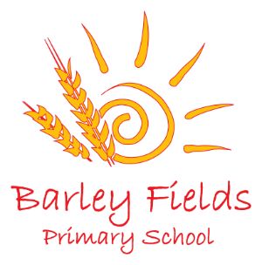
Long Term Planning
Early Years Nursery
2019-20
 | Autumn Term |  |  |  | Spring Term |  |  | Summer Term
 | September | October | November | December | January | February | March | April | May | June | July
Possible Themes | Seasons – Autumn/Winter |  |  |  | Seasons – Winter/Spring |  |  | Seasons – Spring/Summer
 | Mixed-up Nursery Rhymes/Once Upon a Time |  |  |  | Space (Aliens)  Monsters  Dinosaurs |  |  | Pirates  Under the Sea  Living Things (plants, minibeasts, etc.)
 |  | Halloween  Diwali (Hindu) | Remembrance Day  Bonfire Night | Christmas | Chinese New Year  Australia Day | Valentine’s Day  Shrove Tuesday | Lent  Easter  Holi (Hindu)  World Book Day  Mother’s Day |  |  | Ramadan  Father’s Day | Eid  Independence Day

Learning and teaching in EYFS will carefully follow the statuary and non-statuary guidance provided by the DfE. This planning is given as a guide to show how learning may emerge across the year. However, as it is a requirement that learning and development opportunities are planned around the needs and interests of each individual child, it should be noted that it is likely to transform throughout the year in response to our children and the enabling environment we provide for them.

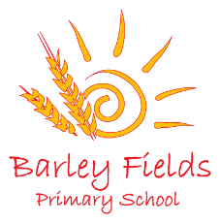
Nursery Long Term Phonics Plan

 | Autumn Term |  |  |  | Spring Term |  |  |  | Summer Term
 | September | October | November | December | January | February |  | March | April | May |  | June | July
 | Aspect 1 - General sound discrimination – environmental  The aim of this aspect is to raise children's awareness of the sounds around them and to develop their listening skills. Activities suggested in the guidance include going on a listening walk, drumming on different items outside and comparing the sounds, playing a sounds lotto game and making shakers.  Aspect 2 - General sound discrimination - instrumental sounds  This aspect aims to develop children's awareness of sounds made by various instruments and noise makers. Activities include comparing and matching sound makers, playing instruments alongside a story and making loud and quiet sounds |  | Aspect 3 - General sound discrimination - body percussion  The aim of this aspect is to develop children's awareness of sounds and rhythms. Activities include singing songs and action rhymes, listening to music and developing a sounds vocabulary.  Aspect 4 - Rhythm and rhyme  This aspect aims to develop children's appreciation and experiences of rhythm and rhyme in speech. Activities include rhyming stories, rhyming bingo, clapping out the syllables in words and odd one out. |  | Aspect 5 – Alliteration  The focus is on initial sounds of words, with activities including I-Spy type games and matching objects which begin with the same sound.  Aspect 6 - Voice sounds  The aim is to distinguish between different vocal sounds and to begin oral blending and segmenting. Activities include Metal Mike, where children feed pictures of objects into a toy robot's mouth and the teacher sounds out the name of the object in a robot voice - /c/-/u/-/p/ cup, with the children joining in. |  | Aspect 7 - Oral blending and segmenting  In this aspect, the main aim is to develop oral blending and segmenting skills.  To practise oral blending, the teacher could say some sounds, such as /c/-/u/-/p/ and see whether the children can pick out a cup from a group of objects. For segmenting practise, the teacher could hold up an object such as a sock and ask the children which sounds they can hear in the word sock. |  | Consolidating all aspects  Introducing Phase 2  In Phase 2, letters and their sounds are introduced one at a time. A set of letters is taught each week, in the following sequence:  Set 1: s, a, t, p  Set 2: i, n, m, d  Set 3: g, o, c, k  Set 4: ck, e, u, r  Set 5: h, b, f, ff, l, ll, ss  As soon as each set of letters is introduced, children will be encouraged to use their knowledge of the letter sounds to blend and sound out words. For example, they will learn to blend the sounds s-a-t to make the word sat. They will also start learning to segment words. For example, they might be asked to find the letter sounds that make the word tap from a small selection of magnetic letters |  | Consolidating all aspects  Introducing Phase 2  In Phase 2, letters and their sounds are introduced one at a time. A set of letters is taught each week, in the following sequence:  Set 1: s, a, t, p  Set 2: i, n, m, d  Set 3: g, o, c, k  Set 4: ck, e, u, r  Set 5: h, b, f, ff, l, ll, ss  As soon as each set of letters is introduced, children will be encouraged to use their knowledge of the letter sounds to blend and sound out words. For example, they will learn to blend the sounds s-a-t to make the word sat. They will also start learning to segment words. For example, they might be asked to find the letter sounds that make the word tap from a small selection of magnetic letters

