Long Term Planning
Key Stage 1 Year 1
Cycle 1 2019-2020
Autumn |  |  |  |  | Spring |  | Summer
English | 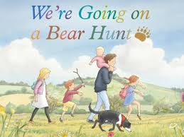  Autumn 1 Unit 1  Stories with a repeating pattern  Reading stories with repeating patterns.  Narrative writing opportunities to write stories with repeating patterns.  Cross curricular with Science – Plants and Seasons  (6 Weeks) |  |  | 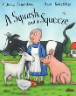  Spring 1 Unit 1  Julia Donaldson Unit  Reading the books of Julia Donaldson and Axel Scheffler  Narrative and Non-narrative writing opportunities based on the books of Julia Donaldson and Axel Scheffler.  (8 Weeks) |  |  |  | Summer 1 Unit 1  David McKee Unit  Reading the books of David McKee.  Narrative and non-narrative writing opportunities based on the books of David McKee.  (5 Weeks)
 | 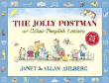  Autumn 2 Unit 2  The Allan Ahlberg Jolly Postman Unit  Reading The Jolly Postman books by Allan Ahlberg.  Narrative and non-narrative writing opportunities based on The Jolly Postman series. | Autumn 2 Unit 3  Christmas Wish Unit  Read, Write, Perform Unit based on writing letters to Father Christmas and performing them through digital media.  (2 weeks) |  | Spring 2 Unit 2  Judith Kerr Unit  Reading the books of Judith Kerr.  Narrative and non-narrative writing opportunities based on the books of Judith Kerr.  (6 Weeks) |  |  |  | 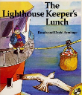  Summer 2 Unit 2  The Lighthouse Keeper’s Lunch Unit  Reading The Lighthouse Keeper’s series and narrative and non-narrative writing opportunities based on these books.  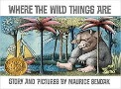  Short Burst Writing Opportunities based on Where the Wild Things Are  (7 Weeks)
Autumn |  |  |  |  | Spring |  | Summer
Mathematics | Autumn 1 Unit 1  Number: Place value within 10  (2 Weeks)  Autumn 1 Unit 2  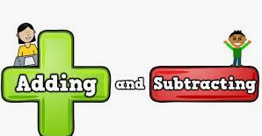  Number: Addition and subtraction Within 10  (2 Weeks) |  | Autumn 1 Unit3  Geometry- Properties of shapes  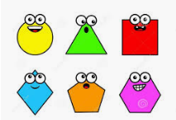  (2 Weeks)  Autumn 1 – 8 Weeks | Spring 1 Unit 1  Addition and subtraction (Within 20)  (1 Week)  Spring 1 Unit 2  Number: Place Value- within 50  (2 Weeks)  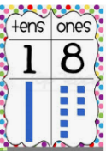 |  | Spring 1 Unit 3  Measurement- Length and Height  (2 Weeks)  Spring 1 – 6 weeks |  | Summer 1 Unit 1  Number- Fractions  (3 weeks)  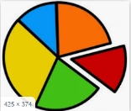 | Summer 1 Unit 2  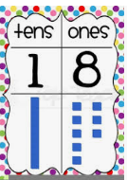  Number- Place Value within 100  (2 weeks)  Summer 1- 5 weeks
 | Autumn 2 Unit 4  Number: Place value  (Within 20) |  | Autumn 2 Unit 5  Number: Addition and subtraction (Within 20)  Autumn 2 – 7 weeks | Spring 2 Unit 4  Measurement- Weight and Volume  (2 Weeks)  Spring 2 Unit 5  Number  Multiplication & Division  (3 Weeks) |  | Spring 2 Unit 6  Geometry- Position and Movement  (2 Weeks)  Spring 2 – 6 weeks |  | Summer 2 Unit 3  Measurement- Money  (2 weeks) | Summer 2 Unit 4  Measurement- Time  (2 weeks)  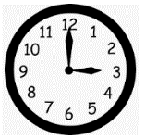  7 weeks

Science | Autumn 1 Unit 1  Seasonal Changes | Autumn 2 Unit 2  Plants | Spring 1 Unit 3  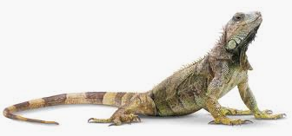  Animals including Humans | Spring 2 Unit 4  Seasonal Changes (Ongoing) | Summer 1 Unit 5  Everyday Materials  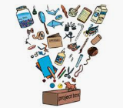 | Summer 2 Unit 6  Plants and Seasonal Changes (ongoing)
Computing | Autumn 1 Unit 1  Uses of Technology | Autumn 2 Unit `  Logging On | 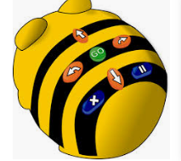  Spring 1 Unit 3  Go Bot Go! | Spring 2 Unit 4  Maze Explorer | Summer 1 Unit 5  Digital Artist | Summer 1 Unit 5  Animated Story Maker
Digital Literacy | Going Places Safely |  | ABC Searching | Keep it Private | My Creative Work | Sending Email
History & Geography | Unitv 1  Childhood Then and Now | Unit 2  Map Makers  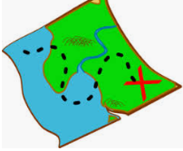 | Unit 3  Life in the city | Unit 4  Travel and transport | Unit 5  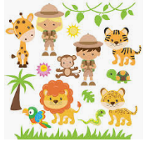  Let’s go on safari? | Unit 6  Castles  `
P.E. | Autumn 1 Unit 1  Dance and Movement | 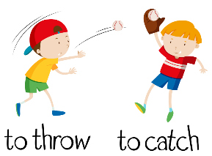  Autumn 1 Unit 2  Throwing and catching skills 1 | Spring 1 Unit 5  Dance and Movement | Spring 1 Unit 6  Running and Jumping | Summer 1 Unit 9  Balance, Agility and Co-ordination  Gymnastics | Summer 1 Unit 10  Games skills –Striking and Fielding
 | Autumn 2 Unit 3  Balance, Agility and Co-ordination | Autumn 2 Unit 4  Throwing and catching skills 2 | Spring 2 Unit 7  Attacking and defending skills 1 | Spring 2 Unit 8  Multi Skills | Summer 2 Unit 11  Running and Jumping | Summer 2 Unit 12  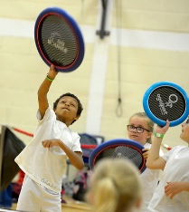  Racket Skills
 | 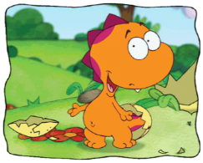  Hocus and Lotus 1  Meet Hocus. Introduce themselves, say hello and name a few animals |  | 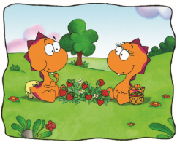  Hocus and Lotus 2  Hocus makes a friend – Lotus. Greetings and simple every day expressions such as ‘It’s good’ |  | 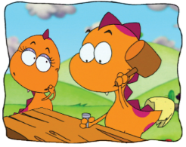  Hocus and Lotus 3  Making a safe home. Simple adjectives, tools and weather
Music | Autumn Unit 1  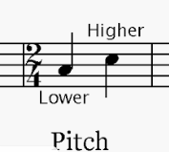  Duration and Pitch | 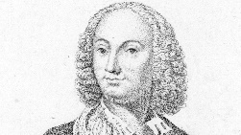  Autumn Unit 2  Composer Study  Vivaldi | Spring Unit 3  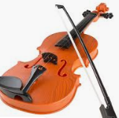  Dynamics, Timbre & Texture | 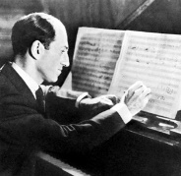  Spring Unit 4 Composer Study  George Gershwin | Summer Unit 5  Tempo and Structure | Summer Unit 6  Music Icon Study  Queen (1970-present)

Art | Unit 1  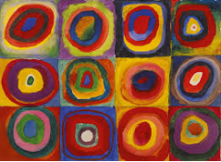  Colour creations  Artist Study - Kandinsky |  |  |  |  |  | Unit 2  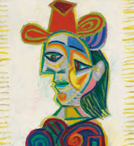  Self Portraits  Artist Study -Picasso |  |  |  |  | Unit 3  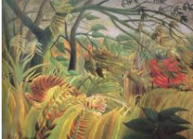  Artist Study -Henri Rousseau
DT | 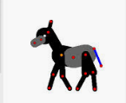  Unit 1  Mechansims  Moving Pictures |  | Unit 2  Design and make  Delightful decorations |  |  | Unit 3  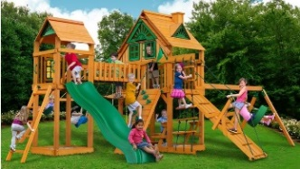  Structures  Playgrounds |  |  |  |  | Unit 4  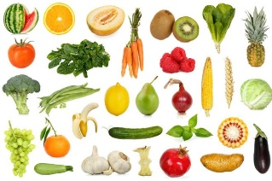  Food  Eat more fruit and vegtables
RE | Unit I  Sacred Texts  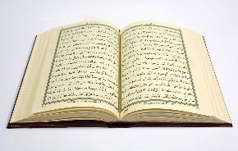  What is the Koran and why is it important? |  |  | Unit 2  Beliefs & Practices  Why do Christians celebrate Christmas? |  |  | Unit 3  Sacred Texts  Why is the Torah important? |  | Unit 4  Beliefs & Practices  What is Easter and why is Palm Sunday important? |  |  | Unit 5  Founders and Leaders  Who is Jesus and who are his disciples? |  | Unit 6  Founders and Leaders  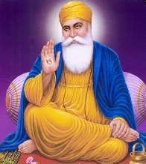  Who is Guru Nanak and why is he important?
PSHE | Unit 1  Healthy Lifestyles | Unit 2  Growing and changing |  |  | Unit 3  Keeping Safe |  | Unit 4  Feelings and emotions | Unit 5  Healthy relationships |  | Unit 6  Valuing differences |  | Unit 7  Rights and responsibility | Unit 8  Taking care of the environment |  | Unit 9  Money matters

