Long Term Planning
Key Stage One Year 2
Cycle 1 2019-2020
 | Autumn |  | Spring |  | Summer
English | Autumn 1 Unit 1  Dragons Unit  (T4W – Unit)  Reading and writing based on fiction stories about dragons. | Autumn 1 Unit 2  Dragons Unit  Reading and writing based on Pete’s Dragon as visual stimulus.  Autumn 1 – 8 Weeks | Spring 1 Unit 1  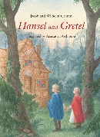  Fairy Tales Unit  Reading and writing based on a range of fairy tales. | Spring 1 Unit 2  Fairy Tales Unit  Reading and writing based on a range of fairy tales.  Spring 1 – 6 weeks | 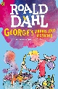  Summer 1 Unit 1  Roald Dahl Unit  Reading and writing based on George’s marvellous medicine and other Roald Dahl texts | Summer 1 Unit 2  Roald Dahl Unit  Reading and writing based on George’s marvellous medicine and other Roald Dahl texts  Summer 1 – 5 Weeks
 | Autumn 2 Unit 3  London’s Burning  (RWP unit)  Reading and writing based on the Great Fire Of London – Producing a News Broadcast | Autumn 2 Unit 4  Christmas Unit  Narrative/non-narrative writing based on familiar Christmas stories.  Autumn 2 – 7 Weeks | Spring 2 Unit 3  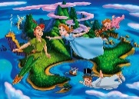  Peter Pan  Reading and writing based on Peter Pan as a visual stimulus. | Spring 2 Unit 4  Pirates  (T4W Unit)  Reading and writing based on fictional and real pirates.  Spring 2 – 6 Weeks | Summer 2 Unit 3  Wish you were here  (RWP Unit)  Writing, reading and performance unit based on holidays. | Summer 2 Unit 4  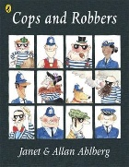  Alan Ahlberg Unit  Short writing based on a range of Allan Ahlberg texts.  Summer 2 - 7 Weeks

Mathematics | 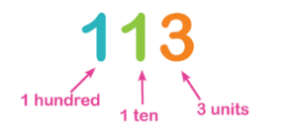  Autumn 1 Unit 1  Number - Place Value  (2 Weeks) |  |  | 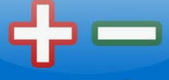  Autumn 1 Unit 2  Number – Addition and Subtraction  (4 weeks)  Measurement – Money  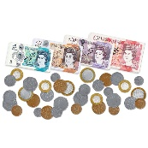  (1 week)  Autumn 1 – 8 Weeks |  |  | Spring 1 Unit 1  Measurement – Length and Height  (2 weeks) |  |  | Spring 1 Unit 2  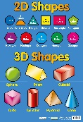  Geometry – Shape  (2 weeks)  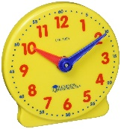  Spring 1 Unit 3  Measurement - Time  (2 weeks)  Spring 1 – 6 weeks |  |  | Summer 1 Unit 1  Consolidation of learning in preparation for SATs  (4 weeks) |  |  | Summer 1 Unit 2  SATs  (1 week)  Summer 1- 5 weeks
 | Autumn 2 Unit 3  Number – Multiplication and Division  (4 weeks) |  |  | Autumn 2 Unit 4  Statistics  (1 week)  Consolidation learning (1 week)  Autumn 2 – 7 weeks |  |  | Spring 2 Unit 4  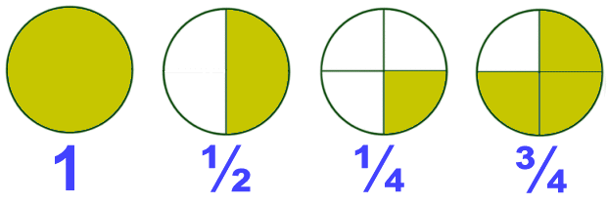  Measurement – Fractions  (3 Weeks) |  |  | 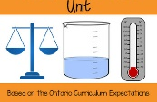  Spring 2 Unit 5  Measurement – Mass, Capacity and Temperature  ( 2 weeks)  Spring 2 Unit 6  Position and Direction  (1 week)  Spring 2 – 6 weeks |  |  | Summer 2 Unit 3  Problem Solving  (3 weeks)  Revisiting units |  |  | Summer 2 Unit 4  Revisiting units and  Investigations  (3 weeks)  Summer 2 7 weeks
Science | Autumn 1 Unit 1  Plants |  | 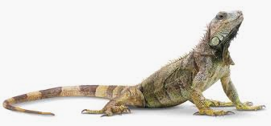  Autumn 2 Unit 2  Living Things and their Habitats |  |  | 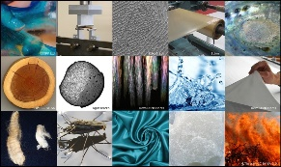  Spring 1 Unit 3  Everyday Materials |  |  | Spring 2 Unit 4  Animals including humans |  |  | Summer 1 Unit 5  Animals including humans |  |  | Summer 2 Unit 6  Plants
Computing | Autumn 1 Unit 1  I can code |  | 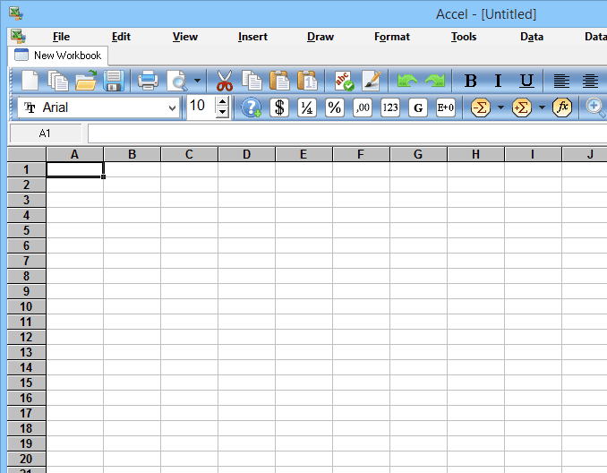  Autumn 2 Unit 2  Spreadsheets |  |  | Spring 1 Unit 3  Email |  |  | Spring 2 Unit 4  Digital images |  |  | Summer 1 Unit 5  Presenting ideas |  |  | Summer 1 Unit 6  Making music
Digital Literacy | Staying safe online |  | Staying safe online |  |  | Follow the digital trail |  |  | Screen out the mean |  |  | Staying safe online |  |  | Sites I like
History & Geography | Unit 1  Childhood Then and Now |  | 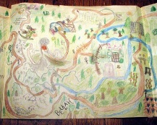  Unit 2  Map Makers |  |  | Unit 3  Life in the City |  |  | Unit 4  Travel and Transport |  |  | 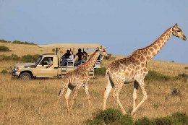  Unit 5  Let’s go on Safari |  |  | Unit 6  Castles
P.E. | Autumn 1 Unit 1  Gymnastics |  | Autumn 1 Unit 2  Throwing and Catching |  |  | 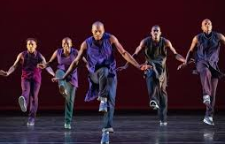  Spring 1 Unit 5  Dance |  |  | Spring 1 Unit 6  Attacking and Defending, Striking and Fielding |  |  | Summer 1 Unit 9  Gymnastics |  |  | Summer 1 Unit 10  Attacking and Defending, Striking and Fielding
 | Autumn 2 Unit 3  Running and Jumping |  | Autumn 2 Unit 4  Throwing and catching |  |  | Spring 2 Unit 7  Throwing and Catching |  |  | Spring 2 Unit 8  Multi-Skills |  |  | Summer 2 Unit 11  Dance |  |  | Summer 2 Unit 12  Net and Wall
MFL | 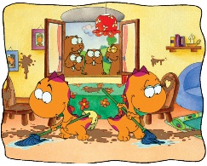  Hocus and Lotus 4 |  |  |  |  | 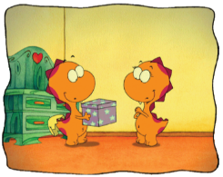  Hocus and Lotus 5 |  |  |  |  |  | 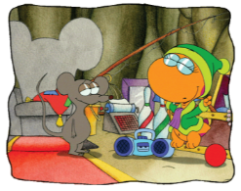  Hocus and Lotus 6
MUSIC | Autumn Unit 1  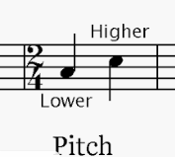  Duration and Pitch |  | 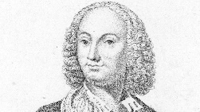  Autumn Unit 2  Composer Study  Vivaldi |  |  | Spring Unit 3  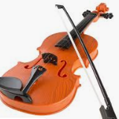  Dynamics, Timbre & Texture |  |  | 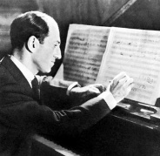  Spring Unit 4 Composer Study  George Gershwin |  |  | Summer Unit 5  Tempo and Structure |  |  | Summer Unit 6  Music Icon Study  Queen (1970-present)
Art | Unit 1  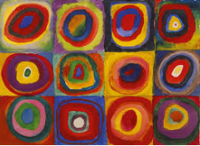  Colour creations  Artist Study - Kandinsky |  |  |  |  | Unit 2  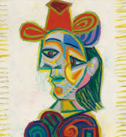  Self Portraits  Artist Study -Picasso |  |  |  |  |  | Unit 3  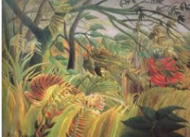  Artist Study -Henri Rousseau
DT | 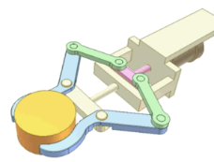  Unit 1  Mechanisms |  | Unit 2  Textiles |  |  | Unit 3  Food |  |  |  |  |  | Unit 4  Textiles
RE | Unit I  Sacred Texts  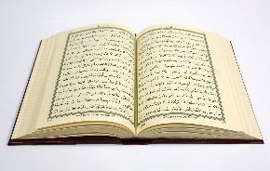  What is the Koran and why is it important? |  | Unit 2  Beliefs & Practices  Why do Christians celebrate Christmas? |  |  | Unit 3  Sacred Texts  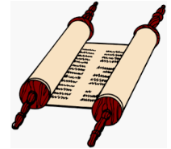  Why is the Torah important? |  |  | Unit 4  Beliefs & Practices  What is Easter and why is Palm Sunday important? |  |  | Unit 5  Founders and Leaders  Who is Jesus and who are his disciples? |  |  | Unit 6  Founders and Leaders  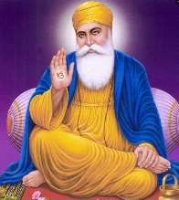  Who is Guru Nanak and why is he important?
 | Unit 1  Healthy Lifestyles | Unit 2  Growing and changing |  |  | Unit 3  Keeping Safe | Unit 4  Feelings and emotions |  | Unit 5  Healthy relationships |  |  | Unit 6  Valuing differences | Unit 7  Rights and responsibility |  | Unit 8  Taking care of the environment |  |  | Unit 9  Money matters

