Long Term Planning
Key Stage Two Year 3
Cycle 1 2019-2020
 | Autumn |  |  |  |  |  |  | Spring |  |  |  |  | Summer
English | Autumn 1 Unit 1  Cracking Contraptions  (T4W – Unit)  Reading and writing based on instructional texts with explanation. |  |  |  | Autumn 1 Unit 2  Cracking Contraptions  Reading and writing based on instructional texts with explanation.  Autumn 1 – 8 Weeks |  |  | 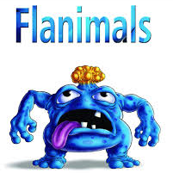  Spring 1 Unit 1  Flanimals  (T4W Unit)  Reading and writing explanatory texts based on Flanimals |  |  | Spring 1 Unit 2  Flanimals  Reading and writing explanatory texts based on Flanimals  Spring 1 – 6 weeks |  | Summer 1 Unit 1  Gorilla  (T4W Unit)  Reading and writing narrative/poetry based on Gorilla |  |  |  |  | Summer 1 Unit 2  Gorilla  (T4W Unit)  Reading and writing narrative/poetry based on Gorilla  Summer 1 – 5 Weeks
 | Autumn 2 Unit 3  Crazy Creatures  (RWP – Unit)  Creating animal fact files for an audience of children and publishing using e-books. |  |  |  | Autumn 2 Unit 4  Crazy Creatures  (RWP – Unit)  Creating animal fact files for an audience of children and publishing using e-books.  Autumn 2 – 7 Weeks |  |  | 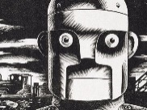  Spring 2 Unit 3  The Iron Man  (T4W Unit)  Reading and writing narrative/poetry based on the Iron Man. |  |  | Spring 2 Unit 4  The Iron Man  (T4W Unit)  Reading and writing narrative/ poetry based on the Iron Man.  Spring 2 – 6 Weeks |  | Summer 2 Unit 3  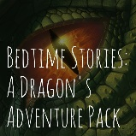  Bedtime Stories  (RWP Unit)  Reading, writing, performing and publishing Bedtime Stories for a younger audience. |  |  |  |  | Summer 2 Unit 4  Bedtime Stories  Reading, writing, performing and publishing Bedtime Stories for a younger audience.  Summer 2 - 7 Weeks
Mathematics | 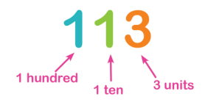  Autumn 1 Unit 1  Number - Place Value  (3 Weeks) |  |  |  | Autumn 1 Unit 2  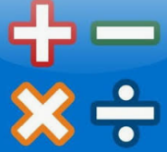  Number – Addition, Subtraction, Multiplication & Division  (4 weeks) |  |  | Spring 1 Unit 1  Number –Multiplication & Division  (2 weeks) |  |  | Spring 1 Unit 2  Measurement - Money  (2 Weeks)  Unit 3  Number – Fractions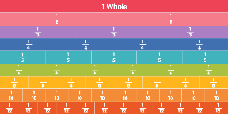  (2 weeks) |  | Summer 1 Unit 1  Measurement – Mass and Capacity (3 weeks) |  |  |  |  | Summer 1 Unit 2  Measurement – Time (  2 weeks)
 | Autumn 2 Unit 3  Number –Multiplication & Division  (3 weeks) |  |  |  | Autumn 2 Unit 4  Number –Multiplication & Division |  |  | Spring 2 Unit 3  Number – Fractions  (4 weeks) |  |  | Spring 2 Unit 4  Measurement – Length and Perimeter (2 weeks) |  | Summer 2 Unit 2  Measurement – Time (1 week)  Unit 3  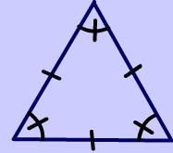  Geometry – Properties of Shape  (3 weeks) |  |  |  |  | Summer 2 Unit 4  Statistics  (1 week)  Consolidation and assessment  (2 weeks)
Science | Autumn 1 Unit 1  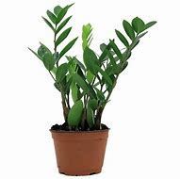  Plants |  |  | 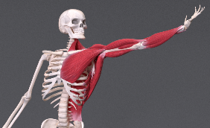  Autumn 2 Unit 2  Animals including Humans |  |  | Spring 1 Unit 3  Forces and Magnets |  | 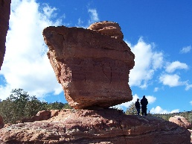  Spring 2 Unit 4  Rocks |  |  | Summer 1 Unit 5  Light |  |  | 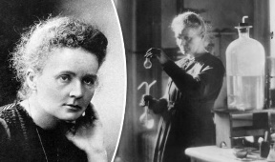  Summer 2 Unit 6  Scientists and Inventors
Computing | Autumn 1 Unit 1  Coding |  |  | Autumn 2 Unit 2  Word Processing |  |  | 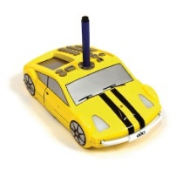  Spring 1 Unit 3  Creating with Robots |  | Spring 2 Unit 4  Presentations |  |  | Summer 1 Unit 5  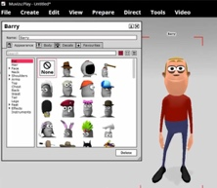  Awesome Animations |  |  | Summer 2 Unit 6  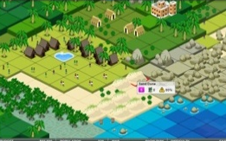  Simulations
Digital Literacy | Powerful Passwords |  |  | My Online Community |  |  | Things for Sale |  | Show Respect Online |  |  | Writing a good email
History and Gepgraphy | 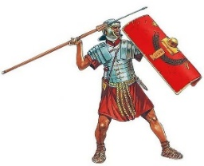  Autumn 1 Unit 1  Invaders and Settlers – The Romans |  |  | 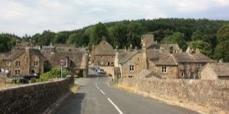  Autumn 2 Unit 2  Village Settlers |  |  | Spring 1 Unit 3  Polar Exploration |  | 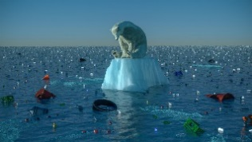  Spring 2 Unit 4  Climate Change |  |  | 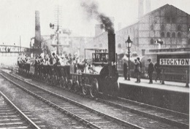  Summer 1 Unit 5  The Railway Revolution |  |  | 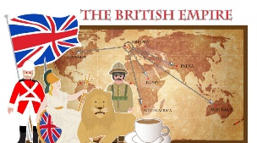  Summer 2 Unit 6  The British Empire
P.E. |  | 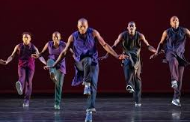  Autumn 1 Unit 1  Dance and Movement | 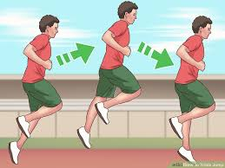  Autumn 1 Unit 2  Running & Jumping |  |  | Spring 1 Unit 3  Net and Wall  Tennis |  |  |  | Spring 1 Unit 4  Gymnastics |  |  |  | Summer 1 Unit 7  Dance |  | 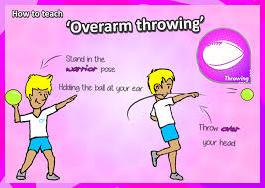  Summer 1 Unit 8  Throwing & Catching
 |  | Autumn 2 Unit 3  Throwing and Catching | Autumn 2 Unit 4  Running and Jumping |  |  | 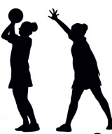  Spring 2 Unit 5  Attacking and Defending - Netball |  |  |  | Spring 2 Unit 6  Attacking and Defending -Football |  |  |  | Summer 2 Unit 9  Gymnastics |  | Summer 2 Unit 10  Health Related Exercise
MFL |  | Autumn and first half Spring - Unit 1  Moi  Introduce themselves, greet others and say how they are and their age. Discuss linguistic diversity within their class and understand that French is spoken in France and elsewhere. Learn some family terms. |  |  |  |  |  |  |  | Second half Spring and Summer - Unit 2  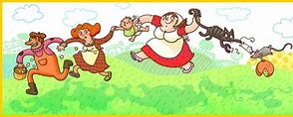  Jeux et Chansons  ‘The Farmer’s in His Den’ and a few French games. Numbers to 20 and talking about their favourite games.
Music |  | Autumn Unit 1  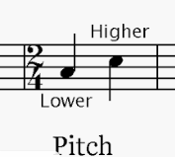  Duration and Pitch | Autumn Unit 2  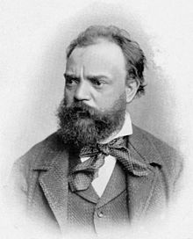  Composer Study -Dvorak |  |  | Spring Unit 3  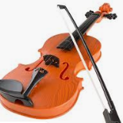  Dynamics, Timbre & Texture |  |  |  | Spring Unit 4  Composer Study -  – Terje Isungset |  |  |  | Summer Unit 5  Tempo and Structure |  | 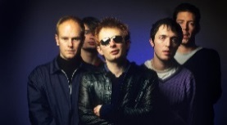  Summer Unit 6 Composer Study  Composer / Artist Study - Radiohead
Art |  | Unit 1  Famous Buildings |  |  |  | Unit 2  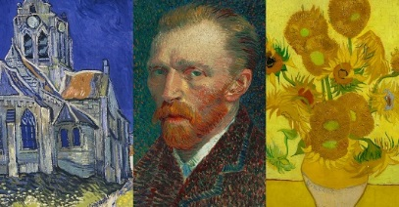  Vincent Van Gogh |  |  |  |  |  |  |  | Unit 3  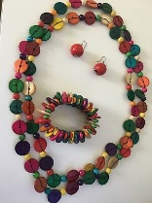  Jewellery Designers
DT |  | Unit 1  Textiles seasonal stockings |  |  |  | Unit 2  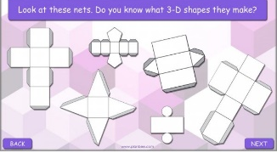  Structures - shell structures  Packaging |  |  |  |  |  |  |  | Unit 3  Food – healthy diet  Sandwich Snacks
RE |  | Unit 1  Sacred Texts:  What is the Bible and why is it important? | Unit 2  Festivals  What are the symbols associated with Christmas?  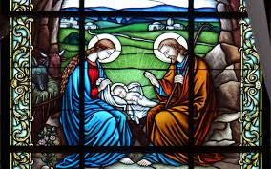 |  |  | Unit 3  Places of Worship:  What is a mosque and why is it important?  Visit to the Mosque |  |  |  | Unit 4  Festivals/Beliefs and Practices:  Why is Easter important to Christians? |  |  |  | Unit 5  Beliefs and Practices  What is Buddhism?  Buddhist Festivals |  |  | Unit 6  Festivals:  What is EID and why is it important?
PSHE |  | Unit 1  Healthy Lifestyles  Growing and Changing  Keeping Safe |  |  |  | Unit 2  Healthy Relationships  Feelings and Emotions  Valuing Difference |  |  |  |  |  |  |  | Unit 3  Rights and Responsibilities  Taking Care of the Environment  Money Matters

