Long Term Planning
Lower Key Stage Two Year 4
Cycle 1 2019-2020
 | Autumn |  |  |  | Spring |  |  |  | Summer
English | Autumn 1 Unit 1  Villains  Reading and writing unit based on well-known villainous characters from reading. Character Descriptions and Police Reports. |  | Autumn 1 Unit 2  Villains  Reading, writing and performance unit based on villainous characters from reading.  Villainous Speeches.  (RWP Unit) |  | Spring 1 Unit 1  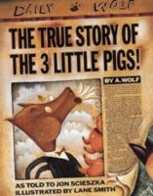  Fairy Tale Twists  Reading and writing based on fractured fairy tales. |  | Spring 1 Unit 2  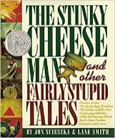  Fairy Tale Twists  Reading and writing based on fractured fairy tales. |  | 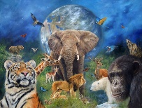  Summer 1 Unit 1  Planet Earth  Reading, writing and performance unit based on the art of documentary narration.  (RWP Unit) |  | Summer 1 Unit 2  Planet Earth  Reading, writing and performance unit based on the art of documentary narration.
 | 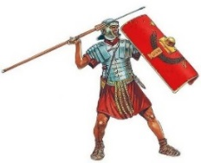  Autumn 2 Unit 3  Invaders  Reading, writing based on history topic. |  | 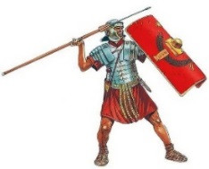  Autumn 2 Unit 4  Invaders  Reading, writing based on history topic. |  | Spring 2 Unit 3  Polar Exploration  Reading, writing & performance based on Polar Exploration. |  | 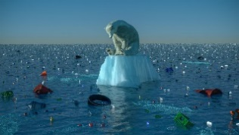  Spring 2 Unit 4  Climate Change  Reading, writing and performance based on climate change. |  | Summer 2 Unit 3  Sports Manager  Reading, writing and performance unit based on motivational speaking. |  | Summer 2 Unit 4  Sports Manager  Reading, writing and performance unit based on reporting.
Autumn |  |  |  |  | Spring |  |  |  | Summer
Mathematics | 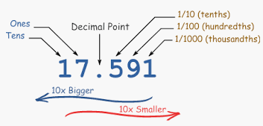  Autumn 1 Unit 1  Number - Place Value  (3 weeks) |  | Autumn 1 Unit 2  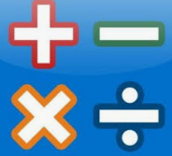  Number – Addition and  Subtraction  (4 weeks) |  | Spring 1 Unit 1  Number – Multiplication and Division  (3 weeks)  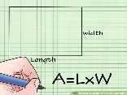  Measurement - Area  (1 week) |  | 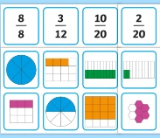  Spring 1 Unit 2  Number –Fractions  (2 weeks) |  | Summer 1 Unit 1  Measurement - Money  (2 weeks)  Measurement -Time  (2 weeks) |  | Summer 1 Unit 2  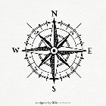  Geometry – Position and Direction  (1 weeks)
 | Autumn 2 Unit 3  Measurement – Length and Perimeter  (1 week)  Number – Multiplication and Division  (2 weeks) |  | Autumn 2 Unit 4  Number – Multiplication and Division  (2 weeks)  Consolidation and Assessment  (2 weeks) |  | Spring 2 Unit 3  Number – Fractions  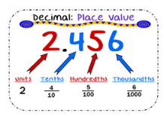  (2 weeks)  Number – Decimals  (1 weeks) |  | Spring 2 Unit 4  Number – Decimals  (1 week)  Consolidation and Assessment (2 weeks) |  | Summer 2 Unit 3  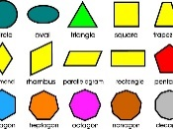  Geometry – Properties of Shapes  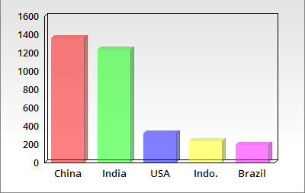  (2 weeks)  Statistics  (1 weeks) |  | Summer 2 Unit 4  Consolidation and  Problem Solving  (3 weeks)
Science | Autumn 1 Unit 1  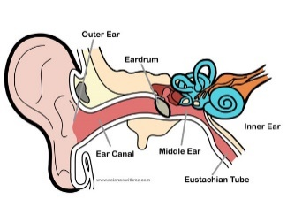  Sound - Hearing | 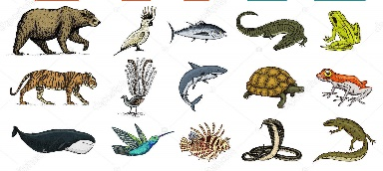  Autumn 2 Unit 2  Living Things and Their Habitats |  | Spring 1 Unit 3  Animals Including Humans |  | 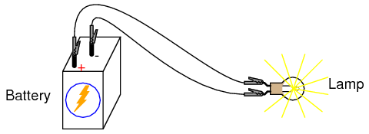  Spring 2 Unit 4  Electricity |  | 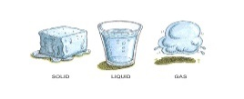  Summer 1 Unit 5  States of Matter |  | 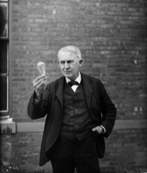  Summer 2 Unit 6  Scientists and Inventors  Alexander Graham Bell and Gerald Durrell
Computing | Autumn 1 Unit 1  Internet Inspector | Autumn 2 Unit 2  Coding – Go Sprite Go! |  | 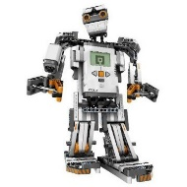  Spring 1 Unit 3  Engineering Expert - Lego |  | 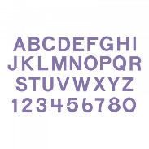  Spring 2 Unit 4  Using Logo |  | Summer 1 Unit 5  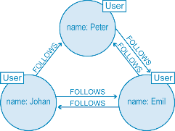  Show what you know - Databases |  | Summer Unit 6  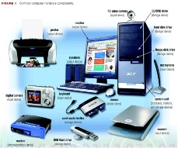  Hardware Investigators
Digital Literacy | 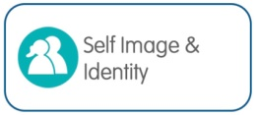  Rings of Responsibility | Private and Personal Information |  | The Power of Words |  | 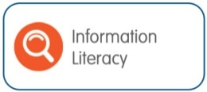  The Key to Key Words |  | Whose is it, anyway?
History & Geography | 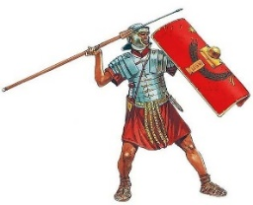  Autumn 1 Unit 1  Invaders and Settlers – The Romans | 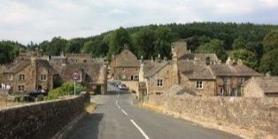  Autumn 2 Unit 2  Village Settlers |  | Spring 1 Unit 3  Polar Exploration |  | Spring 2 Unit 4  Climate Change |  | 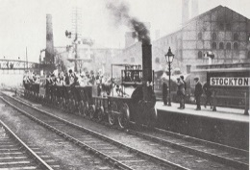  Summer 1 Unit 5  The Railway Revolution |  | 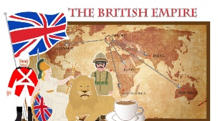  Summer 2 Unit 6  The British Empire
P.E. | Autumn 1 Unit 1  Running and Jumping - Cross Country | Autumn 1 Unit 2  Gymnastics |  | Spring 1 Unit 3  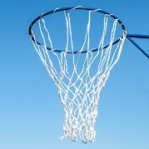  Attacking and Defending - Netball |  | Spring 1 Unit 4  Throwing and Catching |  | 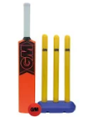  Summer 1 Unit 7  Attacking and Defending - Cricket |  | Summer 1 Unit 8  Throwing and Catching
 | Autumn 2 Unit 3  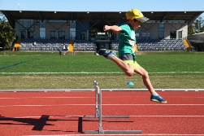  Running and Jumping - Athletics | 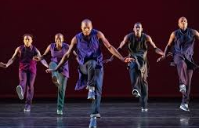  Autumn 2 Unit 4  Dance and Movement - Dancefuzion |  | Spring 2 Unit 5  Net and Wall - Tennis |  | Spring 2 Unit 6  Dance and Movement Dancefuzion |  | Summer 2 Unit 9  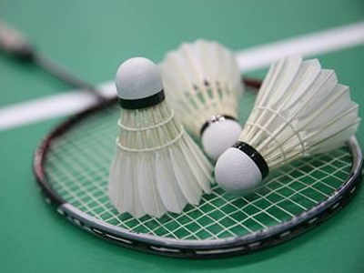  Net and Wall - Badmintonl |  | Summer 2 Unit 10  Health Relataed Fitness
MFL | On Fait La Fete.  Children learn language related to special celebrations |  |  | Portraits  Children learn the names of body parts and begin to use adjectives |  |  |  | Consolidation
Music | Autumn Unit 1  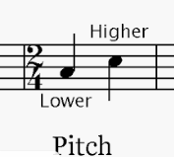  Duration and Pitch | Autumn Unit 2  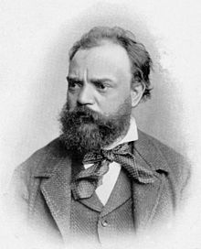  Composer Study -Dvorak |  | Spring Unit 3  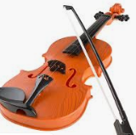  Dynamics, Timbre & Texture |  | 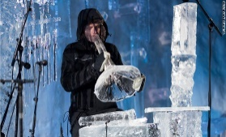  Spring Unit 4  Composer Study - – Terje Isungset |  | Summer Unit 5  Tempo and Structure |  | 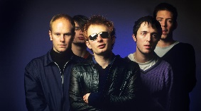  Summer Unit 6 Composer Study  Composer / Artist Study - Radiohead
Art | Unit 1  Famous Buildings |  |  | Unit 2  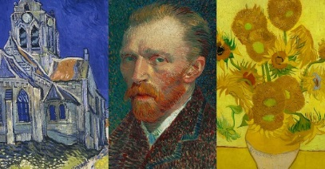  Vincent Van Gogh |  |  |  | Unit 3  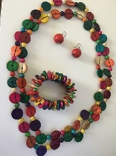  Jewellery Designers
DT | Mechanical Systems – Levers and Linkages  Unit 1 - Moving Monsters |  |  | 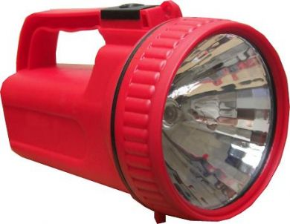  Electrical Systems  Uniit 2 - Torches |  |  |  | Food  Unit 3 - American Food
RE | Unit I  Sacred Texts  What is the Bible and why is it important? | Unit 2  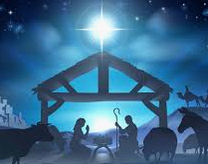  Beliefs & Practices  What are the Symbols of Christmas ? |  | Unit 3  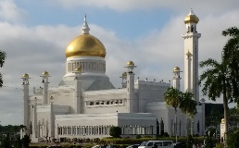  Places of Worship  What is a Mosque and why is it important? |  | Unit 4  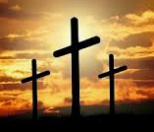  Beliefs & Practices  Why is Easter important to Christians? |  | Unit 5  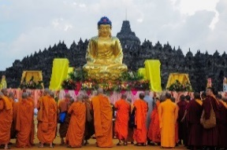  Beliefs and Practices  What is Buddism? |  | Unit 6  Festivals  Whats is Eid and why is it important?
PSHE | Unit 1  Healthy Lifestyles  Growing and Changing  Keeping Safe |  |  | Unit 2  Healthy Relationships  Feelings and Emotions  Valuing Difference |  |  |  | Unit 3  Rights and Responsibilities  Taking Care of the Environment  Money Matters

