Long Term Planning
Upper Key Stage 2 Year 5
Cycle 1 – 2019-2020
TERM | Autumn |  | Spring |  | Summer
English | Autumn 1 Unit 1  Romeo and Juliet  Online/live news report and Mercutio and Tybalt. | 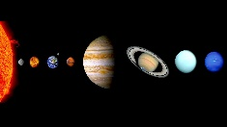  Autumn 1 Unit 2  Science- Cross Curricular  Explanation texts in the form of letters/emails. | 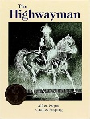  Spring 1 Unit 1  The Highwayman  Poetry and Diary Entries | Spring 1 Unit 2  Changes  Holiday Brochures  Persuasive travel adverts | Summer 1 Unit 1  Non-narrative –Persuasion  and discussion | Summer 1 Unit 2  Non-narrative –Persuasion  and discussion
 | Autumn 2 Unit 3  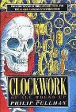  Clockwork- Philip Pullman  Narrative/non-narrative | 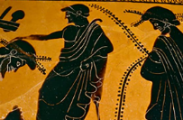  Autumn 2 Unit 4  Ancient Greece- Cross Curricular  Narrative/non-narrative writing based on the Battle of Thermopylae. | 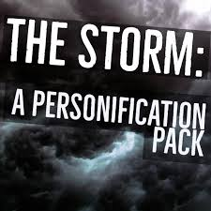  Spring 2 Unit 3  The Storm RWP Unit  Setting description through personification | Spring 2 Unit 4  The Storm RWP Unit  Suspense in narrative | 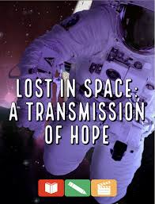  Summer 2 Unit 3  Lost in Space – A Transmission of Hope RWP Unit | Summer 2 Unit 4  Science-Fiction  Narrative
Mathematics | 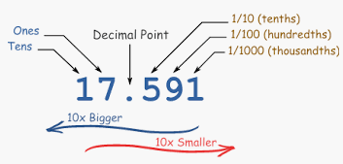  Autumn 1 Unit 1  Number – Place Value  (2 weeks) | Autumn 1 Unit 2  Number – Addition & Subtraction  (3 weeks) | Spring 1 Unit 1  Measurement - Perimeter & Area  (2 weeks) | 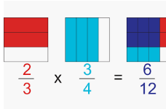  Spring 1 Unit 2  Number - Fractions (5 weeks) | 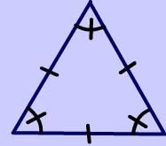  Summer 1 Unit 1  Geometry – Properties of Shape (2 weeks)  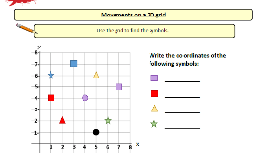  Geometry – Position & Direction  (1 week) | Summer 1 Unit 2  Measurement – Converting Units  (2 weeks)  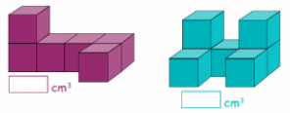  Measurement – Volume  (2 weeks)
 | 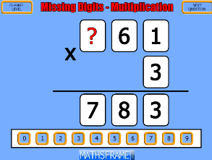  Autumn 2 Unit 3  Number – Multiplication & Division (4 weeks) | Autumn 2 Unit 4  Statistics  (2 weeks)  Consolidation learning  (1 week) | 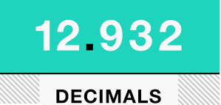  Spring 2 Unit 3  Number – Decimals  (3 weeks) | Spring 2 Unit 4  Number – Percentages  (2 weeks)  Consolidation learning  (1 week) | Summer 2  Revisiting and addressing misconceptions.  Applying reasoning skills in these areas:  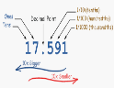  Place value (1 week)  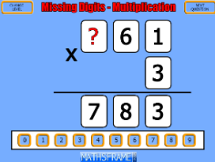  Multiplication & Division (1 week) | 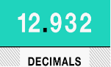  Fractions (1 week)  Decimals (1 week)  Consolidation learning  (1 week)

Science: | Unit 3  Earth and Space  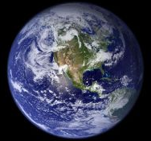 | Unit 4 Properties and Changes of Materials  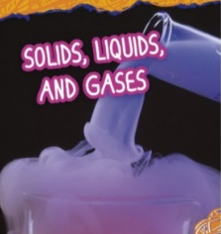 | Unit 1 Living things and their habitats  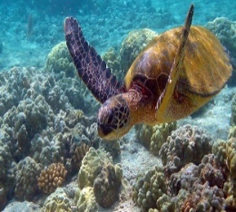 | Unit 2 Animals Including Humans  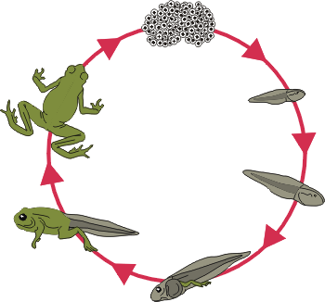 | Unit 5  Forces  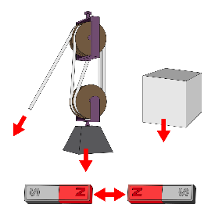 | Unit 6 Scientists and Inventors
Computing | Unit 1  Coding - Precise Programming | Unit 2  Understanding Networks | Unit 3  Blogging | Unit 4  Code based Text Adventures  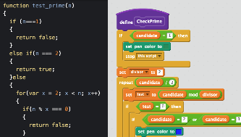 | Unit 5  3D modelling  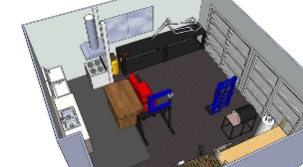 | Unit 6  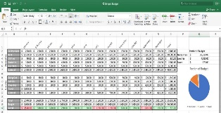  Spread it Out – using spreadsheets
Digital Literacy | Strong passwords | Digital citizenship pledge | You’ve won a prize! | How to cite a site | Picture Perfect
History | 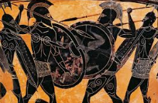  Who Were the Ancient Greeks? | 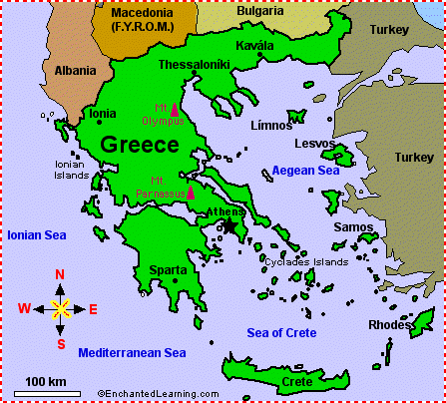  Contrasting Locality – Exploring Greece | 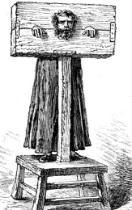  Crime and Punishment through the Ages |  | The United Kingdom | Investigating Rivers
Physical Education | Autumn 1 Unit 1  Invasion Games  Tag Rugby | Autumn 1 Unit 2  Running and Jumping Cross Country | Spring 1 Unit 3  Balance, agility and coordination  Gymnastics | Spring 1 Unit 4  Attacking and Defending  Football | Summer 1 Unit 7  Running and Jumping  Athletics | Summer 1 Unit 8  Striking and Fielding  Cricket
 | 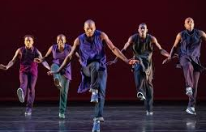  Autumn 2 Unit 3  Dance and Movement Patterns | Autumn 2 Unit 4  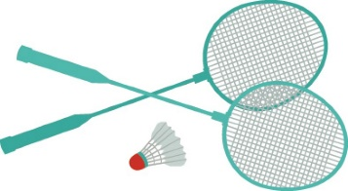  Net and Wall  Badminton | 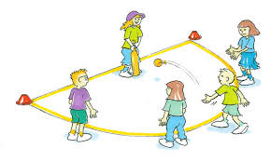  Spring 2 Unit 5  Attacking and Defending  Striking and Fielding | Spring 2 Unit 6  Running and Jumping  Netball | Summer 2 Unit 9  Net and Wall  Tennis | Summer 2 Unit 10  Dance and Movement Patterns
MFL | Autumn Unit 1  Les quatre amis  Describing and talking about animals |  | Spring Unit 2  L’argent de poche  Numbers to 100, likes and dislikes, the Euro, TV adverts |  | Summer Unit 3  Introduction to German
Music | Autumn Unit 1  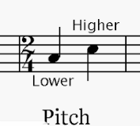  Duration and Pitch | Autumn Unit 2  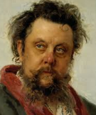  Composer Study  Modest Mussorgsky | Spring Unit 3  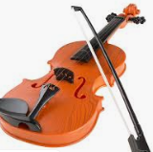  Dynamics, Timbre & Texture | Spring Unit 4 Composer Study  Mason Bates | 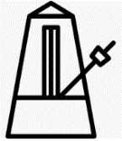  Summer Unit 5  Tempo and Structure | Summer Unit 6 Composer Study  Noel Gallagher
Art | 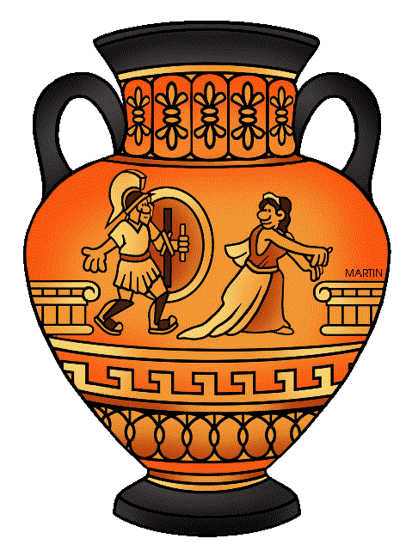  Greek Art | 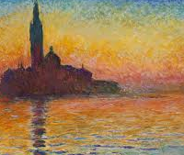  Artist Study - Monet and the Impresionists | Street Art  Artist Study – Banksy |  | 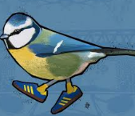  Artist Study -Local Street Art – Bobzilla
DT | Unit 1  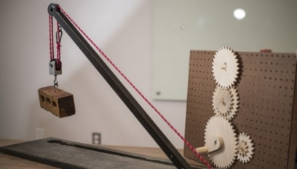  Mechanical Systems: Pulleys and Gears.  Moving Toys |  | Unit 2  Food – Celebrating Culture and Seasonality  Bread |  | Unit 3  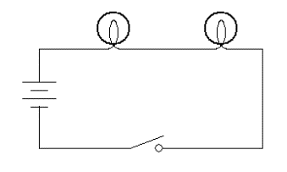  Electrical Systems – Complex Switches and Circuits  Programming Pioneers
RE | Unit I  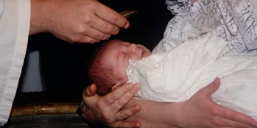  Rites of Passage  Compare rites of passage rituals in Christanity and Islam | Unit 2  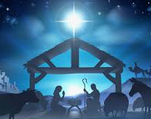  Festivals and Celbrations  What do the gospel stores tell us of Jesus’ birth | Unit 3  Beliefs & Practices  Islam  What do we know about being a Muslim? | Unit 4  Beliefs & Practices  Who was responsible for Jesus’ death? | Unit 5  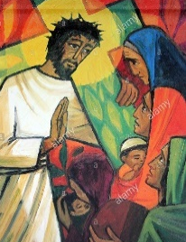  Expressions of Faith through Art | Unit 6  Festivals  Festivals in other religions
PSHE | Unit 1  Healthy Lifestyles  Growing and Changing  Keeping Safe |  | Unit 2  Healthy Relationships  Feelings and Emotions  Valuing Difference |  | Unit 3  Rights and Responsibilities  Taking Care of the Environment  Money Matters

