Long Term Planning
Upper Key Stage 2 Year 6
Cycle 1 2019-2020
Autumn |  |  | Spring |  | Summer
English | Autumn 1 Unit 1  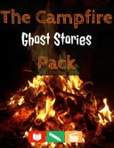  Ghost Stories  (RWP – Unit)  Reading, writing and performance unit based on the art of verbal story-telling. | Autumn 1 Unit 2  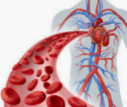  Red Blood Cells  Reading and writing based on science topic. | 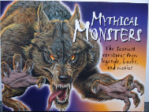  Spring 1 Unit 1  Mythical Monsters  Reading and writing based on mythical monsters | 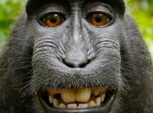  Spring 1 Unit 2  Changes  Reading and writing based on science topic | Summer 1 Unit 1  SATs Revision | Summer 1 Unit 2  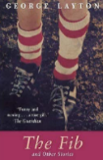  The Fib  Reading and writing based on ‘The Long Walk’ by George Layton.
 | Autumn 2 Unit 3  Macbeth Unit  Reading and writing based on Shakespeare’s Macbeth | 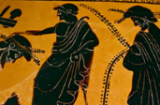  Autumn 2 Unit 4  300 Spartans  Narrative/non-narrative writing based on the Battle of Thermopylae. | Spring 2 Unit 3  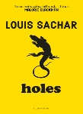  Holes  Reading and writing based on ‘Holes’ by Louis Sachar. | Spring 2 Unit 4  SATs Revision | Summer 2 Unit 3  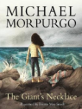  The Giant’s Necklace  Writing based on ‘The Giant’s Necklace’ by Michael Morpurgo | Summer 2 Unit 4  The Battle Cry  (RWP-Unit)  Speeches based on Gladiator and Braveheart.

Mathematics | Autumn 1 Unit 1  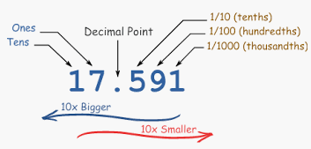  Number - Place Value  2 Weeks | Autumn 1 Unit 2  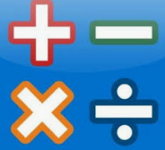  Number – Addition, Subtraction, Multiplication & Division  4 weeks | Spring 1 Unit 1  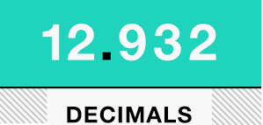  Number – Decimals  2 weeks | Spring 1 Unit 2  Number –Percentages 2 weeks  Spring 1 Unit 3  Number - Algebra 2 weeks | Summer 1 Unit 1  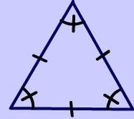  Geometry – Properties of Shape  (2 weeks) | Summer 1 Unit 2  Statistics  (2 weeks)
 | 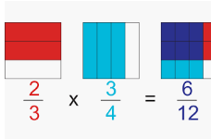  Autumn 2 Unit 3  Number – Fractions 4 weeks | Autumn 2 Unit 4  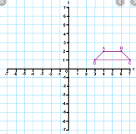  Geometry – Position and Direction  1 week  Consolidation learning 1 week | Spring 2 Unit 3  Measurement – Converting Units  1 Week  Perimeter, Area and Volume  2 weeks | 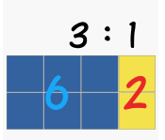  Spring 2 Unit 4  Number – Ratio 2 weeks  Consolidation learning 1 week | Summer 2 Unit 3  Problem Solving  3 weeks | Summer 2 Unit 4  Maths Investigations  3 weeks

Science |  | Autumn 1 Unit 1  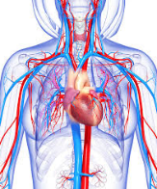  Animals including Humans  The circulation system | 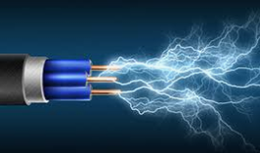  Autumn 2 Unit 2  Electricity  Circuits and Circuit diagrams | 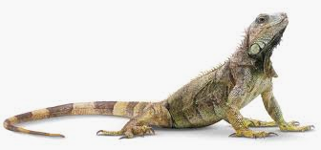  Spring 1 Unit 3  Living Things and their Habitats  Classification | 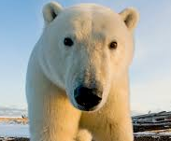  Spring 2 Unit 4  Inheritance and Adaptation  Evolution and Adaptation |  | 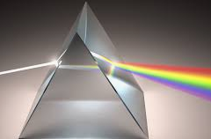  Summer 1 Unit 5  Light  Sources and movement of light |  | 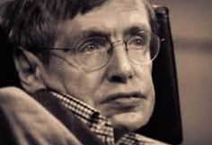  Summer 2 Unit 6  Scientists and Scientific Discovery  Stephen Hawking
Computing |  | Autumn 1 Unit 1  Coding - Scratch | 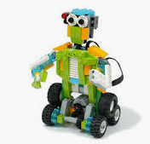  Autumn 2 Unit 2  Robot Controller – Lego We Do | 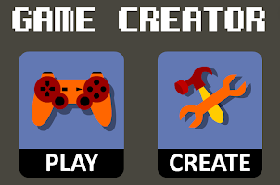  Spring 1 Unit 3  Game Creator 3D – Purple Mash | Spring 2 Unit 4  Game Designer - Kodu |  | Summer 1 Unit 5  Lights, Camera, Action!
Digital Literacy |  | Talking Safely Online | 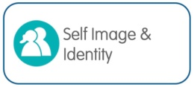  Super Digital Citizen | Privacy Rules | What is Cyberbullying? |  | 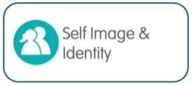  Selling Stereotypes.
History & Geography |  | 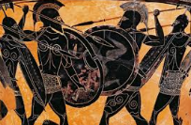  Who Were the Ancient Greeks? | 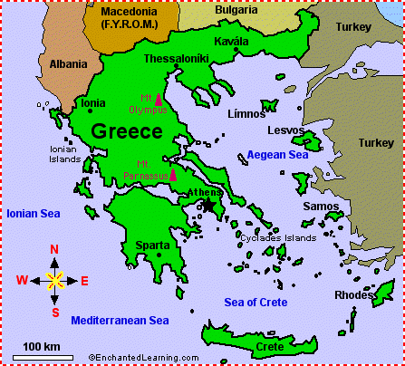  Contrasting Locality – Exploring Greece | 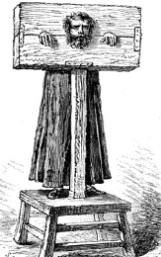  Crime and Punishment through the Ages |  |  | 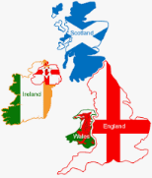  The United Kingdom |  | 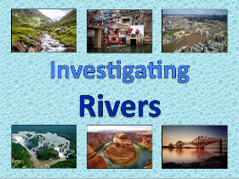  Investigating Rivers
P.E. |  | Autumn 1 Unit 1  Invasion Games  Tag Rugby | 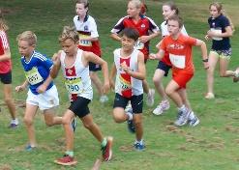  Autumn 1 Unit 2  Running and Jumping Cross Country | Spring 1 Unit 3  Balance, agility and coordination Gymnsastics |  | Spring 1 Unit 4  Attacking and Defending  Basketball | Summer 1 Unit 7  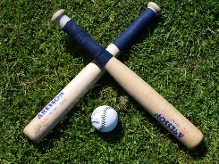Striking and Defending  Rounders | Summer 1 Unit 8  Attacking and Defending  Hockey
 |  | Autumn 2 Unit 3  Attacking and Defending  Dodgeball | Autumn 2 Unit 4  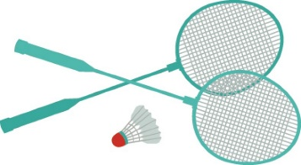  Net and Wall  Badminton | 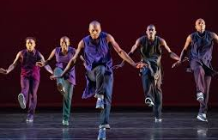  Spring 2 Unit 5  Dance  Dancefuzion |  | 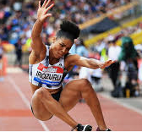  Spring 2 Unit 6  Running and Jumping  Athletics | 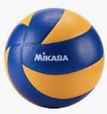  Summer 2 Unit 9  Net and Wall  Volleyball | 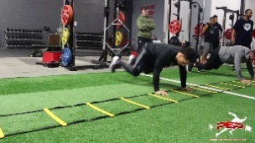  Summer 2 Unit 10  Health Related Fitness
MFL |  | 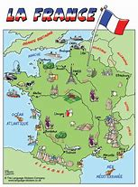  On y va  Learn to name Fracophone countries and towns in France. |  | L’argent de poche  Numbers to 100, likes and dislikes, the Euro, create a toy advert |  |  | Language around the world  Introduction to German, Mandarin and Spanish
Music | Autumn Unit 1  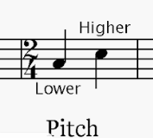  Duration and Pitch |  | Autumn Unit 2  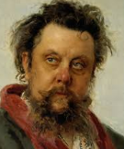  Composer Study  Modest Mussorgsky | Spring Unit 3  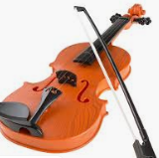  Dynamics, Timbre & Texture |  | Spring Unit 4 Composer Study  Mason Bates | 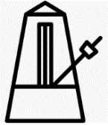  Summer Unit 5  Tempo and Structure | 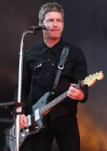  Summer Unit 6 Composer Study  Noel Gallagher
Art | 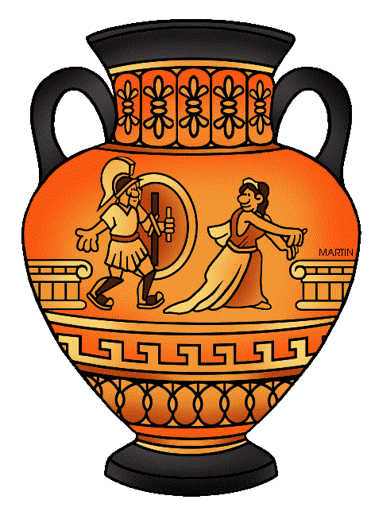  Greek Art |  | 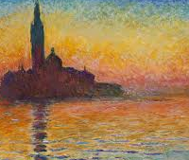  Artist Study - Monet and the Impresionists | Street Art  Artist Study – Banksy |  |  | 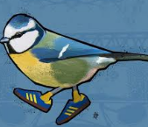  Artist Study -Local Street Art – Bobzilla
DT | Unit 1  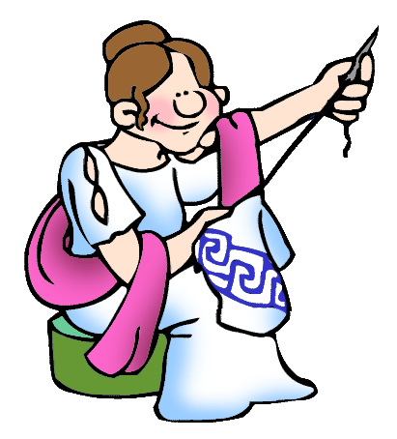  Fashion and Textiles - Greek Fashion |  |  | Unit 2  Frame Structures – Building Bridges |  |  | Unit 3  Food – celebrating culture and seasonality  Burgers
RE | Unit I  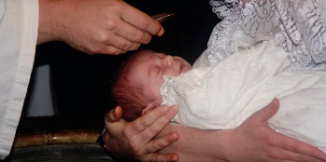  Rites of Passage  Compare rites of passage rituals in Christanity and Islam |  | Unit 2  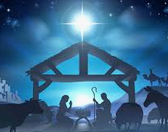  Festivals and Celbrations  What do the gospel stores tell us of Jesus’ birth? | Unit 3  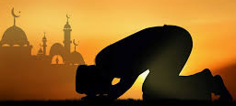  Beliefs & Practices  Islam  What do we know about being a Muslim? |  | Unit 4  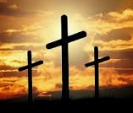  Beliefs & Practices  Who was responsible for Jesus’ death? | Unit 5  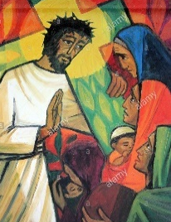  Expressions of Faith through Art |  | Unit 6  Festivals  Festivals in other religions
PSHE | Unit 1  Healthy Lifestyles  Growing and Changing  Keeping Safe |  |  | Unit 2  Healthy Relationships  Feelings and Emotions  Valuing Difference |  |  | Unit 3  Rights and Responsibilities  Taking Care of the Environment  Money Matters

