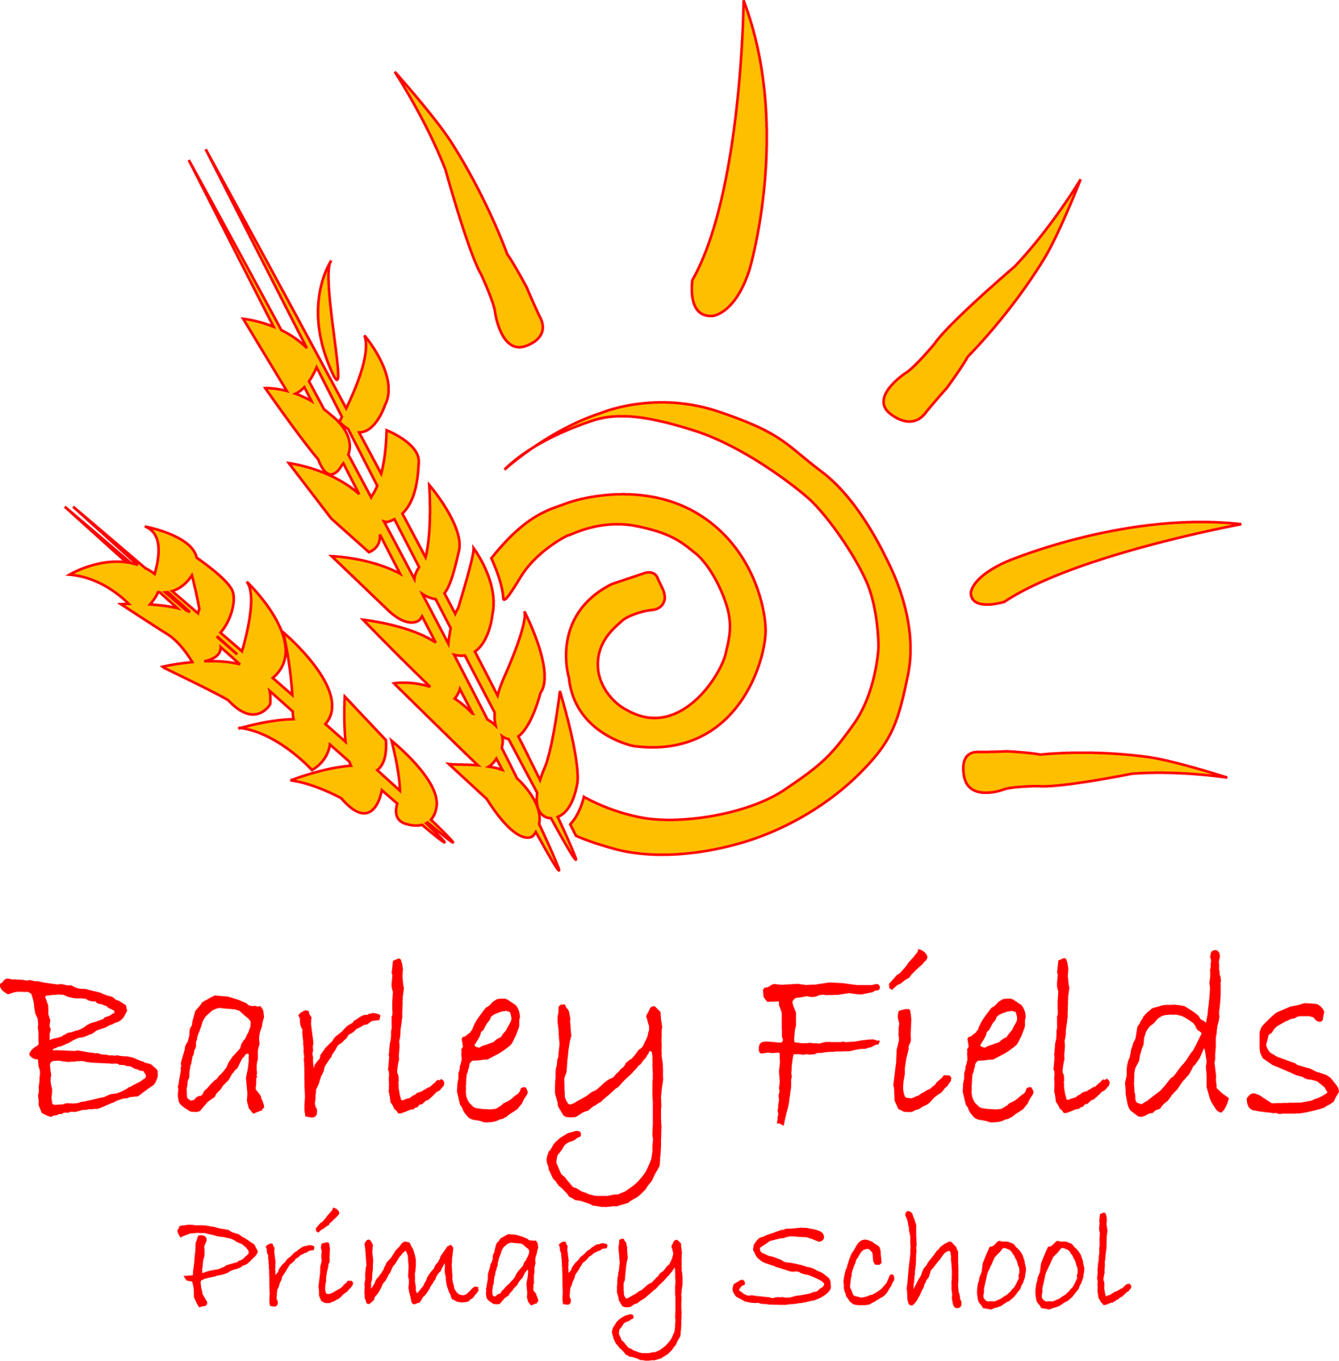

Sex and Relationship Education Policy
2017
Date Issued: | February 2017
Prepared by: | Head Teacher, PSHE and Citizenship lead
Review date: | February 2019
Date Adopted by Governing Body:

Introduction
Sex and Relationship Education (SRE) is part of the personal, social and health education (PSHCE) curriculum in our school. We aim to provide a successful education programme, firmly embedded in PSHCE which will help young people learn to respect themselves and others and move with confidence from childhood through adolescence and on into adulthood. SRE aims to prepare children to cope with the physical and emotional challenges of growing up, and to give them an elementary understanding of basic human reproduction. When we inform our pupils through sex education about sexual issues, we do this with regard to morality and individual responsibility, and in a way that allows children to ask and explore moral questions. We do not use sex education as a means of promoting any form of sexual orientation.

Aims and objectives
We teach children about:
- the physical development of their bodies as they grow into adults;
- the way humans grow, develop and reproduce;
- respect for their own bodies and the importance of sexual activity as part of a committed, long-term, and loving relationship;
- the importance of family life;
- moral questions;
- relationship issues;
- respect for the views of other people;
- sexual abuse, and what they should do if they are worried about any sexual matters.

Context
We teach SRE in the context of the school’s aims and values. In particular, we teach SRE in the belief that:
- sex should be taught about in the context of marriage and family life;
- sex education is part of a wider process of social, personal, spiritual and moral education;
- children should be taught to have respect for their own bodies;
- children should learn about their responsibilities to others, and be aware of the consequences of sexual activity;
- it is important to build positive relationships with others, involving trust and respect;
- children need to learn the importance of self-control.

Roles and Responsibilities
Governors - As part of their general responsibilities for the management of the school, the Governors play a key role in the development of the school’s Sex and Relationship policy. They will continue with their role of monitoring and regular evaluation of it.

Head Teacher - The Head Teacher takes overall responsibility for this policy, its implementation, for liaison with the Governing Body, parents and the Local Authority and other appropriate agencies

It is the responsibility of the head teacher to ensure that both staff and parents are informed about the SRE policy, and that the policy is implemented effectively. It is also the head teacher’s responsibility to ensure that members of staff are given sufficient training, so that they can teach SRE effectively, and handle any difficult issues with sensitivity.

The head teacher liaises with external agencies and PSHE and citizenship lead regarding the school SRE programme, and ensures that all adults who work with our children on these issues are aware of the school policy, and work within its framework.

The head teacher monitors this policy on a regular basis, and reports to governors, when requested, on the effectiveness of the policy.

Senior Leadership Team - The Senior Leadership team, with the Head Teacher, have a general responsibility for supporting other members of staff in the implementation of this policy and will provide a lead in the dissemination of the information relating to Sex and Relationships education and the provision of in-service training.

Staff - Sex and Relationship Education is a whole school issue. All staff have been included in the development of this policy and how it relates to them.

Parents - Parents are the key people in teaching their children about Sex and Relationships by:
- Maintaining the culture and ethos of the family
- Helping their children cope with emotional and physical aspects of growing up
- Preparing them for the challenges and responsibilities that sexual maturity brings.

Parents need to know that the school’s Sex and Relationship Education programme will compliment and support their role as parents and that they can be actively involved in the implementation of the school’s policy. Parents will be encouraged to support the school’s Sex and Relationship Education and have access to the policy. They will be fully informed of the content of the lessons and it is their statutory right to be able to look at the resources used to deliver the curriculum. Permission from parents will be sought when teaching particular aspects of the curriculum.

Curriculum Organisation
SRE is delivered through different aspects of the curriculum. While we address the majority of issues in our Personal, Social, Health and Economic (PSHE) and citizenship curriculum, we also offer some aspects of SRE through other subject areas (for example, science, philosophy and PE) which we believe contribute significantly to children’s knowledge and understanding of their own bodies, feelings and how they are changing and developing. In summary we teach children about relationships, and we encourage children to discuss issues. We teach about the parts of the body, and how these work, and we explain to the children what will happen to their bodies during human lifecycle changes including puberty.

In Year 5/6 we place a particular emphasis on health education and the effects of puberty, as many children experience puberty at this age. We inform all parents and carers of children in Year 5/6 of this particular programme of lessons and provide them with opportunities to discuss with staff the issues covered, how they are taught, and to see the materials the school uses in its teaching. We liaise with the Local Health Authority about suitable teaching materials to use with our children in these lessons and invite visitors into school. Teachers do their best to answer all questions with sensitivity and care. By the end of Key Stage 2, we ensure that both boys and girls know how babies are born, how children’s bodies change during puberty, what menstruation is, and how it affects women. We always teach this with due regard for the emotional development of the children.

Procedures for the involvement of Health Professionals
We encourage other valued members of the community to work with us to provide advice and support to the children with regard to health education. In particular, members of the Local Health Authority, such as the school nurse and other health professionals, give us valuable support with our sex education programme. The school nurse visits school to discuss a range of health issues and helps to deliver work on the topic - sex and relationships.

Facilities for Menstruating Girls
Any child requiring sanitary materials during the school day may bring a supply for safe keeping in the main school office if they wish or may store them in their personal bag etc. Emergency sanitary products are available from the school office/AHT and the upper Key Stage 2 girls’ toilets are equipped with suitable disposal equipment.

The role of parents
The school is well aware that the primary role in children’s sex education lies with parents and carers. We therefore wish to build a positive and supporting relationship with the parents of children at our school, through mutual understanding, trust and cooperation. To promote this objective we:

- inform parents about the school’s sex education policy and practice;
- answer any questions that parents may have about the sex education of their child;
- take seriously any issue that parents raise with teachers or governors about this policy, or about the arrangements for sex education in the school;
- encourage parents to be involved in reviewing the school policy, and making modifications to it as necessary;
- inform parents about the best practice known with regard to sex education, so that the teaching in school supports the key messages that parents and carers give to children at home.

Parents have the right to withdraw their child from all or part of the sex education programme that we teach in our school. If a parent wishes their child to be withdrawn from sex education lessons, they should discuss this with the head teacher, and make it clear which aspects of the programme they do not wish their child to participate in. The school always complies with the wishes of parents in this regard.

Confidentiality
Teachers conduct sex education lessons in a sensitive manner, and in confidence. However, if a child makes a reference to being involved (or being likely to be involved) in sexual activity, then the teacher will take the reference seriously, and deal with it as a matter of child protection. Teachers will respond in a similar way if a child indicates that they may have been a victim of abuse. They will not try to investigate, but will immediately inform the designated teacher for child protection issues about their concerns. The head teacher will then deal with the matter in consultation with health care professionals (see also our policy on Safeguarding and Child Protection/KCSIE 2016).

Monitoring and review
The governing body monitors the impact of the SRE policy on an annual basis and gives serious consideration to comments from parents about the programme, and makes a record of all such comments.

This policy will be reviewed every two years, or earlier if necessary.

Sex and Relationships Education – Curriculum Content

Early Years – Early Learning Goals

- All sessions will be delivered using subject appropriate language
- Making relationships
- Self-confidence and self-awareness
- Managing feelings and behaviour
- Health and self-care
- People and communities

Work will specifically address-
- Responses to significant experiences, showing a range of feelings when appropriate
- The developing awareness of children’s own needs, views and feelings and be sensitive to the needs, views and feeling of others
- The developing respect for children’s own cultures and beliefs and those of other people
- Forming good relationships with adults and peers
- Working as part of a group or class, taking turns and sharing fairly, understanding that there needs to be agreed values and codes of behaviour for groups of people, including adults and children, to work together harmoniously.
- Considering the consequences of children’s words and actions for themselves and others
- The developing of an understanding that people have different needs, views, cultures and beliefs, that need to be treated with respect
- The developing of an understanding that they can expect others to treat their needs, views, cultures and beliefs with respect.

At Barley Fields Primary School Sex and Relationship policy contributes to the foundation of PSHE by ensuring that all children:
- Develop confidence in talking, listening and thinking about feelings and relationships
- Are able to name parts of the body and describe how their body works
- Can protect themselves and ask for help and support
- Are prepared for puberty

Links to the Science Curriculum

Early Years/Key Stage 1
Animals including humans
Statutory requirements. Pupils should be taught to:
- Notice that animals, including humans, have offspring which grow into adults.
- Find out about and describe the basic needs of animals, including humans, for survival (water, food and air).
- Describe the importance for humans of exercise, eating the right amounts of different types of food and hygiene.
- Identify, name, draw and label the basic parts of the human body and say which part of the body is associated with each sense.

Key Stage 2
Animals including humans (Year 5)
Statutory requirements. Pupils should be taught to:
- Describe the changes as humans develop to old age

Notes and Guidance (Non-statutory)
- Pupils should draw a time line to indicate stages in the growth and development in humans. They should learn about the changes experienced in puberty.
- Pupils could work scientifically by researching the gestation periods of other animals and comparing them with humans; by finding out and recording the length and mass of a baby as it grows.

Animals including humans (Year 6)
Statutory requirements. Pupils should be taught to:
- Identify and name the main parts of the human circulatory system and describe the functions of the heart, blood vessels and blood
- Recognise the impact of diet, exercise, drugs and lifestyle on the way their bodies function
- Describe the ways in which nutrients and water are transported within animals, including humans

Notes and guidance (Non- statutory)
- Pupils should build on their learning from years 3 and 4 about the main body parts and internal organs (skeletal, muscular and digestive system) to explore and answer questions that help them to understand how the circulatory system enables the body to function.
- Pupils should learn how to keep their bodies healthy and how their bodies might be damaged – including how some drugs and other substances can be harmful to the human body
- Pupils might work scientifically by: exploring the work of scientists and scientific research about the relationship between diet, exercise, drugs, lifestyle and health.

