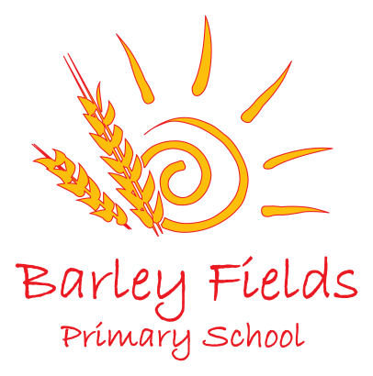
Governance Statement for the Governing Body of
Barley Fields Primary School
2019-2020

In accordance with the Government’s requirement for all governing bodies, the three core strategic functions of the Barley Fields Primary School Governing Body are:

- Ensuring clarity of vision, ethos and strategic direction;
Governors are responsible for setting the school’s strategic framework, identifying priorities for school improvement and monitoring progress towards these goals. Governors are also responsible for setting a school ethos of high expectations of behaviour, progress and attainment of all pupils and of conduct of staff and governors.

- Holding the Head Teacher to account for the educational performance of the school and its pupils;
Governors must provide challenge to the school and hold the Head Teacher and senior leaders to account for improving the quality of teaching and learning and school performance. Governors do this through questioning and through regular monitoring and analysis of data on children’s performance and progress. Governors hold the Head Teacher to account for the performance management of teachers. The performance management of the Head Teacher is conducted by governors together with an external advisor.

3. Overseeing the financial performance of the school and making sure it’s money is well spent.
Governors look at financial statements and ask questions to ensure that the school makes efficient use of its budget and provides best value for money.
Governance arrangements
The Governing Body was re-constituted under the 2012 School Governance Regulations in November 2016 with a revised governing body membership of 11 governors plus 2 associate governors.
The Governing Body now includes:
- 2 staff governors (including the Head Teacher)
- 4 elected Parent Governors
- 1 Local Authority Governor
- 4 Co-opted Governors
- 2 Associated Governors

Co-opted governors are appointed by the Governing Body and are people who, in the opinion of the governing body, have the skills required to contribute to the effective governance and success of the school:
The full Governing Body meets once each term.
The Pay and Performance Committee meet annually and other committees that meet if required to consider pupil discipline and staffing matters.
Attendance record of governors
You can see the full list of governors and their attendance at meetings on the school website.
The governing body completed a skills audit to identify any further skills or training they needed to be able to deliver their functions effectively.
As a result of the audit, a governors training session on “Safeguarding” was held at the school in November and on “Financial Budgets and Financial Monitoring” in May which most governors attended.
Individual governors have also attended training including Induction for new Governors and Health and Safety.
Each year, governor’s sign a Code of Conduct which can be viewed on our website and the Governing Body have also published their Register of Business and Pecuniary Interests.
The work that we have do on our committees and in the governing body
The majority of the work this year will involve:
- planning and supporting development of the school leadership structure;
- reviewing school self-evaluation;
- monitoring progress against the school development plan;
- challenging school outcomes and setting aspirational targets for all pupils;
- monitoring “vulnerable” children and challenging how the Pupil Premium Grant is being spent by the school and the impact this has on their outcomes;
- monitoring how the Sports Premium is used to improve the quality of the PE curriculum by providing opportunities for pupils to participate in competitive sports and games as well as a wide range of enrichment PE activities;
- reviewing and agreeing the school budget. Supporting the strategic budget and ensuring that the school has solid management of the finances and remains within allocated budget;
- reviewing and approving key school policies. A number of statutory policies and procedures have been written / updated in compliance with all relevant legislation including Safeguarding and Child Protection Policy, Recruitment Polices, Curriculum Polices; Health and Safety Policy, Attendance Policy.
- involvement in review meetings with the School Development Partner;
Another important role for governors is ensuring the safety and well-being of the children and we have a nominated Governor for Safeguarding – Glynis Pattison who meets regularly with the DSL and reports to governors about any safeguarding matters/issues.
The minutes of Governing Body meetings are public documents and you can ask at the school office if you would like to see any of the minutes of our meetings.
Future plans for the governors
- The governing body will continue to support the Head Teacher and senior leaders in the efficient running of the school whilst continuing to strategically develop the excellent standard of education in the current challenging and changing environment.
- Governors will closely monitor the financial viability of the school in the context of tightening budgets.
- Governors will continue to establish systems and styles of working through which the governing body can work most effectively in fulfilling their roles.
- They will also look to increase their communication with parents and the community through attendance at parent’s meetings and school events.
How you can contact the governing body
We always welcome suggestions, feedback and ideas from parents. You can contact Glynis Pattison, Chair of Governors via the school office.

