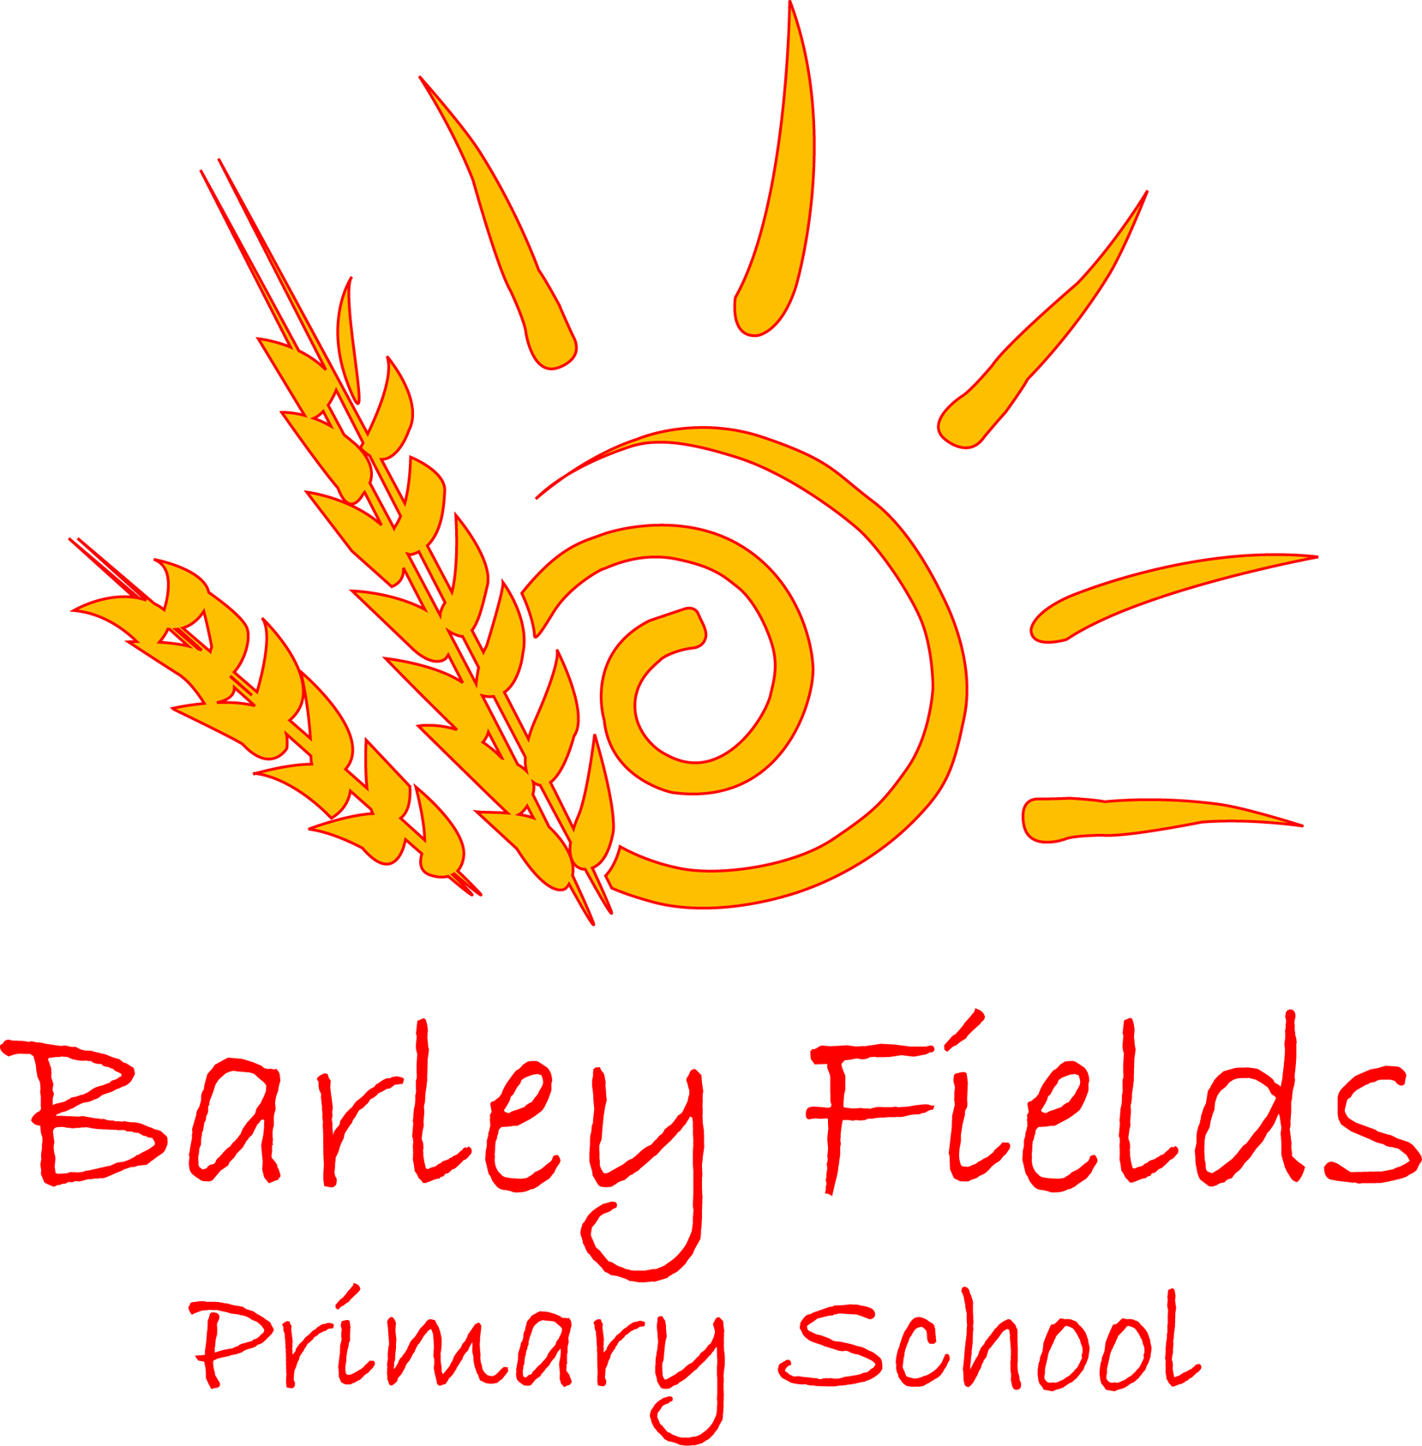

Charging and Remissions Policy

2018

Date Issued: | October 2018
Prepared by: | Head Teacher
Review date: | October 2020
Date Adopted by Governing Body:

We recognise the valuable contribution that the wide range of additional activities, including trips, clubs and residential experiences can make towards pupils’ education. We aim to promote and provide such activities as part of a broad and balanced curriculum for the pupils of the school and as additional optional activities.

We believe that all our pupils should have an equal opportunity to benefit from school activities and visits (curricular and extracurricular) independent of their parents’/carers’ financial means. This policy describes how we will do our best to ensure a good range of visits and activities is offered and, at the same time, try to minimise the financial barriers which may prevent some pupils taking full advantage of the opportunities.

All education at Barley Fields Primary School during school hours is free. We do not charge for any activity undertaken as part of the National Curriculum.

Voluntary contributions
When organising school trips or visits to enrich the curriculum and the educational experience of the children, the school invites parents to contribute to the cost. All contributions are voluntary. If we do not receive sufficient voluntary contributions, we may cancel a trip. If a trip goes ahead, it may include children whose parents have not paid any contribution. We do not treat these children differently from any others.

If a parent wishes their child to take part in a school trip or event, but is unwilling or unable to make a voluntary contribution, we do allow the child to participate fully in the trip or activity. School generally subsidises the cost of each visit to limit the contributions requested. When calculating the contribution requested per pupil, the total cost for the visit including transport and any admission charges minus the school subsidy are divided equally amongst the number of pupils expected to participate. Parents have a right to know how each trip is funded. The school provides this information on request. In any case where an activity cannot be afforded without voluntary funding, this will be made clear to the parents by the school. If the activity is cancelled all monies paid will be returned to parents.

The following is a list of additional activities, organised by the school, which require voluntary contributions from parents. These activities are known as ‘optional extras’. This list is not exhaustive:
- visits to museums;
- transport;
- sporting activities which require transport expenses;
- outdoor adventure activities;
- visits to or by a theatre company;
- musical events.

Admissions
There is no charge for admissions to the school.

School Meals
There is no charge for children who are entitled to free school meals or the universal free school meals programme. Pupils who are not eligible for free school meals are charged the amount as determined by the local authority catering service.

Activities that take place during school hours (this does not include the break in the middle of the school day)
There is no charge for activities during school hours with the exception of personal music tuition.
There is no charge for transport during school hours to school-organised activities.
We may occasionally charge for books and materials that the parent wishes the child to keep (the cost will be made clear to the parents before charge).

Swimming
The school organises swimming lessons for all children in Key Stage 2. These take place in school time and are part of the National Curriculum. We make no charge for this activity. We inform parents when these lessons are to take place, and we ask parents for their written permission for their child to take part.

Optional Extras - Residential visits
If the school organises a residential visit they key costs include transport and board and lodging. We aim to make the payments as flexible as possible in order to promote access of the activity to as many pupils as possible. Wherever possible payment plans are offered to allow parents to pay more substantial amounts over a longer period of time.

In line with government guidance parents who are entitled to free school meals for their children are not required to pay for the board and lodgings element of any residential visit. This may be part or fully funded by pupil premium allocation.

Again, the contributions requested for the activities and transport included in residential visits are voluntary however it is made clear to parents that without these the residential visit would be unable to go ahead.

Optional Extras - Music tuition
All children study music as part of the normal school curriculum. We do not charge for this. There is a charge for individual or small-group music tuition, since this is an additional curriculum activity, and not part of the National Curriculum. These individual or small-group lessons are taught by peripatetic music teachers. The service makes a charge for these lessons, but parents in receipt of state benefits are exempt from payment.

Optional Extras - Extended School Activities
The school offers a range of additional activities after school. These are run by both staff members and external coaches. There is a charge for these sessions to cover the costs of teaching and non-teaching staff. The total charge will not exceed the cost of providing the activity and no parent will be asked to subsidise others.

Damage to property and breakages
Where school property has been wilfully or recklessly damaged by a pupil the school may charge those responsible for some or all of the cost of repair or replacement. Where property belonging to a third party has been damaged by a pupil, and the school has been charged, the school may charge some or all of the cost to those responsible.
Whether or not these charges will be made will be decided by the Head Teacher and dependent on the situation.

Families qualifying for remission or concession with charges
The school will give consideration to the remission of charges to parents or carers who receive the following support payments:
- Income Support
- Income based Job-seekers Allowance
- Child Tax Credit (where the person is not receiving Working Tax Credit as well)
- Support under part VI of the Immigration and Asylum Act 1999
- Guaranteed Element of State Pension Credit
- Income related employment and support allowance
Children of families who receive these payments are also entitled to free school meals. Parents who are eligible for the remission of charges will be dealt with confidentially.

The Head Teacher and Chair of Governors will authorise the remission of charges.

The school may choose to subsidise part or all of the payment of some charges for certain activities and pupils, and this will be determined by the Governing Body and Head Teacher.

Monitoring and review
This policy is monitored by the governing body, and will be reviewed in two years, or earlier if necessary.

