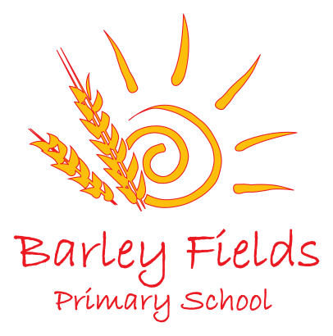
Newsletter
October 2019

As we come to the end of the first half term of the academic year I would like to thank all the staff, parents and children who have worked so hard to make it a success. This term has seen many exciting things occur in school and I have watched many of our new children settle in quickly and become part of the Barley Fields family.
Harvest Festival
Thank you for all your kind donations of food and toiletries as part of our Harvest festival. We had an amazing assembly in school led by Father Clay and your donations were shared with Thornaby Foodbank and Harbour Women’s refuge. As always, your generosity is amazing and the donations were very gratefully received by both organisations.

Book Bus
Thank you to everyone who came and supported the visit of the Book Bus. It was a great success and we raised £629 towards new books for school. It was also great to see many of the children taking time to select a book with care and I hope they all enjoyed reading them at home.

KS2 Challenge Days
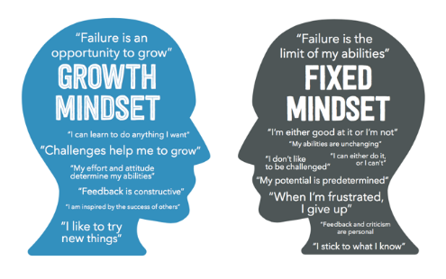
In September we have an exciting opportunity for parents to participate in challenge days with their children. The idea behind this is to share with parents the principles that make a child a successful and confident learner. We hope that you can join us. Dates are as follows:

Year 6 6.11.19
Mrs Shildrick 9.00-10.30am
Miss Barton 10.30-12.00pm
Miss Duncan 1.30-3.00pm

Year 5 21.11.19
Mrs Burton 9.00-10.30pm
Mr Harker 10.30-12.00pm
Mr Durrani 1.30-3.00pm

Year 4 12.11.19
Miss Perkin 9.00-10.30am
Mr Forster 10.30-12.00pm
Mrs Ward 1.30-3.00pm

Year 3 26.11.19
Mrs Pisani 9.00-10.30am
Mrs Nicholls Pickering 10.30-12.00pm
Miss Lane 1.30-3.00pm
Parent Consultation and Workshops
Thank you to all the parents who attended our workshops and consultation evenings this term. Your support and interest in your child’s education is very much valued and can make huge difference to their progress and attainment. If you haven’t yet met with your child’s teacher please make every effort do so as soon as possible.
Friends of Barley Fields events
A big thank you to all the members of Friends of Barley Fields who are working hard to organise some fabulous events in school in the run up to Christmas. Our next events organised by the PTA will be:
- Spooky Disco – Wednesday 6th November
- PTA Christmas Fayre Wednesday 27th November 5.00pm -7.00pm – craft stalls, entertainment, refreshments, tombola and toy stall.
- Christmas sing-a-long on Tuesday 17th December at 5.30pm.
All profits raised will go towards the purchase of equipment and resources for children in school, as well as providing Christmas gifts for all children in school.
Statutory Assessment Tests
Children in Y2 and Y6 will complete their SATs in the week beginning Monday 11th May 2020. It is essential that all children attend school during this week. Children in Y1 will complete the phonics check in the week beginning 8th June. Foundation Stage Profile Assessment will be completed by staff during the summer term for Reception children – this will not be administered as a test but is part of ongoing assessment.

School Council and Pupil Governors
Last week involved the election of members for our new school council. Each class has a representative on the council and they will be responsible for supporting the school in its achievement of a rights respecting schools award from Unicef.
Year Six have elected two pupil governors – congratulations to Hannah Shepherdson and Oscar Pattinson. They will now take a leading role as school representatives and support the work of the school council.

Reading.
We continue to look for volunteers to support our parent reading programme in school and as such we are looking for a group of parents or grandparents who wish to volunteer for short periods on a regular basis to read with our children. This would take place daily from 11.30 - 12.15pm or during the afternoon teaching session. The opportunity to read aloud with an adult is an excellent way to raise attainment in reading and for some of our children this is very important given the challenging demands of the curriculum. Any work would be in line with our volunteering in school policy and adults must be checked by the disclosure and barring service (DBS). School would arrange for these checks to be carried out. If you are interested in volunteering for this project or would like to discuss it further, please contact Mrs Gregory who organises the project.

Building Work
Over the half term [period building work will commence at the Children’s Centre on Lamb Lane and will last until March 2020. This will mean that access to the main school office will be affected. The current gate on Lamb Lane will close and a new gate will be erected further along the path adjacent to the roundabout. Please ensure that all children are fully supervised when moving around this area to ensure their safety.

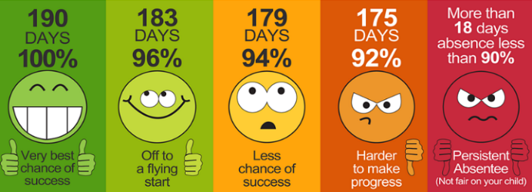
Attendance
Our current whole school attendance rate is 97.5% and many classes have received rewards for 100% weekly attendance – thank you for your support.
The class with the highest attendance this term was in Mrs Pisani’s class in Year 3 with at 98.9% - well done everyone!
May I remind parents that leave of absence requests will only be authorised by the school in very exceptional circumstances as outlined in the school attendance policy (available on the website or in the school entrance). All other requests will be categorised as unauthorised, in line with school

P.E.
Across school, all children are expected to participate in 2 hours of physical activity each week. Children will only be excused from PE if a written note from a parent is received in school stating the reason why they must be excused and duration of the illness. If a reason for non- participation is for a period of more than 2 weeks, medical information or advice must be provided to school.

Please ensure that your child has their PE kit in school at all times. Our school P.E. kits consists of:
- Navy tracksuit (jogging bottoms and sweatshirt top), white t-shirt, navy shorts and trainers/plimsolls.

Dates
Our Christmas Calendar with dates will be sent out immediately after half term.
PD Days 2019-20

Friday 25th October 2019
Monday 1st June 2020
Friday 26th June 2020
Monday 20th July 2020

School will be closed to children on these dates.

For a full list of school holiday dates please see: https://www.stockton.gov.uk/media/1958699/school-term-and-holiday-dates-academic-year-2019-20-updated-june-2019.pdf for a full list of the 2019-20 term dates.

