Christmas Newsletter
December 2019

We have finally come to the end of a very busy Autumn term and a packed Christmas celebration period. As usual the children have excelled in their commitment to all of the activities, which just get better every year!

We began at the start of December with a performance of ‘The Hoity Toity Angel’ performed by our Year 2 children and this was quickly followed by our Reception children who performed ‘The Bossy King’. Both performances were wonderful and created so many special memories and a lot of giggles.

Our performance season continued with an amazing performance of ‘Bethlehem the Musical’ by Year 4 and has ended this week with our Year 6 children and their fabulous pantomime; ‘Sherlock and Cinders’. It makes me so proud to see the talents of our children develop as they go through school and I am sure many of you will agree that we have some real stars in the making!

Children in Year 1 and Year 3 took part in Christingle Services at St Francis Church which were kindly led by Father Nick and Father Clay. The children sang beautifully in both services and were a credit to the school. A big thank you to the parents and grandparents who attended and for the monetary donations offered. These will be forwarded to the Children’s Society to help improve the lives of underprivileged children.

Our Year 5 children held a carol service at St Francis Church and it was wonderful to hear their amazing voices singing carols old and new – we were all privileged to enjoy this concert in school on Thursday. Well done Year 5!

Christmas Craft Days
Thank you to the parents and grandparents who attended Christmas Craft Days, children had opportunities to make Christmas trees, Christmas cards, robin tree decorations and many other things. I have had many positive comments from parents who enjoyed sharing this time with their children in school.

Santa’s Visit
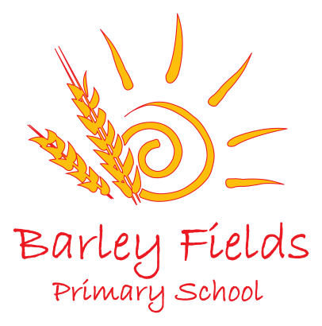
Last week we were lucky enough to have a visit from Santa himself. He spent the whole day in school visiting classrooms and answering children’s questions. He also brought a surprise early Christmas present for every child in school – Thank you Santa!
Christmas Lunch
Tuesday saw the whole school enjoy Christmas Lunch which was kindly provided by Mrs. Williams and her staff in the kitchen. It was wonderful to see all of our school family come together to celebrate Christmas in the traditional manner and was a lovely festive occasion. Thank you to our amazing kitchen staff.

Friends of Barley Fields – Christmas Events
I would like to take this opportunity to thank the Friends of Barley Fields who have organised some amazing events during the Christmas festivities including a spectacular Christmas Fayre, Santa’s Visit, a Christmas Raffle and the Christmas Sing-along.

The funds raised have been used to support Santa’s visit to school and to provide refreshments during the Barley Fields Sing-along which was attended by so many of our families. Well done and thank you to everyone who bought tickets and supported this great event.
Our festivities ended today with a ‘crazy Christmas Dress up day’. The range and originality of the costumes was amazing.

Charity Fundraising
Thank you to everyone who supported the Cause Christmas Hamper campaign. The hampers of food and gifts were collected by the charity on Monday and have been delivered to 26 local families.

We were also able to send donations of food and toys to other local charities including Harbor Women’s Refuge and Thornaby Foodbank.

Thank you to Mr Tavender (an uncle of a child in school) who on behalf of his company EPOCH, kindly donated 120 sets of Sylvanian family toys for us to distribute on their behalf. It is not often that I am at a loss for words, but I was truly humbled by the enormity of this donation. We took the opportunity to support a range of places with these toys including: Cause for Christmas, Harbor, ABC counselling, families from local schools, Remembering Rebecca and the children’s wards at North Tees and James Cook Hospitals.

The children have also astounded me with their generosity – from fundraising for the Unicef advent calendars to asking staff to donate the money usually spent on them by teachers to Unicef causes. Together we are raising children with the most amazing moral values and caring attitudes. I am so proud of them!

Attendance
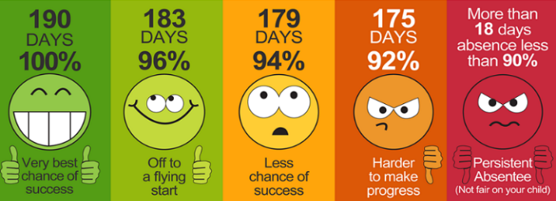
Our current whole school attendance rate is 96.4% and many classes have received rewards for 100% weekly attendance – thank you for your support. The class with the highest attendance is Miss Duncan’s class in Year 6 with an attendance of 98.3%! Well done everyone.
May I remind parents that leave of absence requests will only be authorised by the school in very exceptional circumstances as outlined in the school attendance policy (available on the website or in the school entrance). All other requests will be categorised as unauthorised, in line with school policy.
School Term Dates
We will return to school on Monday 6th January at 8.55am. A calendar outlining key dates for the new term will be issued in January.
Social media and school website
We are currently having a new school website designed which will launch in the New Year. Please look out for further information. Also, we have recently launched a school Twitter page please follow us at @BarleyPrimary for regular updates on our school activities or like our Facebook page.
Parking
Can I remind parents not to park around the roundabout at the end of Lamb Lane or near the temporary entrance. This is an unsafe area for children and I would hate for an accident to occur as a result of irresponsible parking behaviour.
PD Days 2019-20

Monday 1st June 2020
Friday 26th June 2020
Monday 20th July 2020

School will be closed to children on these dates.

For a full list of school holiday dates please see: https://www.stockton.gov.uk/media/1958699/school-term-and-holiday-dates-academic-year-2019-20-updated-june-2019.pdf for a full list of the 2019-20 term dates.

Finally can I say a big thank you to all the staff in school who collectively work extremely hard to make all these wonderful Christmas things run smoothly. From erecting the staging and lighting at the start of December, to designing tickets and programmes, serving refreshments and organising parties and craft days – the staff here really do go the extra mile for your children. Thank you.

From everyone here at Barley Fields we wish you and your families a very happy and peaceful Christmas and a wonderful New Year. See you in 2020!

