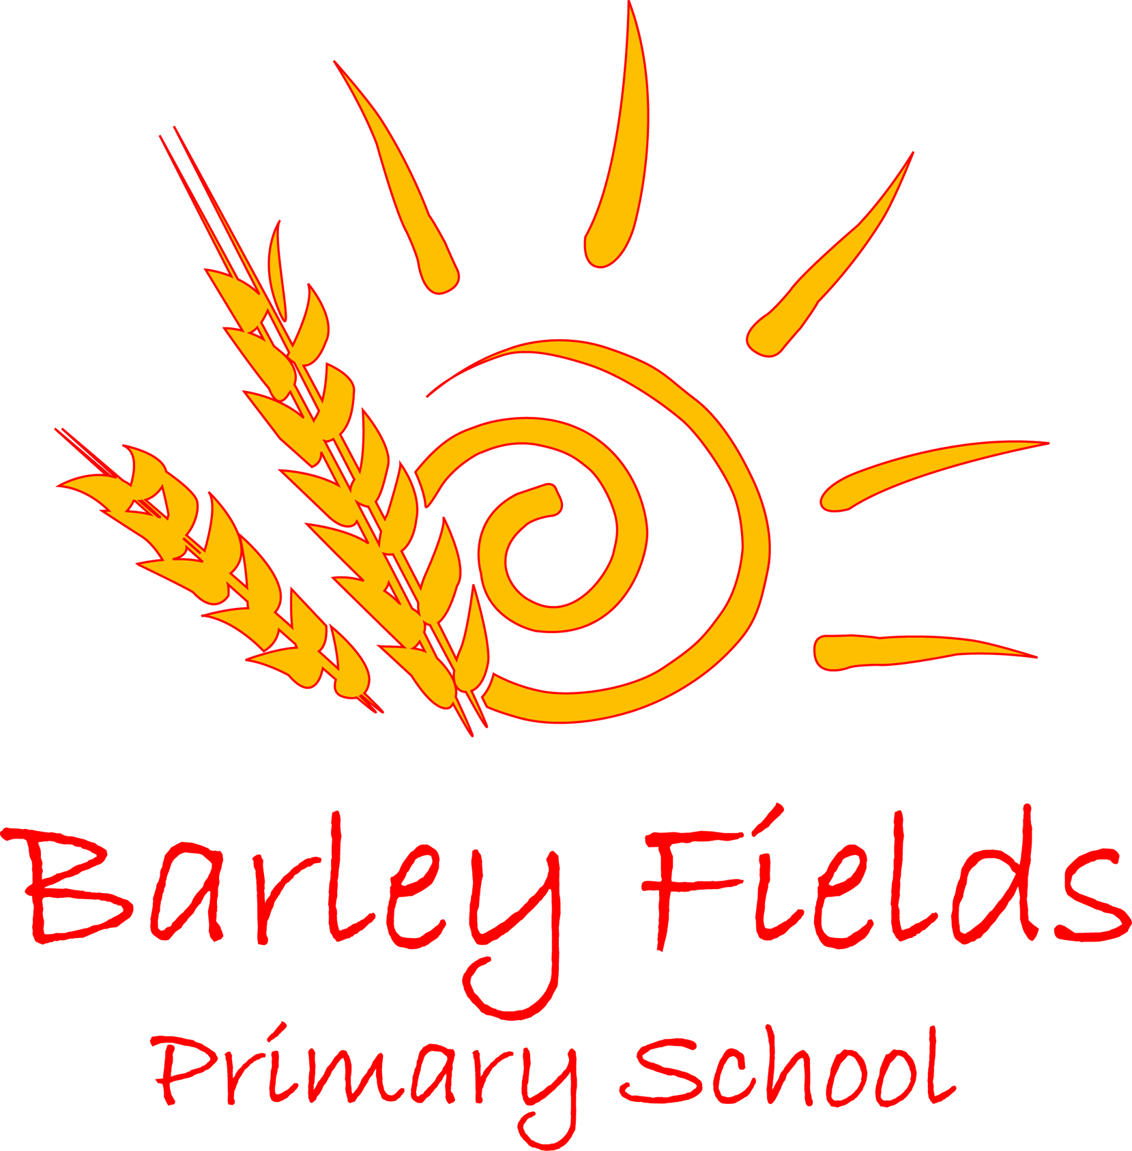

Governing Body of Barley Fields Primary School
Schedule of Meetings
Academic Year 2019/2020
Meeting | Date
Autumn Term 2019  School Improvement Committee | 18 September 2019 at 1.00 pm
Resources Committee | 16 October 2019 at 5.30 pm
Full Governing Body Meeting | 11th December
Performance Management Committee | TBC
Pay Review Committee | TBC
Spring Term 2020  School Improvement Committee | 12 February 2020 at 5.30 pm
Resources Committee | 29 January 2020 at 5.30 p.m.
Resources Committee | 18 March 2020 at 9.00 a.m. (Acklam Hall)
Full Governing Body Meeting | 25 March 2020 at 5.30 pm
Summer Term 2020  Resources Committee | 13 May 2020 at 5.30 pm
School Improvement Committee | 10 June 2020 at 5.30 pm
Full Governing Body Meeting | 8 July 2020 at 5.30 pm

