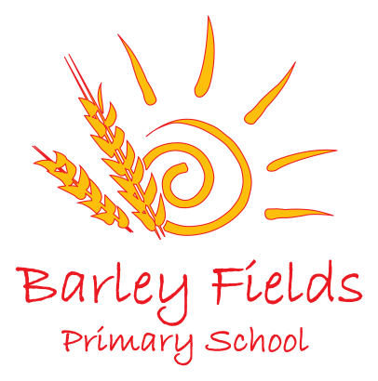
Head Teacher – Mrs Caroline Taylor
Lamb Lane, Ingleby Barwick
Stockton on Tees
TS17 0QP
Tel: 01642 767051

Email: barleyfields@sbcschools.org.uk
Website: www.barleyfieldsprimaryschool.org.uk

Financial Information Report for Parents – Budget Year 2020-2021
Revenue Expenditure | Financial Outturn  2019-20 | Budget  2020-21
Employees | 2,139,641 | 2,271,029
Premises | 188,965 | 184,099
Transport | 8,621 | 14,000
Curriculum | 87,720 | 101,200
Supplies and Services | 340,345 | 326,347
Other Funding | 13,875 | 21,350
Income | 104,190 | 147,092
Total net expenditure | 2,672,978 | 2,770,933
Funding 2019/20 | 2,944,522
Funding 2020/21 |  | 2,778,703
Reserves |  | 7,770
Final Outturn | 271,544

