Long Term Planning
Key Stage Two - Year 3 2020-2021
 | Autumn |  |  |  | Spring |  |  |  | Summer
English | Autumn 1 Unit 1  Cracking Contraptions  (T4W – Unit)  Reading and writing based on instructional texts with explanation. |  | Autumn 1 Unit 2  Cracking Contraptions  Reading and writing based on instructional texts with explanation.  Autumn 1 – 8 Weeks |  | 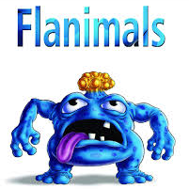  Spring 1 Unit 1  Flanimals  (T4W Unit)  Reading and writing explanatory texts based on Flanimals |  | Spring 1 Unit 2  Flanimals  Reading and writing explanatory texts based on Flanimals  Spring 1 – 6 weeks |  | Summer 1 Unit 1  Gorilla  (T4W Unit)  Reading and writing narrative/poetry based on Gorilla |  | Summer 1 Unit 2  Gorilla  (T4W Unit)  Reading and writing narrative/poetry based on Gorilla  Summer 1 – 5 Weeks
 | Autumn 2 Unit 3  Crazy Creatures  (RWP – Unit)  Creating animal fact files for an audience of children and publishing using e-books. |  | Autumn 2 Unit 4  Crazy Creatures  (RWP – Unit)  Creating animal fact files for an audience of children and publishing using e-books.  Autumn 2 – 7 Weeks |  | 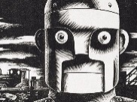  Spring 2 Unit 3  The Iron Man  (T4W Unit)  Reading and writing narrative/poetry based on the Iron Man. |  | Spring 2 Unit 4  The Iron Man  (T4W Unit)  Reading and writing narrative/ poetry based on the Iron Man.  Spring 2 – 6 Weeks |  | Summer 2 Unit 3  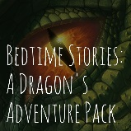  Bedtime Stories  (RWP Unit)  Reading, writing, performing and publishing Bedtime Stories for a younger audience. |  | Summer 2 Unit 4  Bedtime Stories  Reading, writing, performing and publishing Bedtime Stories for a younger audience.  Summer 2 - 7 Weeks
Mathematics | 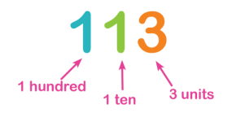  Autumn 1 Unit 1  Number - Place Value  (3 Weeks) |  | Autumn 1 Unit 2  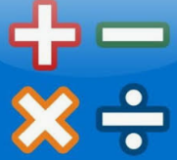  Number – Addition, Subtraction, Multiplication & Division  (4 weeks) |  | Spring 1 Unit 1  Number –Multiplication & Division  (2 weeks) |  | Spring 1 Unit 2  Measurement - Money  (2 Weeks)  Unit 3  Number – Fractions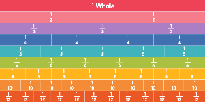  (2 weeks) |  | Summer 1 Unit 1  Measurement – Mass and Capacity (3 weeks) |  | Summer 1 Unit 2  Measurement – Time (  2 weeks)
 | Autumn 2 Unit 3  Number –Multiplication & Division  (3 weeks) |  | Autumn 2 Unit 4  Number –Multiplication & Division |  | Spring 2 Unit 3  Number – Fractions  (4 weeks) |  | Spring 2 Unit 4  Measurement – Length and Perimeter (2 weeks) |  | Summer 2 Unit 2  Measurement – Time (1 week)  Unit 3  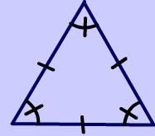  Geometry – Properties of Shape  (3 weeks) |  | Summer 2 Unit 4  Statistics  (1 week)  Consolidation and assessment  (2 weeks)
Science | Autumn 1 Unit 1  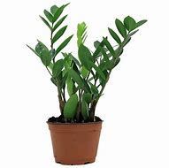  Plants | 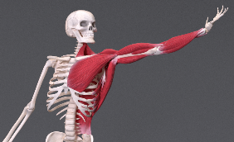  Autumn 2 Unit 2  Animals including Humans |  | Spring 1 Unit 3  Forces and Magnets |  | Spring 2 Unit 4  Rocks |  | Summer 1 Unit 5  Light |  | 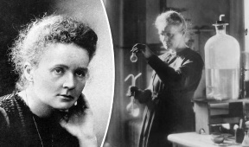  Summer 2 Unit 6  Scientists and Inventors
Computing | Autumn 1 Unit 1  Thinking Like A Programmer | Autumn 2 Unit 2  Creating with Robots |  | Spring 1 Unit 3  Video Creation (including sound) |  | Spring 2 Unit 4  E-books |  | Summer 1 Unit 5  Online Communication |  | Summer 2 Unit 6  I’m An Animator (2)
Digital Literacy

Geography | Autumn 1 Unit 1  Mapping Skills  Investigating Our Local Area - Ingleby Barwick |  |  | Spring 1 Unit 2  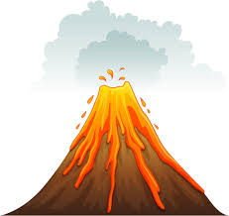  Physical Geography Study  Volcanoes |  | Summer 1 Unit 3  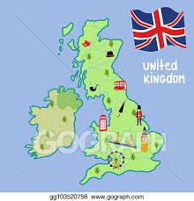  Awareness of Location and Place  The United Kingdom
History | Autumn -Unit 1  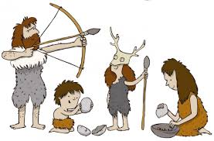  Unit 1- From Stone Age to Iron Age |  |  | Spring -Unit 2  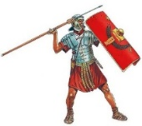  Unit 2- Invaders and Settlers - Romans |  | Summer- Unit 3  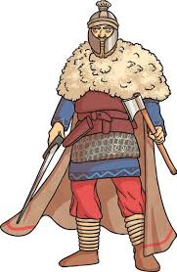  Unit 3- Anglo Saxons
P.E. |  | 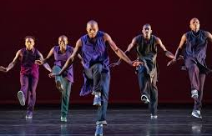  Autumn 1 Unit 1  Dance and Movement | 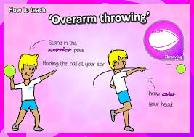  Autumn 1 Unit 2  Throwing and Catching | Spring 1 Unit 3  Net and Wall  Tennis | Spring 1 Unit 4  Health Related Exercise | Summer 1 Unit 7  Dance | Summer 1 Unit 8  Gymnastics
 |  | 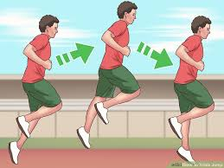  Autumn 2 Unit 3  Running and Jumping | Autumn 2 Unit 4  Invasion- Football Skills | Spring 2 Unit 5 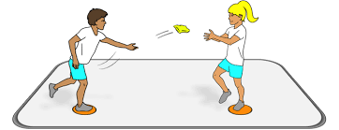  Balance and Cordination Agility | Spring 2 Unit 6  Attacking and Defending - Hockey

MFL | Autumn – Unit 1  A World of Languages and Bonjour | Spring – Unit 1  Ma Famille | Summer - Unit 1  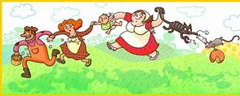  Jeux et Chansons
Music | Autumn Unit 2  Pitch  Composer Study – Antonín Dvořák | Spring Unit 4  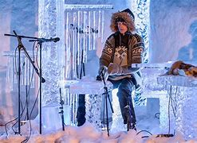  Texture  Composer Study – Terje Insungset | Summer Unit 6  Structure  Musical Artist Study – David Bowie
Art | Unit 1  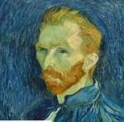  Artist Study: Vincent Van Gogh | 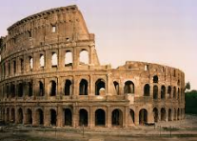  Unit 2  Roman Art & Architecture | Unit 3  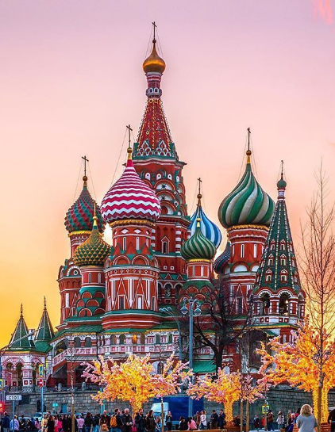  Famous Buildings
DT | Unit 1  Textiles seasonal stockings | Unit 2  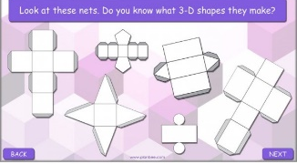  Structures - shell structures  Packaging | Unit 3  Food – healthy diet  Sandwich Snacks

RE | Unit 1  Sacred Texts:  What is the Bible and why is it important? | Unit 2  Festivals  What are the symbols associated with Christmas?  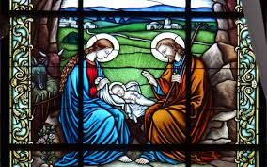 | Unit 3  Places of Worship:  What is a mosque and why is it important?  Visit to the Mosque | Unit 4  Festivals/Beliefs and Practices:  Why is Easter important to Christians? | Unit 5  Festivals/Beliefs and Practices:  Judaism | Unit 6  Festivals:  What is EID and why is it important?
PSHE | Unit 1  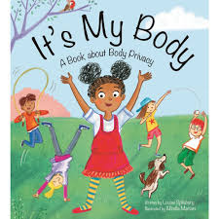  Health and Wellbeing  It’s my body | Unit 2  Health and Wellbeing  Aiming High- Goals | Unit 2  Relationships- Be Yourself | Unit 2  Relationships-Teamwork | Unit 1  Living in the Wider World- Living in Britain today- Democracy and Law | Unit 2-  Money Matters- Where does Money Come From?

