Long Term Planning
Lower Key Stage Two Year 4
2020-2021
 | Autumn |  | Spring |  |  | Summer
English | Autumn 1 Unit 1  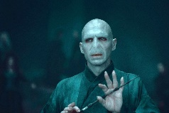  Villains  Reading and writing unit based on well-known villainous characters from reading. Character Descriptions and Police Reports.  (non-narrative) | Autumn 1 Unit 2  Villains  Reading, writing and performance unit based on villainous characters from reading.  Villainous Speeches.  (RWP Unit)  (narrative) | Spring 1 Unit 1  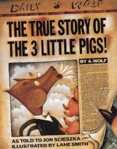  Fairy Tale Twists  Reading and writing based on fractured fairy tales.  (narrative) | Spring 1 Unit 2  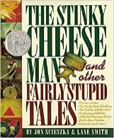  Fairy Tale Twists  Reading and writing based on fractured fairy tales.  (narrative) |  | Summer 1 Unit 1  Sports Manager  Reading, writing and performance unit based on motivational speaking.  (RWP Unit)  (non-narrative) | Summer 1 Unit 2  Sports Manager  Reading, writing and performance unit based on motivational speaking.  (RWP Unit)  (non-narrative)
 | 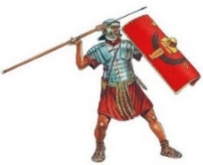  Autumn 2 Unit 3  Invaders  Reading, writing based on history topic.  (non-narrative) | Autumn 2 Unit 4  He’s a mean one, Mr Grinch  Online magazine interview (non-narrative)  (Christmas themed writing) | 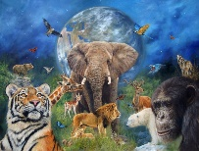  Spring 2 Unit 1  Planet Earth  Reading, writing and performance unit based on the art of documentary narration.  (RWP Unit)  (non-narrative) | Spring 2 Unit 4  Planet Earth  Other non-narrative writing linked to protecting planet earth – current global issues. Persuasive writing.  (non-narrative) |  | Summer 2 Unit 3  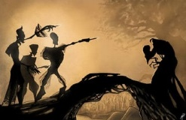  The Tale of The Three Brothers – The Beadle and the Bard  (narrative) | Summer 2 Unit 4  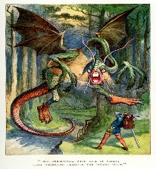  Jabberwocky and Through the Looking Glass…(poetry)  Reading and writing poetry  (The Mulips)
Autumn |  |  | Spring |  |  | Summer
Mathematics | 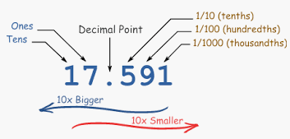  Autumn 1 Unit 1  Number - Place Value  (3weeks) | Autumn 1 Unit 2  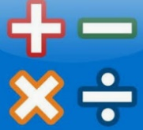  Number – Addition and  Subtraction  (4 weeks) | Spring 1 Unit 1  Number – Multiplication and Division  (3 weeks)  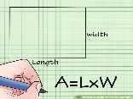  Measurement - Area  (1 week) | 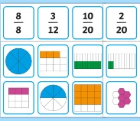  Spring 1 Unit 2  Number –Fractions  (2 weeks) |  | Summer 1 Unit 1  Measurement - Money  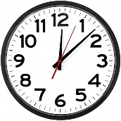  (2 weeks)  Measurement -Time  (2 weeks) | Summer 1 Unit 2  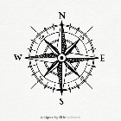  Geometry – Position and Direction  (1 weeks)  Unit 3  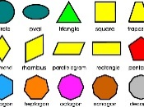  Geometry – Properties of Shapes  (2 weeks)
 | Autumn 2 Unit 3  Measurement – Length and Perimeter  (1 week)  Number – Multiplication and Division  (2 weeks) | Autumn 2 Unit 4  Number – Multiplication and Division  (2 weeks)  Consolidation and Assessment  (2 weeks) | Spring 2 Unit 3  Number – Fractions  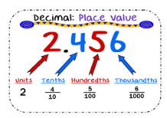  (2 weeks)  Number – Decimals  (1 weeks) | Spring 2 Unit 4  Number – Decimals  (1 week)  Consolidation and Assessment (1 week) |  | 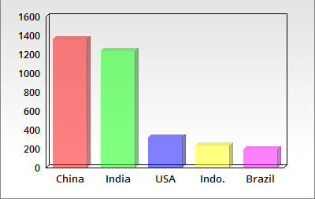  Summer 2 Unit 4  Statistics  (1 weeks) | Summer 2 Unit 4  Consolidation and  Problem Solving  (4 weeks)
Science | Autumn 1 Unit 1  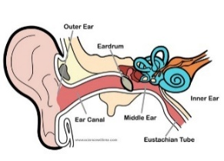  Sound - Hearing | 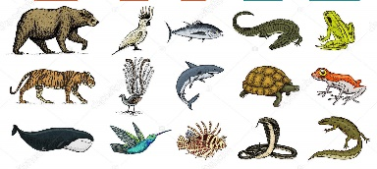  Autumn 2 Unit 2  Living Things and Their Habitats | Spring 1 Unit 3  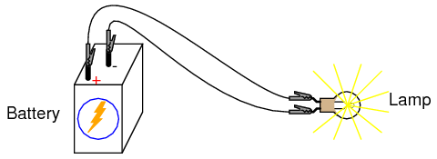  Electricity |  | Spring 2 Unit 4  Animals including Humans | 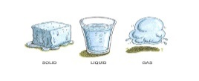  Summer 1 Unit 5  States of Matter | 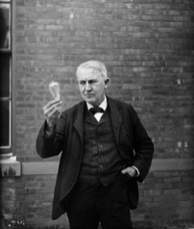  Summer 2 Unit 6  Scientists and Inventors  Alexander Graham Bell and Gerald Durrell
Computing | Autumn 1 Unit 1  Data Handling | Autumn 2 Unit 2  Presentations | Spring 1 Unit 3  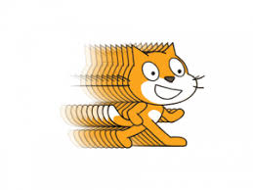  Go Sprite Go |  | Spring 2 Unit 4  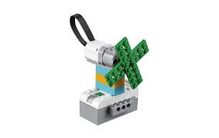  Robot Controller/Engineering Expert | Summer 1 Unit 5  Virtual Tours | Summer Unit 6  Internet and Hardware Inspectors
Digital Literacy
History | Autumn - Unit 1  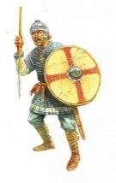  vs  Battles in the past Vikings vs Anglo Saxons |  | Spring - Unit 2  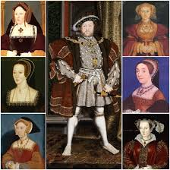  ]  Historical turning point - Why did Henry VIII marry 6 times? |  |  | Summer - Unit 3  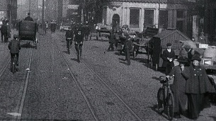  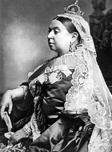  Victorian Life (local depth study)
Geography | Autumn - Unit 1  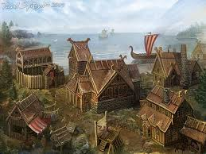  Awareness of Location and Place  Local Field Study - Village Settlers |  | Spring - Unit 2  Physical Geography Study  What is Climate Change? |  |  | Summer - Unit 3  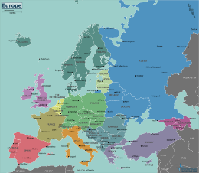  Mapping Skills  Our European Neighbours
P.E. | Autumn 1 Unit 1  Get Fit, Get Active | Autumn 1 Unit 2  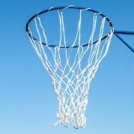  Attacking and Defending Netball | Spring 1 Unit 3  Health Related Exercise |  | Spring 1 Unit 4  Gymnastics | 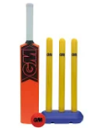  Summer 1 Unit 7  Attacking and Defending - Cricket | Summer 1 Unit 8  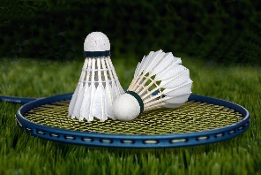  Net and Wall – Badminton
 | 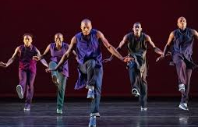  Autumn 2 Unit 3  Dance and Movement | Autumn 2 Unit 4  Invasion Games – Football | Spring 2 Unit 5  Attacking and Defending – Hockey |  | Spring 2 Unit 6  Net and Wall – Tennis | Summer 2 Unit 9  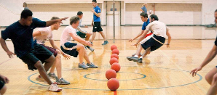  Dodgeball | Summer 2 Unit 10  Health Relataed Fitness
MFL | Jeux et Chansons 2 |  | Mon Anniversaire |  |  | 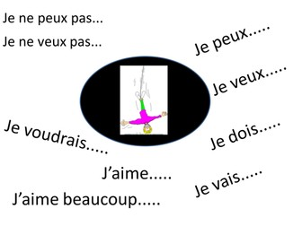  Je Peux, Je Veux et Je Voudrais
Music | Autumn - Unit 1  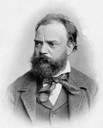  Duration  Stave rhythm notation  Untuned instruments  Appraisals with comparisons  Christmas Production  Composer Study -Dvorak |  | Spring - Unit 2  Dynamics  Crescendo / Dimminuendo  Tuned instruments  Appraisals with comparisons  Composer Study - – Terje Isungset |  |  | Summer – Unit 3  Tempo  Accelerando / Ritardando  Sight Reading  Untuned instruments - Performance  Appraisals with comparisons  Celebration Assembly  Composer Study – David Bowie
Art | Unit 1  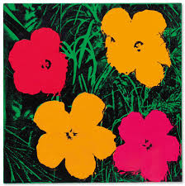  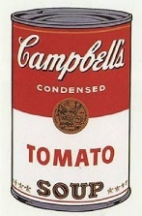  Andy Warhol and the Pop Art Movement |  | Unit 2  The Tudors |  |  | Unit 3  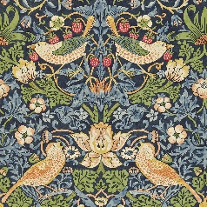  William Morris and Victorian Art
DT | Mechanical Systems – Levers and Linkages  Unit 1 - Moving Monsters |  | 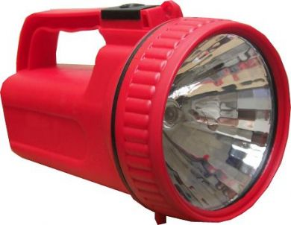  Electrical Systems  Uniit 2 - Torches |  |  | Food  Unit 3 - American Food
RE | Unit I  Festivals  Divali | Unit 2  Festivals  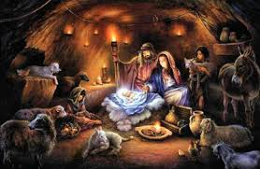  Christmas | Unit 3  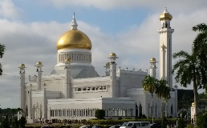  Places of Worship  What is a Mosque and why is it important? |  | Unit 4  Beliefs & Practices  Why is Easter important to Christians? | Unit 5  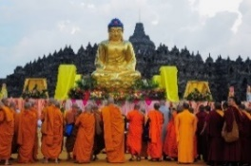  Beliefs and Practices  What is Buddism? | Unit 6  Beliefs and Practices  Islam in the UK
PSHE | Unit 1  Think Positively  Safety First |  | Unit 2  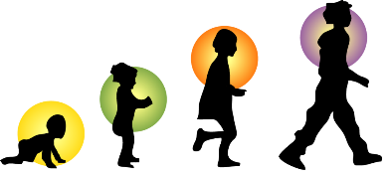  VIPs  Growing Up |  |  | Unit 3  Respecting Rights  One World

