Long Term Planning
Upper Key Stage 2 Year 5
2020-2021

English | 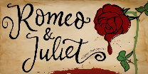  Autumn 1 Unit 1  Romeo and Juliet  Online/live news report and Mercutio and Tybalt. | 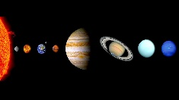  Autumn 1 Unit 2  Science- Cross Curricular  Explanation texts in the form of letters/emails. | 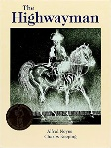  Spring 1 Unit 1  The Highwayman  Poetry and Diary Entries | Spring 1 Unit 2  Changes  Holiday Brochures  Persuasive travel adverts | Summer 1 Unit 1  Non-narrative –Persuasion  and discussion | Summer 1 Unit 2  Non-narrative –Persuasion  and discussion
 | Autumn 2 Unit 3  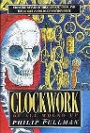  Clockwork- Philip Pullman  Narrative/non-narrative | 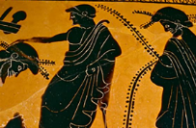  Autumn 2 Unit 4  Ancient Greece- Cross Curricular  Narrative/non-narrative writing based on the Battle of Thermopylae. | 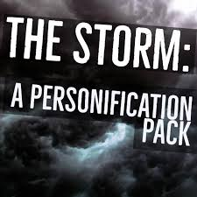  Spring 2 Unit 3  The Storm RWP Unit  Setting description through personification | Spring 2 Unit 4  The Storm RWP Unit  Suspense in narrative | 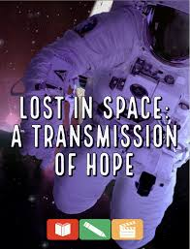  Summer 2 Unit 3  Lost in Space – A Transmission of Hope RWP Unit | Summer 2 Unit 4  Science-Fiction  Narrative
Mathematics | 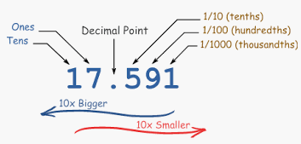  Autumn 1 Unit 1  Number – Place Value  (2 weeks) | Autumn 1 Unit 2  Number – Addition & Subtraction  (3 weeks) | Spring 1 Unit 1  Measurement - Perimeter & Area  (2 weeks) | 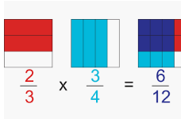  Spring 1 Unit 2  Number - Fractions (5 weeks) | 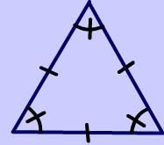  Summer 1 Unit 1  Geometry – Properties of Shape (2 weeks)  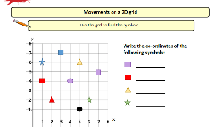  Geometry – Position & Direction  (1 week) | Summer 1 Unit 2  Measurement – Converting Units  (2 weeks)  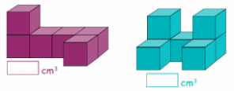  Measurement – Volume  (2 weeks)
 | 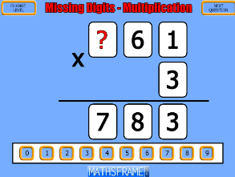  Autumn 2 Unit 3  Number – Multiplication & Division (4 weeks) | Autumn 2 Unit 4  Statistics  (2 weeks)  Consolidation learning  (1 week) | Spring 2 Unit 3  Number – Decimals  (3 weeks) | Spring 2 Unit 4  Number – Percentages  (2 weeks)  Consolidation learning  (1 week) | Summer 2  Revisiting and addressing misconceptions.  Applying reasoning skills in these areas:  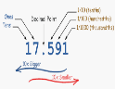  Place value (1 week)  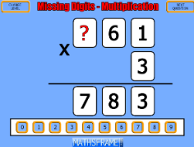  Multiplication & Division (1 week) | Fractions (1 week)  Decimals (1 week)  Consolidation learning  (1 week)

Science: | Earth and Space  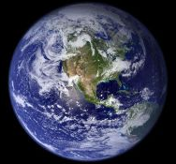 | Unit 4 Properties and Changes of Materials  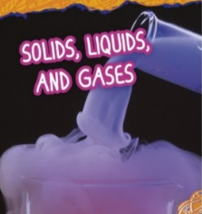 |  | Unit 1 Living things and their habitats  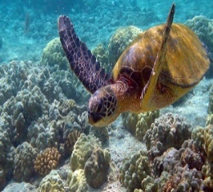 |  | Unit 2 Animals Including Humans  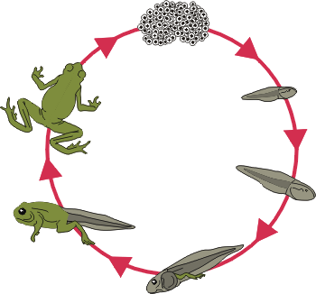 |  | Unit 5  Forces  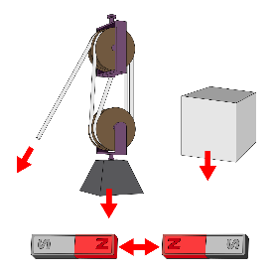 | Unit 6 Scientists and Inventors
Computing | Unit 1  Coding - Precise Programming | Unit 2  3D Modelling |  | Unit 3  Computer Networks |  | Unit 4  Spread It Out  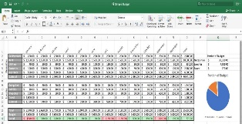 |  | Unit 5  Blogging | Unit 6  Interviews/Podcasts
Digital Literacy
History/Geography | Local Area Study  Investigating Rivers | What can we find out about life in Ancient Egypt?  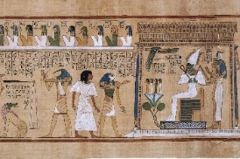 |  | Physical Geography  Study  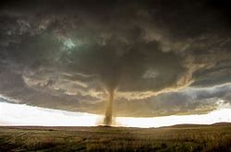  Extreme Earth |  | Who were the Ancient Greeks?  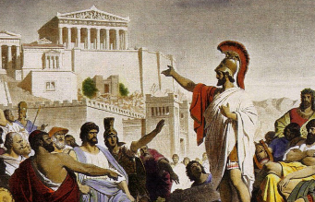 |  | Awareness of Location  and Place  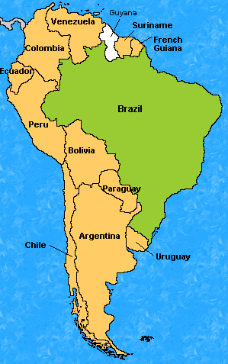  South America | The Maya  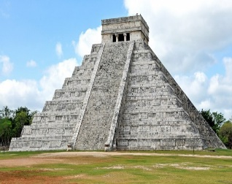
Physical Education | Autumn 1 Unit 1  Invasion Games  Tag Rugby | Autumn 1 Unit 2  Running and Jumping Cross Country |  | Spring 1 Unit 3  Balance, agility and coordination  Gymnastics |  | Spring 1 Unit 4  Attacking and Defending  Football |  | Summer 1 Unit 7  Running and Jumping  Athletics | Summer 1 Unit 8  Striking and Fielding  Cricket
 | 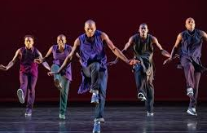  Autumn 2 Unit 3  Dance and Movement Patterns | Autumn 2 Unit 4  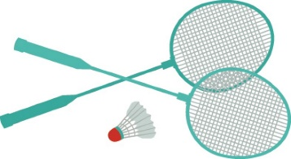  Net and Wall  Badminton |  | 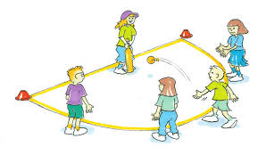  Spring 2 Unit 5  Attacking and Defending  Striking and Fielding |  | Spring 2 Unit 6  Running and Jumping  Netball |  | Summer 2 Unit 9  Net and Wall  Tennis | Summer 2 Unit 10  Dance and Movement Patterns
MFL | Autumn Unit 1  Les quatre amis  Describing and talking about animals |  |  | Spring Unit 2  L’argent de poche  Numbers to 100, likes and dislikes, the Euro, TV adverts |  |  |  | Summer Unit 3  Introduction to German
MUSIC | Tuned Instruments –Ukulele  Duration  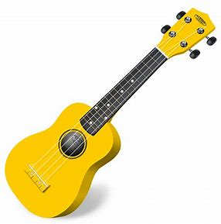 |  |  | Tuned Instruments –Ukulele  Dynamics |  |  |  | Tuned Instruments –Ukulele  Tempo | Artist Study-Damon Albarn/Blur  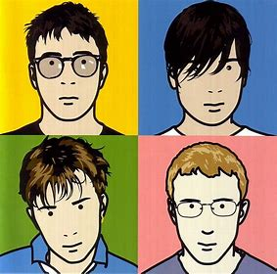
ART | 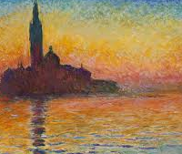  Monet and the Impresionists |  |  |  | The Maya  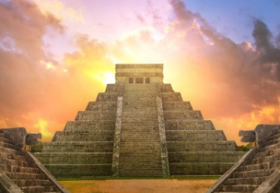 |  |  | 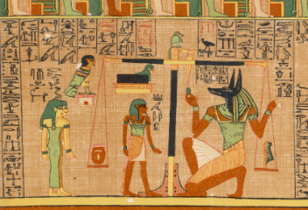  Egyptian Art
DT | Mechanical Systems: Moving Toys.  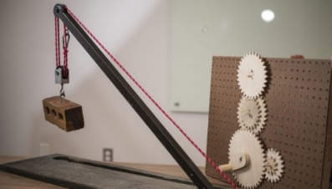 |  |  |  | Food – Bread |  |  | Electrical Systems Programming Pioneers  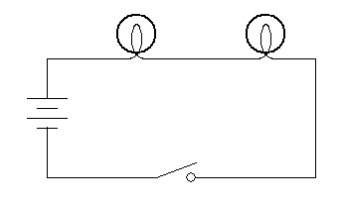
RE | Unit I  What Is a Gurdwara and why is it important? |  | Unit 2  Is Christmas Too Commercial? |  | Unit 3  What Are Religious Rules For? |  | Unit 4  Who is responsible for Jesus’ Death? | Unit 5  What is a puzzling question?  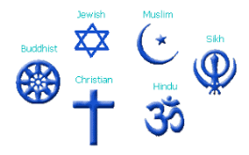
PSHE | 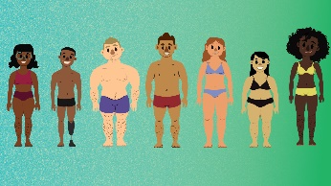  Unit 1  Health and Wellbeing  Its my Body. |  | Unit 2  Health and Wellbeing  Aiiming High |  | Unit 3  Relationships  Be yourself! |  | Unit 4  Relationships  Teamwork | Unit 5  Living in the Wider World  Living in Britian - Government | Unit 6  Money Matters

