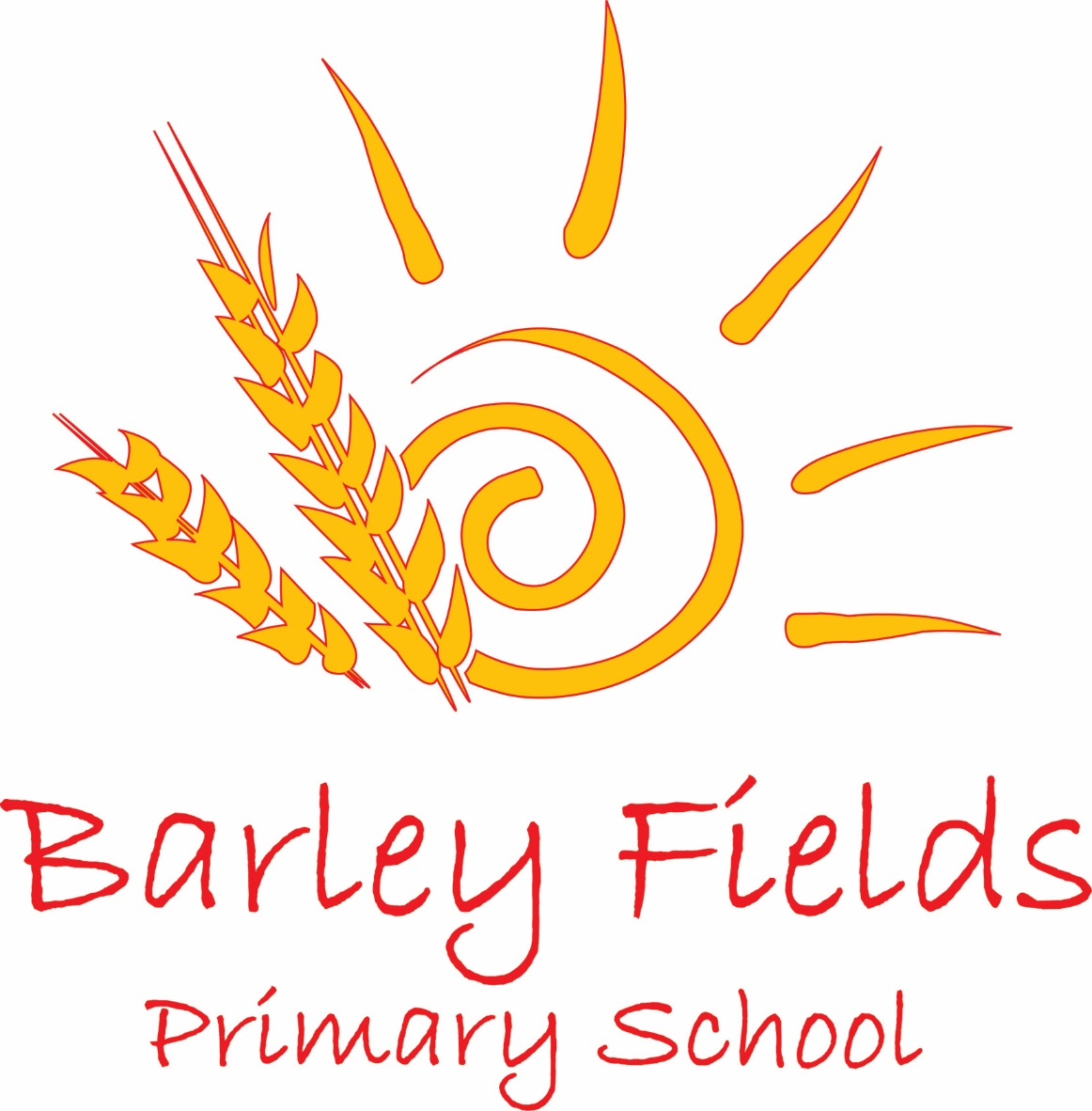

Relationships and Sex Education Policy
2020
Date Issued: | June 2020
Prepared by: | Head Teacher
Review date: | June 2022
Date Adopted by Governing Body: | October 2020

1. Aim
The aim of relationships and sex education (RSE) in our school is to:

- Provide a framework in which sensitive discussions can take place
- Prepare pupils for puberty, and give them an understanding of sexual development and the importance of health and hygiene
- Help pupils develop feelings of self-respect, confidence and empathy
- Create a positive culture around issues of sexuality and relationships
- Teach pupils the correct vocabulary to describe themselves and their bodies

2. Statutory requirements
As a maintained primary school, we must provide relationships education to all pupils as per section 34 of the Children and Social work act 2017. However, we are not required to provide sex education but we do need to teach the elements of sex education contained in the science curriculum. In teaching RSE, we must have regard to guidance issued by the secretary of state as outlined in section 403 of the and from September 2020 will follow new statutory guidance (Appendix 4 summary of objectives). At Barley Fields Primary School, we teach RSE as set out in this policy.

3. Policy development
This policy has been developed in consultation with staff, pupils and parents. The consultation and policy development process involved the following steps:

- Review of all relevant information including relevant national and local guidance
- Staff consultation – all school staff were given the opportunity to look at the policy and make recommendations
- Parent consultation – parents and any interested parties were invited to make comment about the policy following distribution to the wider school community
- Ratification – once amendments are made, the policy will be shared with governors and ratified

4. Definition
RSE at Barley Fields Primary primarily involves learning about relationships, healthy lifestyles, personal safety, diversity and personal identity and development. RSE involves a combination of sharing information, exploring issues and values. RSE is not about the promotion of sexual activity.

5. Curriculum
Our RSE curriculum is set out as per Appendix 1 and the progression of knowledge in Appendix 2. It is underpinned by the PSHE curriculum objectives. We have also made explicit the progression in vocabulary and terminology that will be used as children move through school (Appendix 3). We reserve the right to adapt our curriculum in response to ongoing assessment as and when necessary.

We have reviewed our curriculum in response to recent guidance and legislation taking into account the age and needs of our children pupils. If pupils ask questions outside the scope of this policy, teachers will respond in an appropriate manner so they are fully informed and do not seek answers online.

Primary the sex education aspect of the curriculum will focus on:
- Recognising differences between males and females
- Preparation for the physical and emotional changes that puberty and adolescence bring (Y4, Y5, Y6)
- An understanding that puberty links to a preparation for human reproduction (Y6)

6. Delivery of RSE
RSE is taught within the personal, social, health and economic (PSHE) education curriculum and the biological aspects of RSE are taught within the science curriculum. It will be delivered by class teachers. At key points in the academic journey, older children will receive stand-alone teaching linked to puberty, adolescence and reproduction. Parents will be given prior notice that these lessons will be taking place.

Relationships education focuses on teaching the fundamental building blocks and characteristics of positive relationships including:
- Families and people who care for me
- Caring friendships
- Respectful relationships
- Online relationships
- Being safe

Sex Education in National Curriculum Science.
Maintained primary and secondary schools must teach the National Curriculum, which includes some sex and relationship education within Science. From Sept 2014, Primary Science includes pupils learning about:
- the parts of the body, growth, reproduction, life cycles and ageing;
- changes that occur in puberty (Y4, Y5 and Y6).

All areas of learning will be taught within the context of family life taking care to ensure that there is no stigmatisation of children based on their home circumstances. Families can include single parent families, LGBT parents, families headed by grandparents, adoptive parents and foster parents/carers). We will also reflect sensitively that some children may have a different structure of support around them (for example; looked after children or young carers).

7. Roles and responsibilities
The governing body
The governing body will approve the RSE policy, and hold the Head Teacher to account for its implementation.

The Head Teacher
The Head Teacher is responsible for ensuring that RSE is taught consistently across the school, and for managing requests to withdraw pupils from non-statutory components of RSE (see section 8).

Staff
Staff are responsible for:
- Delivering RSE in a sensitive way and for following the Long Term and Medium term curriculum guidance
- Modelling positive attitudes to RSE
- Monitoring progress and responding to the needs of individual pupils
- Responding appropriately to pupils whose parents wish them to be withdrawn from the non-statutory components of RSE

Staff do not have the right to opt out of teaching RSE. Staff who have concerns about teaching RSE are encouraged to discuss this with the Head Teacher.

8. Parental right to withdraw
Parents do not have the right to withdraw their children from relationships education but do have the right to withdraw their children from the non-statutory components of sex education within RSE. At Barley Fields Primary, we will not be teaching anything beyond the statutory guidance. Requests for withdrawal should be put in writing and addressed to the Head Teacher. Alternative work will be given to pupils who are withdrawn from sex education.

9. Training
Staff will be trained on the delivery of RSE as part of their induction and it is included in our continuing professional development calendar. Materials used in delivery will be standardised and shared across the school. The Head Teacher will also invite visitors from outside the school, such as school nurses or sexual health professionals, to provide support and training to staff teaching RSE.

10. Monitoring arrangements
The delivery of RSE is monitored by the Head Teacher through phase days.

Appendix 1 RSE key teaching units

School Overview of RSE teaching
Year | Autumn | Spring | Summer
Reception | Caring Friendships | Being Kind | Families
1 | Different Friends | Growing and Changing | Families and Care
2 | Differences | Male and Female animals | Naming Body Parts
3 | Who has what? Body Differences | Personal Space | Getting Help and Support
4 | The changing adolescent body | What is puberty? | Healthy Relationships
5 | Talking about Puberty  The Reproductive System | Puberty - Help and Support
6 | Puberty  Human Reproduction |  | Communication in Relationships  Managing Safe Online Relationships

Appendix 2 – RSE Progression Ladder
Year | Objectives | EMERGING CONCEPTS
EYFS | - Recognise people and the roles of those who are part of my family  - Know that there are many types of family  - Name the main parts of the human body | - Parts of the body  - Family
Y1 | - Understand that there are always similarities and differences between people but we can all be friends  - Understand that there are many different types of family and that families provide safety, love and care  - Understand and sequence how babies grow and change from birth to childhood | - Difference between people  - How does family help me  - Growth and change from birth –child  - Private parts
Y2 | - Begin to understand the differences between male and females (babies)  - Begin to identify and challenge gender stereotypes  - Understand that making a new life (using animals as the basis) requires a male and a female  - Name the main features of the human body (including genitals names penis and ) | - Differences between boys and girls / gender stereotypes  - Parts of the body (including genitals)
Y3 | - Understand that all people are different and that differences should be respected  - Understand the physical differences between males and females.  - Identify body parts using agreed vocabulary (breast, nipple, penis, pubis)  - Understand the concept of personal space  - Understand the concept of appropriate and inappropriate physical contact | - Respecting difference  - Physical similarities and difference between males and female
Y4 | - Sequence and describe the main stages of the human lifecycle  - Know when puberty is likely to occur and recognise some basic physical changes that will happen to males and females  - Recognise puberty as the bodies development towards adulthood and preparation for reproduction  - Know that respect is a key aspect of relationships and identify the features of positive friendships  - Know and recognise the difference between healthy and unhealthy relationships (including online) | - Puberty - Basic physical changes including growth of hair, breast development, voice changes, spots, sweating etc.
Y5 | - Understand the key physical changes that occur in puberty - internally and externally  - Understand how the reproductive organs develop in puberty including sperm production and menstruation.  - Understand the increased need for personal hygiene during puberty | - Puberty – physiological changes including Menstruation and Sperm production
Y6 | - Confidently describe how the body changes in puberty in preparation for reproduction and ask questions linked to this  - Recognise how communication and respect are important in healthy relationships  - Recognise the difference between public and private information (as linked to themselves)  - Be aware of the dangers of over sharing information / images with others (linked to e-safety) | - Puberty – changes linked to reproduction  - E- Safety  - Healthy relationships with others

Appendix 3 RSE Vocabulary Progression
Year Group | Vocabulary that may arise: | New Vocabulary that will be taught continuing from the previous year groups:
Year 1 | pregnancy, birth | love, relationships, family, marriage, support, roles, community, male, female, feelings, emotions, change, care
Year 2 | pregnancy, scrotum, womb, gay, lesbian | vagina, vulva, penis, testicles, birth, life-cycle, nipples, breasts, breastfeed, baby, stereotype
Year 3 +  Year 4 | vagina, vulva, penis, testicles, transgender, gay, lesbian, homosexual, sperm, egg, ovary, womb, pubic hair | private, consent, cells, puberty, pregnancy, foreskin, scrotum, erection, reproduction, gender, hormones, voice ‘breaks’, period, bra, spots/acne, hygiene
Year 5 | transgender, gay, lesbian, homosexual, homophobic, circumcised, womb, uterus | sexuality, menstruation, genitals, pubic hair, sanitary wear, sanitary towels/pads, tampons, wet dream, ejaculate/ejaculation, semen, sperm, egg, ovum, ovary, fallopian tube
Year 6 | transgender, transsexual, gay, lesbian, homosexual, homophobic, heterosexual, transphobic, bisexual, | reproductive organs, sex cells, anus, cervix, womb, uterus, conception, fertilisation, pregnant, pregnancy, embryo, foetus, umbilical cord, amniotic fluid, placenta, amniotic sac, contractions, labour, immune system, female genital mutilation (FGM)

Appendix 4 RSE Statutory Curriculum Objectives
Topic | Pupils should know
Families and people who care about me | - That families are important for children growing up because they can give love, security and stability  - The characteristics of healthy family life, commitment to each other, including in times of difficulty, protection and care for children and other family members, the importance of spending time together and sharing each other’s lives  - That others’ families, either in school or in the wider world, sometimes look different from their family, but that they should respect those differences and know that other children’s families are also characterised by love and care  - That stable, caring relationships, which may be of different types, are at the heart of happy families, and are important for children’s security as they grow up  - That marriage represents a formal and legally recognised commitment of two people to each other which is intended to be lifelong  - How to recognise if family relationships are making them feel unhappy or unsafe, and how to seek help or advice from others if needed
Caring friendships | - How important friendships are in making us feel happy and secure, and how people choose and make friends  - The characteristics of friendships, including mutual respect, truthfulness, trustworthiness, loyalty, kindness, generosity, trust, sharing interests and experiences and support with problems and difficulties  - That healthy friendships are positive and welcoming towards others, and do not make others feel lonely or excluded  - That most friendships have ups and downs, and that these can often be worked through so that the friendship is repaired or even strengthened, and that resorting to violence is never right  - How to recognise who to trust and who not to trust, how to judge when a friendship is making them feel unhappy or uncomfortable, managing conflict, how to manage these situations and how to seek help or advice from others, if needed
Respectful relationships | - The importance of respecting others, even when they are very different from them (for example, physically, in character, personality or backgrounds), or make different choices or have different preferences or beliefs  - Practical steps they can take in a range of different contexts to improve or support respectful relationships  - The conventions of courtesy and manners  - The importance of self-respect and how this links to their own happiness  - That in school and in wider society they can expect to be treated with respect by others, and that in turn they should show due respect to others, including those in positions of authority  - About different types of bullying (including cyberbullying), the impact of bullying, responsibilities of bystanders (primarily reporting bullying to an adult) and how to get help  - What a stereotype is, and how stereotypes can be unfair, negative or destructive  - The importance of permission-seeking and giving in relationships with friends, peers and adults
Online relationships | - That people sometimes behave differently online, including by pretending to be someone they are not  - That the same principles apply to online relationships as to face-to face relationships, including the importance of respect for others online including when we are anonymous  - The rules and principles for keeping safe online, how to recognise risks, harmful content and contact, and how to report them  - How to critically consider their online friendships and sources of information including awareness of the risks associated with people they have never met  - How information and data is shared and used online
Being safe | - What sorts of boundaries are appropriate in friendships with peers and others (including in a digital context)  - About the concept of privacy and the implications of it for both children and adults; including that it is not always right to keep secrets if they relate to being safe  - That each person’s body belongs to them, and the differences between appropriate and inappropriate or unsafe physical, and other, contact  - How to respond safely and appropriately to adults they may encounter (in all contexts, including online) whom they do not know  - How to recognise and report feelings of being unsafe or feeling bad about any adult  - How to ask for advice or help for themselves or others, and to keep trying until they are heard  - How to report concerns or abuse, and the vocabulary and confidence needed to do so  - Where to get advice e.g. family, school and/or other sources

