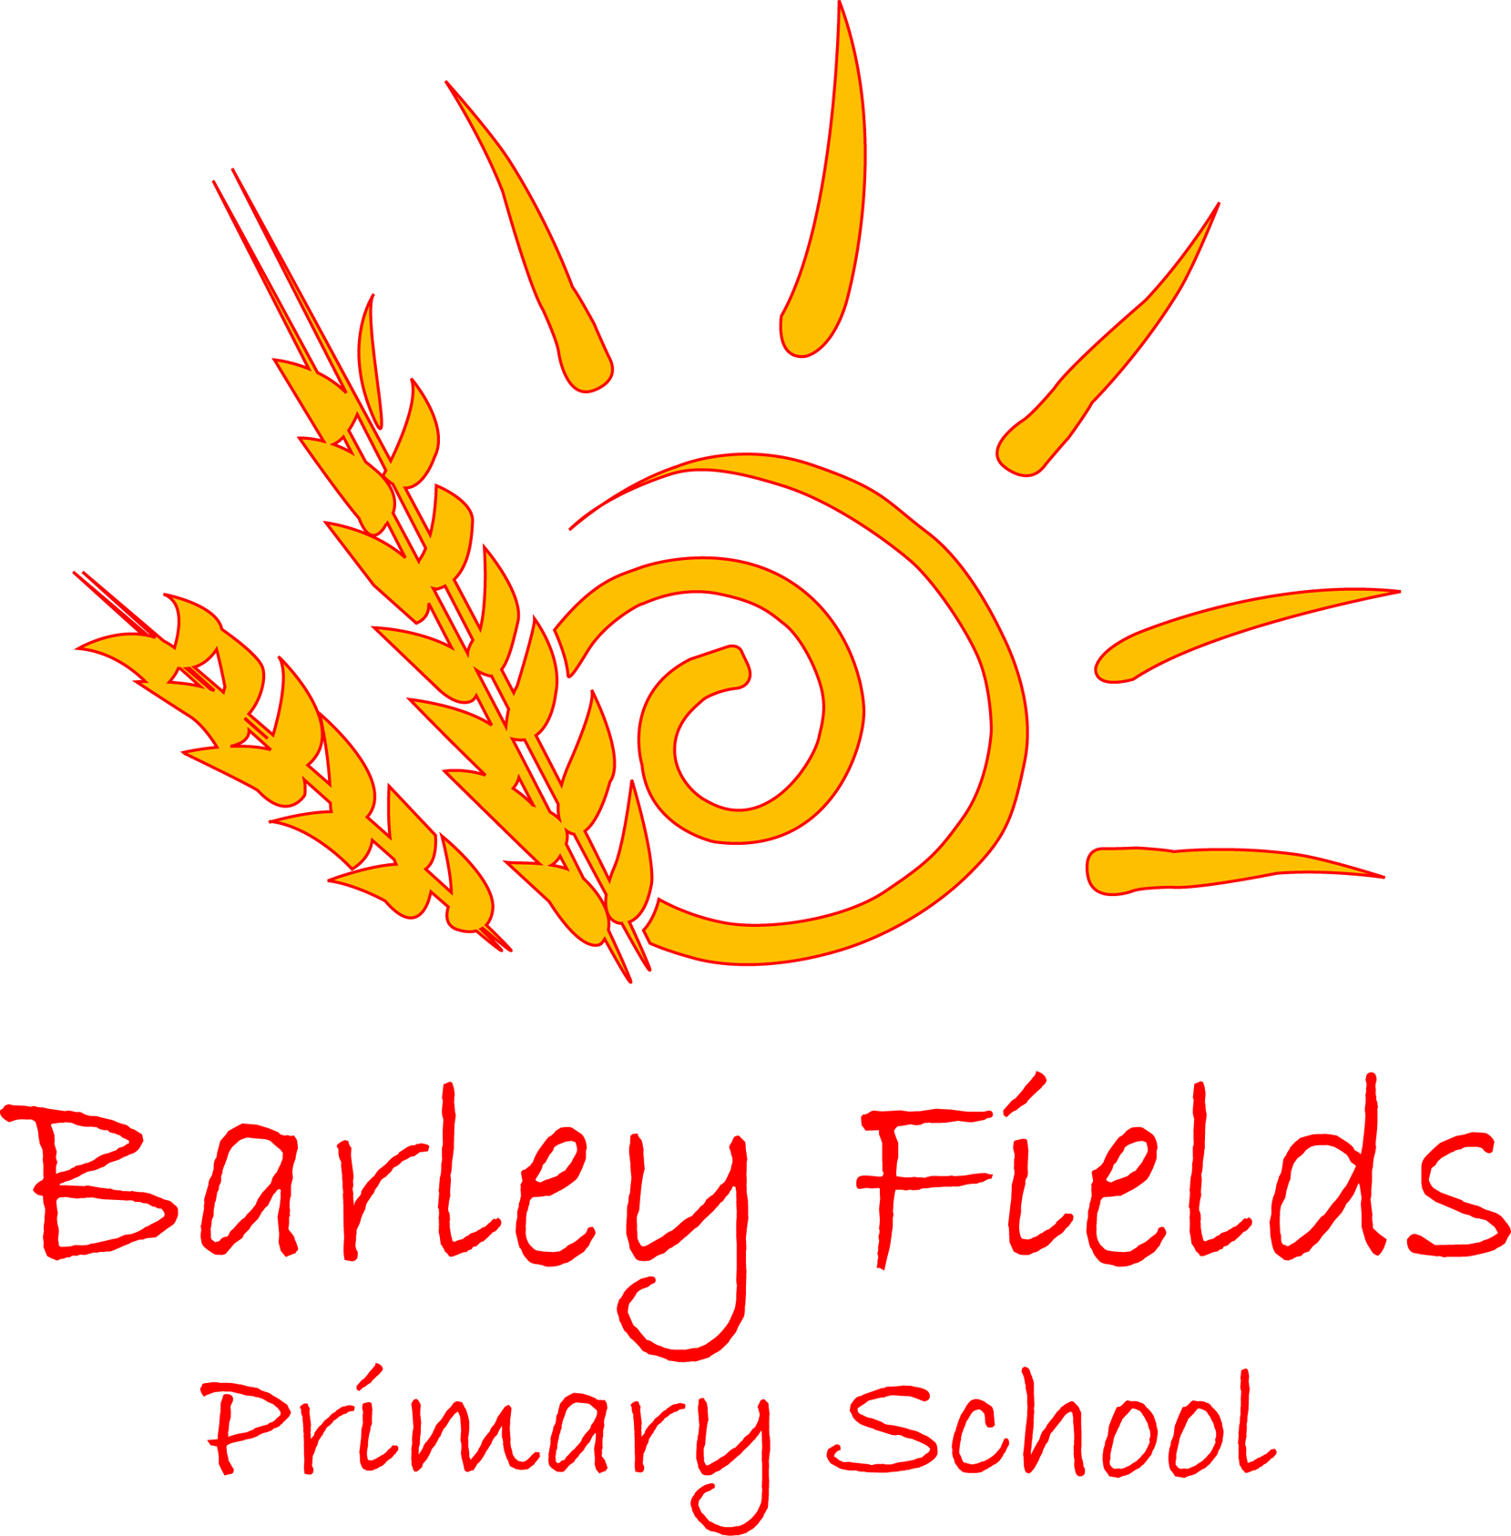

INCLUSION POLICY
2019

Date Issued: | April 2019
Prepared by: | SENCO
Review date: | April 2021
Date Adopted by Governing Body: | TBA

At Barley Fields Primary School, the concept of inclusion is at the very heart of our educational philosophy and we continually strive to improve our inclusive provision.

Inclusive Practice
We aim to meet the needs of all our children in a positive and pro-active way. We view inclusion as part of our overall improvement strategy and acknowledge it as integral in everything we do. We strive to hold the moral vision that our school is entirely about helping all children to learn regardless of factors such as:

- Gender;
- Special Educational Need;
- Disability;
- Social and Cultural backgrounds;
- Membership of ethnic groups including travellers, refugees and asylum seekers;
- Sexual orientation;
- Diverse linguistic backgrounds.

We view inclusion as incorporating provision for every child in our school and making sure their educational experience allows them to maximise their individual potential.

We believe that as an inclusive school we should:
- promote an inclusive ethos and culture;
- provide a broad and balanced curriculum for all pupils;
- implement systems for the early identification of barriers to learning and participation;
- have high expectations and set suitable targets for all children.

Ethos and Culture.
This is central to our provision and our school is a secure, accepting, collaborating and stimulating community in which everyone is valued. An important aspect of this is the ‘sense of community’ and the agreeing of shared values and practices supportive to inclusion amongst staff, children, governors and parents.

Building a sense of community:
- Everyone is made to feel welcome;
- Children are encouraged to help one another;
- Staff collaborate with each other;
- Staff and children treat one another with respect;
- There is partnership between staff and parents;
- Staff and governors work well together;
- Local communities are involved with the school.

Establishing inclusive values:
- There are high expectations for all children;
- Staff, governors, parents share a philosophy of inclusion;
- Children are equally valued;
- Staff and children are treated as human beings as well as occupants of a role;
- Staff seek to remove all barriers to learning and participation in school;
- The school actively strives to minimise discriminatory practices.
PROVIDING A BROAD AND BALANCED CURRICULUM.
Barley Fields Primary School has a responsibility to provide a broad and balanced curriculum for all children. The National Curriculum and E.Y. guidance offer a starting point for planning a school curriculum that meets the specific needs of individuals and groups of children. In planning teaching and learning opportunities teachers at Barley Fields Primary School strive to give due regard to the following principles:

- Setting Suitable Learning Challenges.
- Teachers should aim to give every child the opportunity to experience success in learning and to achieve as high a standard as possible.
- For children whose attainment falls significantly below expected levels, differentiation in curriculum content should matched their personalised needs and age.
- For children whose attainment significantly exceeds the expected level of attainment teachers will need to plan suitably challenging work.

- Responding to children’s diverse learning needs.
- Teachers should set high expectations and provide children with opportunities to achieve.
- Planning should take into account the wide variety of groups that exist within the school and should offer a range of approaches to teaching and learning to enable all children to take part fully and effectively.
- Teachers should ensure they meet the full range of children’s needs and should be aware of requirements as detailed in school policies.

- Creating an effective learning environment in which:
- the contribution of all children is valued;
- all children feel secure and able to contribute appropriately;
- stereotypical views are challenged and children learn to appreciate and positively view differences in others, whether arising from race, gender, ability or disability;
- children learn to take responsibility for their actions and behaviour both in school and in the wider community;
- all forms of bullying and harassment, including racial harassment, are challenged;
- children are able to participate safely in clothing appropriate to their religious beliefs.

- Securing children’s motivation and concentration by:
- using teaching appropriate to different learning styles;
- using, where appropriate a range of organisational approaches, such as setting, grouping or individual work to ensure that learning needs are properly addressed;
- varying subject content and presentation so this matches learning needs;
- planning work which builds on interests and cultural experiences;
- planning appropriately challenging work for those whose ability and understanding are in-advance of their language skills and comprehension;
- using materials which reflect social and cultural diversity and provide positive images of race, gender and disability;
- planning and monitoring the pace of work so that all children have a chance to learn effectively and achieve success;
- taking action to maintain interest and continuity of learning for all children who may be absent for extended periods.

- Providing equality of opportunity by:
- ensuring that boys and girls are able to participate in the same curriculum, particularly in science, design and technology and P.E.;
- taking into account the interests and concerns of boys and girls by using a range of activities and contexts;
- avoiding gender stereotyping when organising children into groups, assigning them activities or arranging equipment;
- taking account of children’s’ specific religious or cultural beliefs relating to the representation of ideas or experiences;
- enabling the fullest possible participation of children with disabilities or particular medical needs in all subjects, offering positive role models and making provision, where necessary, to facilitate access to activities with appropriate support aids or adaptations.

- Using assessment approaches which:
- allow for different learning styles and ensure that children are given the chance and encouragement to demonstrate competence and attainment through appropriate means;
- that are familiar to the children and that are adequately prepared to meet their needs;
- use materials which are free from discrimination and stereotyping in any form;
- provide clear and unambiguous feedback to children concerning their achievements and as an aid to further learning.

- Setting targets for learning which:
- build on children’s knowledge, experiences, interests and strengths to improve areas of weakness and demonstrate progression over time;
- are attainable, yet challenging and which help children to develop their self-esteem and confidence in their ability to succeed;

