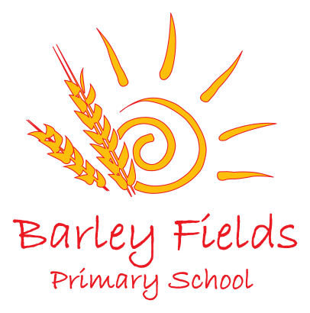

School Performance Results 2018

Performance of all Key Stage 2 pupils 2018  (60 children) | Expected Standard |  | Higher  Standard
 | School | National | School | National
% of pupils attaining expectations in reading | 97% | 75% | 42% | 28%
% of pupils attaining expectations in writing | 92% | 78% | 44% | 20%
% of pupils attaining expectations in maths | 97% | 76% | 47% | 24%
% of pupils attaining expectations in reading, writing and maths | 86% | 64% | 25% | 10%
% of pupils attaining expectations in spelling, punctuation and grammar | 93% | 78% | 58% | 34%

KS2 Progress Measures
The new progress measures are a type of value added measure which means that pupils’ results are compared to the actual achievement of other pupils nationally with similar prior attainment. The progress measure comes in the form of a scaled score and a school progress score.
Scaled scores are reported between 80 and 120, with 100 being the national standard.
Progress scores are for the school only, not individual pupils. A score of 0 means that pupils in the school on average do as well in KS2 as those with similar starting points nationally. A positive score means pupils do better. A negative score does not mean that pupils did not make any progress, rather it means they made less progress than other pupils nationally with similar starting points.
Progress | Average Scaled Score |  | Progress  Score
 | School | National | School
Reading | 108.9 | 105 | 1.5
Writing | NA | NA | 1.4
Spelling, punctuation and grammar | 110.7 | 106 | *
Maths | 108.3 | 104 | 1.4

Performance of all Key Stage 1 pupils in 2018  (89 children) | Expected Standard |  | Greater  Depth
 | School | National | School | National
% of pupils attaining expectations in reading | 80% | 75% | 35% | 26%
% of pupils attaining expectations in writing | 72% | 70% | 30% | 16%
% of pupils attaining expectations in maths | 81% | 76% | 29% | 22%
% of pupils attaining expectations in reading, writing and maths | 70% | *** | 24% | ***

Performance in Phonics Check 2018 | School | National
Y1 - % of pupils attaining expectations (91 children) | 86% | 82%
Y2 - % of pupils attaining expectations (90 children) | 97% | 91%

Performance in all EYFS pupils 2016  (90 children) | School | National
% of pupils achieving a Good Level of Development (GLD)  (achieving the expected level in all Prime Areas and the Specific Areas of Mathematics and Literacy | 77% | 71%

