**Operation Encompass – Information for Parents**

[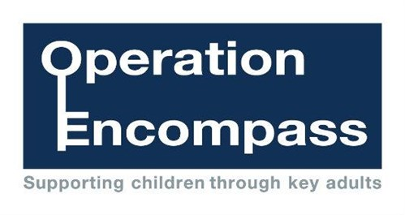](http://www.google.co.uk/url?sa=i&rct=j&q=&esrc=s&source=images&cd=&cad=rja&uact=8&ved=0ahUKEwj--pK9zvXLAhXCtBoKHYMZAq4QjRwIBw&url=http%3A%2F%2Fwww.northumbria.police.uk%2Fadvice_and_information%2Foperation_encompass%2F&psig=AFQjCNG4ONPS1C9BkmGi2_OqYiLH_cbmfw&ust=1459880946804900)As part of our safeguarding procedures, we now have a direct link with Cleveland Police, which provides us with key information in respect of Domestic Violence incidents.

Operation Encompass, has been designed to provide early reporting to schools of any domestic abuse incidents that occur outside of normal school hours and that might have an impact on a child attending our school the following day. This information will be shared at the earliest opportunity between Monday to Thursday and, when an incident occurs on a Friday, Saturday or a Sunday, the police will contact us the following Monday.

A nominated member of school, known as a key adult, will be trained to liaise with the police. They will be able to use information that has been shared with them, in confidence, to ensure that the school is able to make provision for possible difficulties experienced by children, or their families.

**Information will be shared where it is identified that a child or young person was present, witnessed or was involved in a domestic abuse incident.**

Operation Encompass was introduced in Plymouth, Devon and Cornwall, in February 2011 and has proved very effective in providing appropriate support in a timely manner. This initiative has already been implemented in Hartlepool and is now being extended across Cleveland. If you would like some more information about how Operation Encompass operates and the benefits, you can view it online at <http://www.cleveland.police.uk/advice-information/OperationEncompass.aspx>

We are keen to offer the best support possible to all our children and we believe this initiative is going to be extremely beneficial and supportive for all of those involved.

If you have any questions or concerns with this provsion please make an appointment to discuss them with the Head Teacher.

Thank You