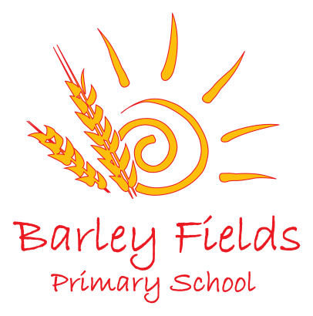
____________________________
Head Teacher – Mrs Caroline Taylor
Lamb Lane, Ingleby Barwick
Stockton on Tees
TS17 0QP
Tel: 01642 767051
Fax: 01642 767308
Email: barleyfields@sbcschools.org.uk

_______________________________________________________________________________________________

Pupil Premium – Pupil Outcomes 2019

KS1 Outcomes 2019
Standard | Subject | Pupil Premium  (6 children) | Non Pupil Premium  (83 children)
Expected Standard | Reading | 83% (62%) | 80% (78%)
 | Writing | 67% (55%) | 78% (73%)
 | Maths | 67% (62%) | 81% (79%)
 | CRWM | 50% | 72%
Standard | Subject | Pupil Premium | Non Pupil Premium
Higher Standard | Reading | 0% (14%) | 35% (22%)
 | Writing | 0% (10%) | 22% (17%)
 | Maths | 0% (12%) | 30% (24%)
 | CRWM | 0% | 18%

KS2 Outcomes 2019
Standard | Subject | Pupil Premium  (12 children) | Non Pupil Premium  (47 children)
Expected Standard | Reading | 92% (62%) | 94% (78%)
 | Writing | 92% (68%) | 94% (83%)
 | Maths | 92% (67%) | 94% (84%)
 | CRWM | 92% (51%) | 90% (71%)
Standard | Subject | Pupil Premium | Non Pupil Premium
Higher Standard | Reading | 33% (17%) | 42% (31%)
 | Writing | 8% (11%) | 35% (24%)
 | Maths | 8% (16%) | 35% (32%)
 | CRWM | 8% (5%) | 19% (13%)

Evaluation
The school’s evaluation of its own performance is rigorous and pupils attain well. Tracking of progress over time for each pupil is thorough, and so we can quickly identify any dips and develop strategies and interventions to promote improvement quickly.

- A wide range of data is used – achievement data, pupils’ work, observations, learning walks, case studies and staff, parent and pupil voice;

- Assessment data collected termly to that the impact of intervention can be monitored;
- Teaching staff and support staff attend and contribute to pupil progress meetings each term and the identification of children reviewed;
- Regular feedback about performance is shared with parents;
- Interventions are adapted and changed if they are not working;
- A designated member of the Senior Leadership Team and Governing Body maintain an overview of pupil premium spending.

Internal tracking of the academic performance of pupils in the Pupil Premium group across the school from Y1-Y6 indicates that attainment and progress by children in this group is good. Where progress and attainment is less than good these children are typically in multiple vulnerable groupings and additional support and intervention is planned.

