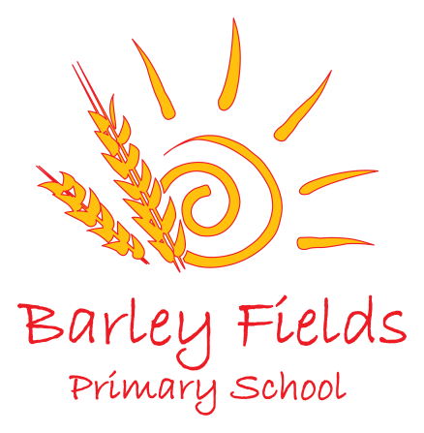
The Government is providing additional funding to schools to help children in a range of circumstances. This funding is called a ‘Pupil Premium’.
Pupil Premium is a sum of money paid to schools on an annual basis to support the education of children who have been in receipt of:
- Free school meals;
- Have parents who are members of the armed forces;
- In looked After Care or have been adopted.

With this money we are able to fund additional teaching for pupils on a one-to-one or small group basis. We can also provide financial support to enhance opportunities within the curriculum for residential visits and extra curricula access to enhance learning. If you think you are eligible please contact the Head Teacher or the school office to make sure your child doesn’t miss out.
Free School Meals
How does it work?
First, check if you qualify – it is not just if you are unemployed, so please look at the list provided.
- Registering is really quick and easy – if you think you qualify, contact the Free School Meals Team at Stockton Borough Council on 01642 526606 who will help you to register.
- If you want your child to have a free, healthy meal at lunchtime that’s great – they will get the free meal (saving you more than £350 a year), extra benefits and the school gets £1320 extra.
- If you don’t want your child to have the school meals they can continue their lunchtime routine as normal – as long as you qualify and are registered, the school still gets £1320 extra.
- No one will know you have registered and it will not affect any other benefits you are claiming.

Do you qualify?
You can register your child for Free School Meals if you get any of these benefits:
- Income Support
- Income-based Jobseeker's Allowance
- Income-related Employment and Support Allowance
- Support under Part VI of the Immigration and Asylum Act 1999
- The Guarantee element of State Pension Credit
- Child Tax Credit, provided they are not entitled to Working Tax Credit and have an annual income (as assessed by HM Revenue & Customs) that does not exceed £16,190
- Working Tax Credit 'run-on' - the payment someone may receive for a further four weeks after they stop qualifying for Working Tax Credit

Application Process
Parents can now apply for free school meals by ringing the Stockton Borough Council Contact Centre on 01642 526606. The operator will complete the form for the parent on line and it is then emailed to our School Administrator.
When you ring the Contact Centre, you will need to give the following information:
- claimants name, date of birth and NI number;
- home address;
- names and dates of birth of the children;
- which school they are attending.
A check will then be made to see if you are eligible and if so the service will inform you and the school and your child will go onto free school meals straight away. In some cases it may be necessary to contact you to obtain some paper proof if they say they are on one of the eligible benefits.

Children who receive Pupil Premium support under the free school meals category will be eligible for the
Pupil Premium funding for 6 years following their initial claim.

Children with parents who are members of the armed forces
All children who have parents who are members of the armed forces are also entitled to pupil premium support. If your child is eligible in this category please inform the school office so that the information can be accurately recorded. These children receive £300 in addition to school funding each year.

Children in Looked After Care/Adoption
Children who are in the Care of the local Authority are also eligible for Pupil Premium funding but from April 2014 there will be some changes in this category to include children who have been placed in Adoptive placements

From April 2014, schools in England will attract the Pupil Premium for children adopted from care or who left care under special Guardianship Order (SGO) on or after 30th December 2005. Schools will also attract the Pupil Premium for children who left are under a Residence Order (RO) on or after 14th October 1991.

To attract the pupil premium for adopted children, and those who are subject to a SGO and RO, parents and carers will need to inform school about their child’s circumstances and provide the school with supporting evidence. This will be in the form of the Adoption (Court) order.

Summary
As a school we appreciate that this information is of a very sensitive nature and we should assure you that as for other pupil data items, the school will comply with their responsibilities and with respect to the Data Protection Act when processing this information.

As a school we would like to attract this additional funding so we can further support your child. If you are unsure of your eligibility and have questions to ask please do not hesitate to contact us, confidential meetings can be arranged.

