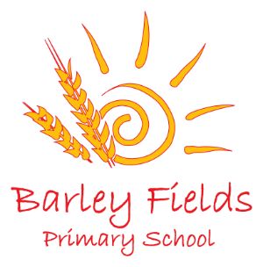
Long Term Planning
Early Years Reception
2020-21
 | Autumn Term |  |  |  | Spring Term |  |  | Summer Term
 | September | October | November | December | January | February | March | April | May | June | July
Possible Themes | Seasons – Autumn/Winter |  |  |  | Seasons – Winter/Spring |  |  | Seasons – Spring/Summer
 | Mixed-up Nursery Rhymes/Pie Corbett’s Reading Spine |  |  |  | Superheroes  Once Upon a Time  Space  Monsters |  |  | Pirates  Under the Sea  Living Things (plants, minibeasts, etc.)  Dinosaurs
 |  | Halloween | Remembrance Day  Bonfire Night  Diwali (Hindu) | Christmas | Australia Day | Valentine’s Day  Shrove Tuesday  Lent  Lunar New Year | Lent  Holi (Hindu)  World Book Day  Mother’s Day | Easter  Ramadan | Ramadan | Father’s Day | Eid  Independence Day

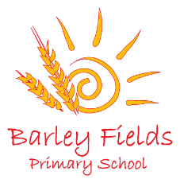
Learning and teaching in EYFS will carefully follow the statuary and non-statuary guidance provided by the DfE. This planning is given as a guide to show how learning may emerge across the year. However, as it is a requirement that learning and development opportunities are planned around the needs and interests of each individual child, it should be noted that it is likely to transform throughout the year in response to our children and the enabling environment we provide for them.
Reception Long Term Phonics Plan
 | Autumn Term |  |  |  | Spring Term |  |  |  | Summer Term
 | September | October | November | December | January | February |  | March | April | May |  | June | July
 | Phase 2:  s, a, t, p, i, n, m, d, g, o, c, k, ck, e, u, r h, b, f  Action Words:  Mum, Dad, my, you, said, he, she, no, I, can, yes, am, going, to, are |  | Phase 2:  ff, l, ll, ss  Phase 3:  j, v, w, x, y, z, zz, qu, ch, sh, th, ng  Action Words:  look, in, up, get, all, this, is, dog, for, the,  we, like, went, they, and |  | Recap trickier phase 2 sounds (g,ck,u,r)  Recap trickier phase 3 sounds (qu,ch,sh,th,ng)  Phase 3: ai, ee, igh, oa, oo, ar, or, ur, ow  Action Words: play, on, come, big, see, go, away, was, it, a, cat, at, day, of, me  At the end of Action Words Set 1 an assessment should be completed to see which children can move on to Set 2. Children should be able to recognise a good amount of words from Set 1 before moving on to Set 2. |  | Phase 3: oi, ear, air, ure, er  Phase 4: consolidate the children's knowledge and to help them learn to read and spell words which have adjacent consonants, such as trap, string and milk.  Read two-syllable words and simple captions, as well as reading and spelling some tricky words.  Action Words Set 2: his, put, got, home, new, down, took, pull, too, push, made, had, what, over, could |  | Phase 5 –  * An assessment should be completed to check children’s retention of sounds in phases 2 and 3. If the child has a good level of recognition and is ready to move on to Phase 5, they should.  Children entering Phase Five will already be able to read and spell words with adjacent consonants, such as trap, string and flask. They will also be able to read and spell some polysyllabic words.  In Phase Five, children will learn more graphemes and phonemes. For example, they already know ai as in rain, but now they will be introduced to ay as in day and a-e as in make.  Alternative pronunciations for graphemes will also be introduced, e.g. ea in tea, head and break.  Sounds learned: ay, ou, ie, ea, oy, ur, ue, aw, wh, ph, oe, au, ey, a-e, e-e, i-e, o-e, u-e.  Phase 2 and 3 should be continuously recapped throughout morning learning and starters when teaching phonics.  Action Words: about, very, her, saw, him, good, came, back, bed, with, water, after, out, help, school |  | A recap of phase 2 (for those who need it) 3 and 5.  Segmenting and blending practise, games to support learning, writing opportunities, reading opportunities, modelled writing etc.  Action Words: did, not, were, by, way, there, ran, little, jump, some, many, house, again, old, many

Reception Long Term Maths Plan

