Long Term Planning
Key Stage 1 Year 1
2020-2021
Autumn |  |  |  | Spring | Summer
English | Autumn 1 Unit 1  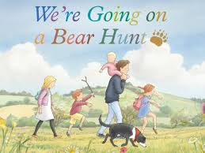  Stories with a repeating pattern |  | Spring 1 Unit 1  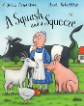  The Julia Donaldson Unit |  |  | Summer 1 Unit 1  The David McKee Unit
 | (8 Weeks) |  | (6 Weeks) |  |  | (7 Weeks)
 | 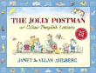  Autumn 2 Unit 2  The Allan Ahlberg Jolly Postman Unit | Autumn 2 Unit 3  Christmas Wish Unit | Spring 1 Unit 2  The Judith Kerr Unit |  |  | Summer 2 Unit 2  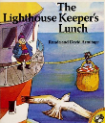  The Lighthouse Keeper’s Lunch Unit
 | (7 weeks) |  | (5 Weeks) |  |  | (7 Weeks)

Autumn |  |  |  | Spring |  | Summer
Mathematics | Autumn 1 Unit1  Number: Place value within 10  (2 Weeks)  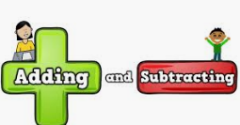  Autumn 1 Unit2  Number: Additiotn and subtraction Within 10  (2 Weeks) | Autumn 1 Unit3  Geometry- Properties of shapes  (2 Weeks)  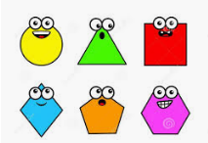 | Spring 1 Unit 1  Addition and subtraction (Within 20)  (1 Week)  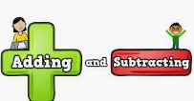  Spring 1 Unit 2  Number: Place Value- (Within 50)  (2 Weeks)  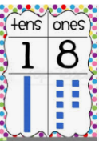 |  | Spring 1 Unit 3  Measurement- Length and Height  (2 Weeks) |  | Summer 1 Unit 1  Number- Fractions  (3 weeks)  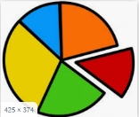 | Summer 1 Unit 2  Number- Place Value within 100  (2 weeks)  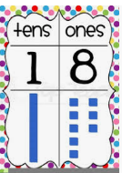
 | Autumn 1 – 8 Weeks |  | Spring 1 – 6 weeks |  |  |  | Summer 1- 7 weeks
 | Autumn 2 Unit 4  Number: Place value (Within 20) | Autumn 2 Unit5  Number: Addition and subtraction (Within 20)  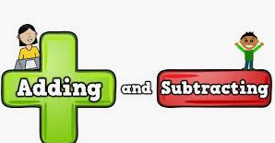 | Spring 2 Unit 4  Measurement- Weight and Volume  (2 Weeks)  Spring 2 Unit 5  Number- Multiplication and division  (3 Weeks) |  | Spring 2 Unit 6  Geometry- Position and Movement  (2 Weeks)  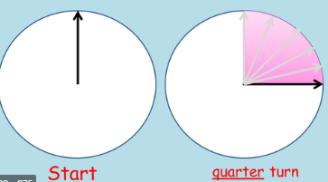 |  | Summer 2 Unit 3  Measurement- Money  (2 weeks) | Summer 2 Unit 4  Measurement- Time  (2 weeks)  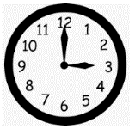
 | Autumn 2 – 7 weeks |  | Spring 2 – 5 weeks |  |  |  | Summer 2 7 weeks

Autumn |  |  | Spring |  | Summer
Science | Autumn 1 Unit 1  Seasonal Changes  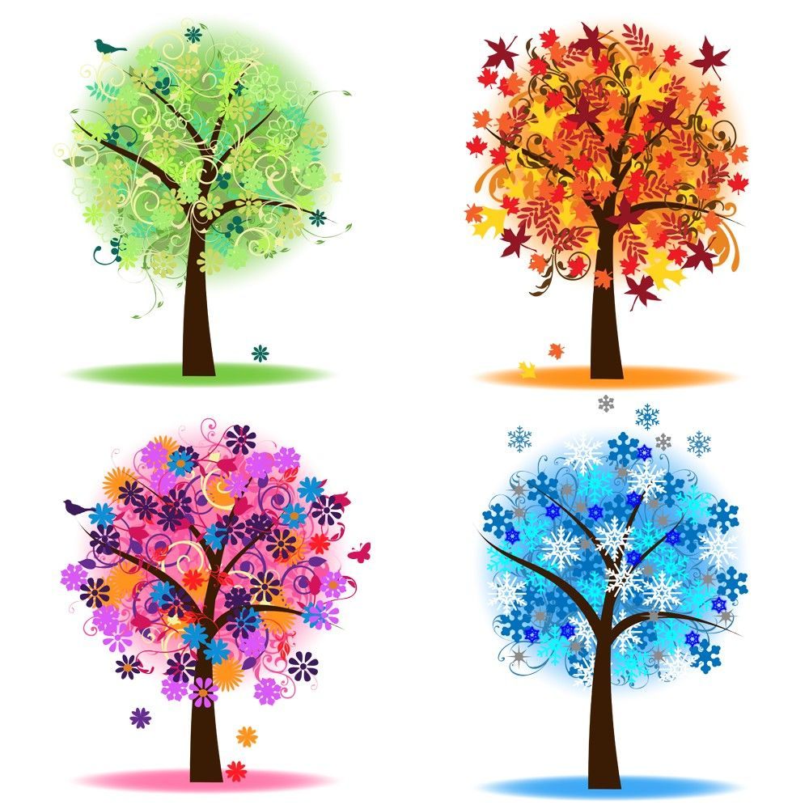 | Autumn 2 Unit 2  Plants  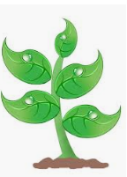 | Spring 1 Unit 3  Animals including Humans  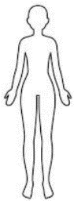 | Spring 1 Unit 4  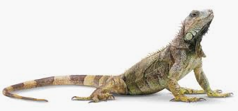  Animals including Humans  Spring 1 Unit 1  Seasonal Changes | Summer 1 Unit 5  Everyday Materials  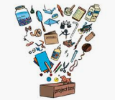 | Summer 2 Unit 6  Plants and Seasonal Changes (ongoing)
Computing | Autumn 1 Unit 1  Logging On |  | Spring 1 Unit 2  Life Online | Spring 2 Unit 3  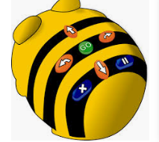  Go-Bot-Go! | Summer 1 Unit 4  Digital Artist | Summer 1 Unit 5  Animated Story Maker
Digital
Literacy

Autumn |  |  |  | Spring |  |  | Summer
History & Geography | 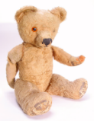  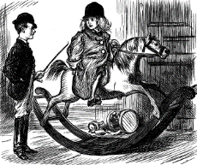  Childhood Now and Then | Mapping Skills: Me and My School |  | Super Sixties: MoonLanding | Awareness of Location and Place: Where do I live? |  | Awareness of Location and Place: The world around me | 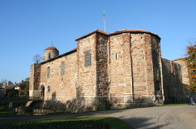  Castles
P.E. | 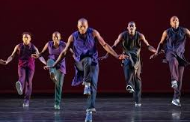  Autumn 1 Unit 1  Dance and Movement |  | Autumn 1 Unit 2  Throwing and catching | Spring 1 Unit 5  Dance and Movement |  | Spring 1 Unit 6  Running and Jumping | Summer 1 Unit 9  Balance, Agility and Co-ordination | Summer 1 Unit 10  Games – Attacking and Defending, Striking and Fielding
 | Autumn 2 Unit 3  Balance, Agility and Co-ordination |  | Autumn 2 Unit 4  Throwing and catching | Spring 2 Unit 7  Attacking and defending |  | Spring 2 Unit 8  Multi Skills | Summer 2 Unit 11  Running and Jumping | Summer 2 Unit 12  Racket Skills

Autumn |  | Spring | Summer
MFL | Autumn  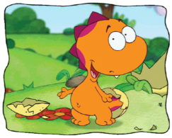  Hocus and Lotus 1 | Spring Unit 2  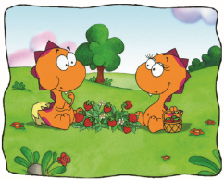  Hocus and Lotus 2 | Summer Unit 3  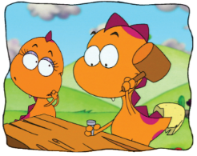  Hocus and Lotus 3
Music | Autumn Unit 1/2  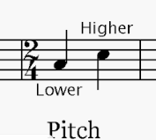  Duration  Composer Study – Vivaldi | Spring Unit 3 /4  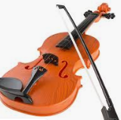  Dynamics  Composer Study – Gershwin | Summer Unit 5  Tempo  Artist study – The Beatles

Autumn |  |  | Spring |  | Summer
Art | Unit 1  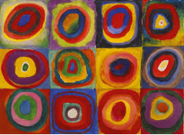  Colour creations Kandinsky |  | Unit 2  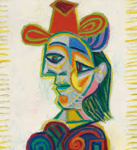  Self Portraits – Picasso |  | Unit 3  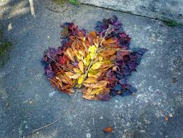  Earth Art – Andy Goldsworthy
DT | Unit 1  Sliders and Levers  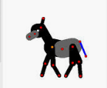  Moving Pictures |  | Unit 3  Free standing structures  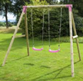  Playgrounds |  | Unit 4  Food  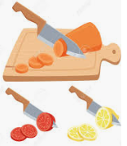  Eat more fruit and vegtables
RE | Unit I  Belonging  How is someone welcomed to Christinaity? | Unit 2  Beliefs & Practices  Why do Christians give gifts at Christmas? | Unit 3  Belonging  What does it mean to belong?- Sikhism | Unit 4  Beliefs & Practices  What are the key events associated with the Easter story? | Unit 5  Belonging  What does it mean to belong?  Islam | Unit 6  Founders and Leaders  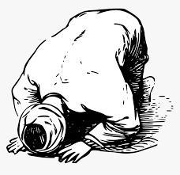  Who is Mohammed and why is he important?

Autumn |  | Spring | Summer
PSHE | Unit 1  Healthy Lifestyles  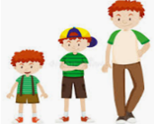  Unit 2  Growing and changing  Unit 3  Keeping Safe | Unit 4  Feelings and emotions  Unit 5  Healthy relationships  Unit 6  Valuing differences | Unit 7  Rights and responsibilities  Unit 8  Taking care of the environment  Unit 9  Money matters
Autumn |  | Spring | Summer
TRIPS and ENRICHMENT | Fairy Dell trip – Science  Preson Park Museum – Toy workshop  Pantomime - Christmas | Fairy Dell trip – Science  Animal Stories | Fairy Dell trip – Science  Castle Trip

