Long Term Planning
Key Stage One Year 2
2020-2021
 | Autumn |  | Spring |  | Summer
 | 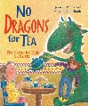  Autumn 1 Unit 1  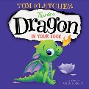  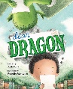  Dragons Unit  Autumn 1 4 weeks | 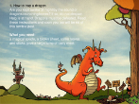  Autumn 1 Unit 2  Dragons Unit  Autumn 1 4 weeks | 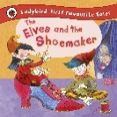  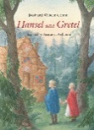  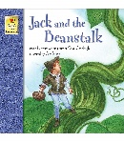  Spring 1 Units 1 & 2  Fairy Tales Unit  Spring 1 – 6 weeks |  | Summer 1 Units 1 & 2  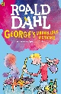  Roald Dahl Unit  Summer 1 – 5 Weeks
 | Autumn 2 Unit 3  Autumn 2 – 3 weeks  London’s Burning Unit | Autumn 2 Unit 4  Christmas Unit  Autumn 2 – 4 Weeks | Spring 2 Unit 3  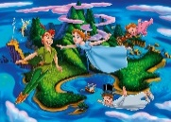  Peter Pan  Spring 2 – 3 weeks | Spring 2 Unit 4  Pirates  Spring 2 – 3 weeks | Summer 2 Unit 3  Wish you were here  Summer 2 – 3 weeks | 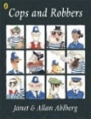  Summer 2 Unit 4  Alan Ahlberg Unit  Summer 2 – 4 weeks
Mathematics | 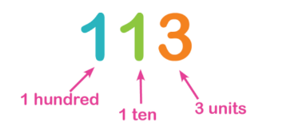  Autumn 1 Unit 1  Number - Place Value  (2 Weeks) | Autumn 1 Unit 2  Number – Addition and Subtraction  (4 weeks)  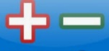  Measurement – Money  (1 week)  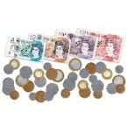 | Spring 1 Unit 1  Measurement – Length and Height  (2 weeks)  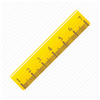 | Spring 1 Unit 2  Geometry – Shape  (2 weeks)  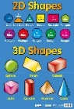  Measurement - Time  (2 weeks)  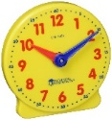 | Summer 1 Unit 1  Consolidation of learning in preparation for SATs  (4 weeks) | Summer 1 Unit 2  SATs  (1 week)
 | Autumn 2 Unit 3  Number – Multiplication and Division  (4 weeks) | Autumn 2 Unit 4  Statistics  (1 week)  Consolidation learning (1 week) | Spring 2 Unit 3  Measurement – Fractions  (3 Weeks)  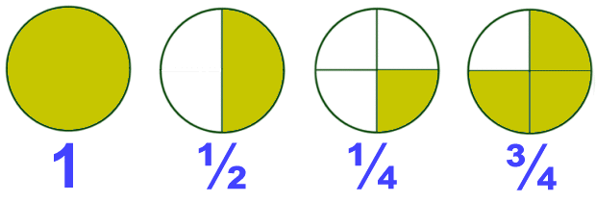 | Spring 2 Unit 4  Measurement – Mass, Capacity and Temperature  (2 weeks)  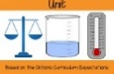  Position and Direction  (1 week)  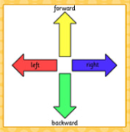 | Summer 2 Unit 3  Problem Solving  (3 weeks) | Summer 2 Unit 4  Revisiting units and  Investigations  (3 weeks)
Science | Autumn 1 Unit 1  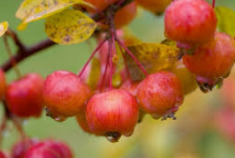  Plants | 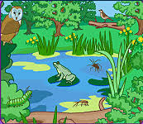  Autumn 2 Unit 2  Living Things and their Habitats | Spring 1 Unit 3  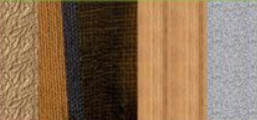  Everyday Materials | Spring 2 Unit 4  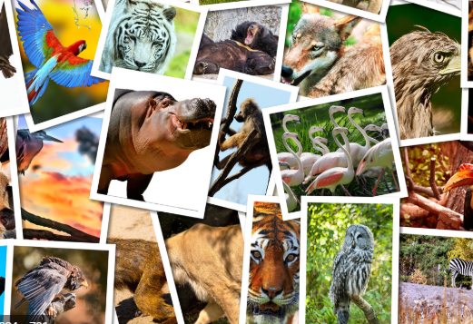  Animals including humans | Summer 1 Unit 5  Animals including humans | Summer 2 Unit 6  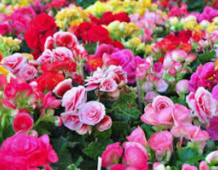  Plants
Computing | Autumn 1 Unit 1 | Autumn 2 Unit 2 | Spring 1 Unit 3 | Spring 2 Unit 4 | Summer 1 Unit 5 | Summer 1 Unit 6
Digital Literacy
History & Geography | Autumn 1  Geography  Map Makers  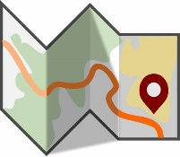 | Autumn 2  History  The Great Fire of London  Historical Figure: Guy Fawkes  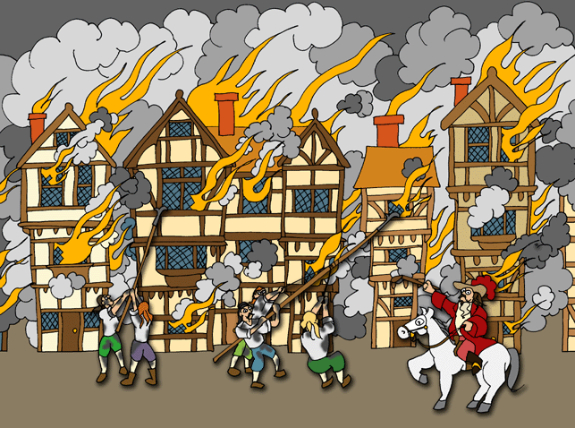 | Spring 1  History  Explorers  Historical Figure: James Cook  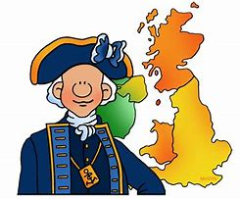 | Spring 2  Geography  Let’s Visit Australia  Geography | Summer 1  History  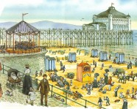  The Seaside – Past and Present | Summer 2  Geography  Seas and Coasts  (Local Study – Saltburn)  Geography  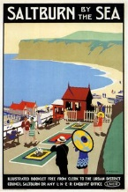
P.E. | Autumn 1 Unit 1  Gymnastics | Autumn 1 Unit 2  Throwing and Catching | 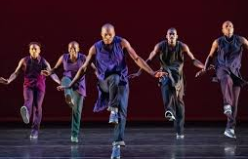  Spring 1 Unit 3  Dance | Spring 1 Unit 4  Attacking and Defending, Striking and Fielding | Summer 1 Unit 7  Gymnastics | Summer 1 Unit 8 Attacking and Defending, Striking and Fielding
 | Autumn 2 Unit 3  Running and Jumping | Autumn 2 Unit 4  Throwing and catching | Spring 2 Unit 6  Multi-Skills |  | 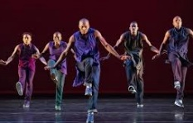  Summer 2 Unit 9 Dance | Summer 2 Unit 10  Net and Wall
MFL | 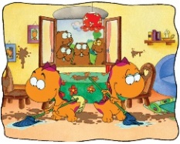  Hocus and Lotus 4 |  | 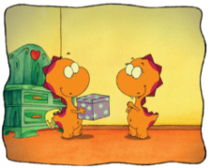  Hocus and Lotus 5 |  | La Salle de Classe
Music | Autumn Unit 2  Pitch  Composer Study – Antonio Vivaldi |  | Spring Unit 4  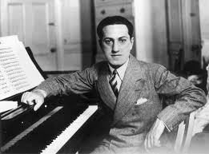  Timbre  Composer Study – George Gershwin |  | 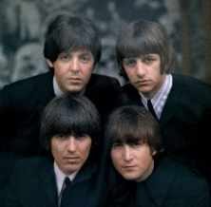  Summer Unit 6  Structure  Composer Study – The Beatles
Art | Autumn Unit 1 Sparks and Flames – Topic Link  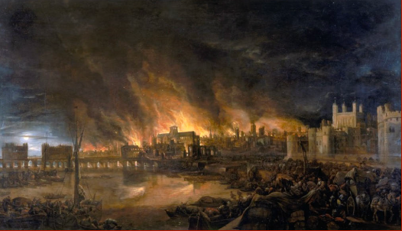 |  | Spring Unit 2 - Aboriginal Art – Topic Link  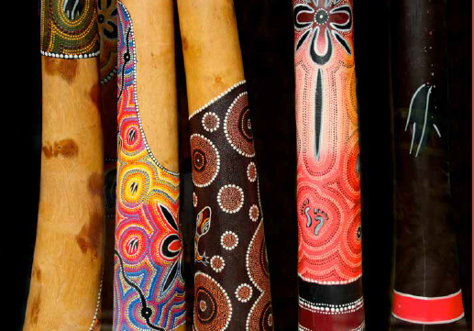 |  | Summer Unit 3 - Paper Art  Artist Study: Mondrian  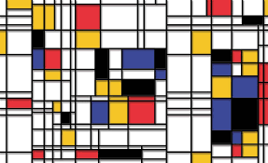
DT | 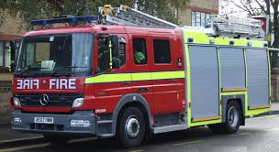  Autumn Unit 1 - Mechanisms  Making Fire Engines |  | 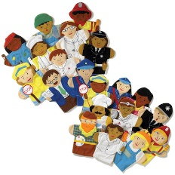  Spring Units 2 - Textiles  Puppets |  | 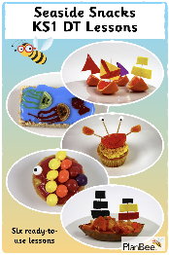  Summer Unit 3 - Food  Seaside Snacks
RE | Sacred Texts  What is the Quran and why is it important? | 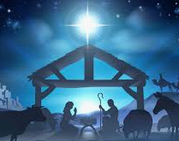  Festivals, Beliefs & Practices  Why do Christians give gifts at Christmas? | Sacred Texts  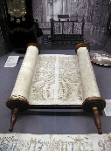  What is the Torah and why is it important? | 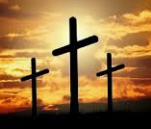  Beliefs & Practices  What is the Last Supper and why is it important? | 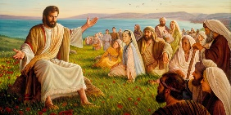  What did Jesus leave behind? | 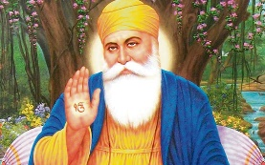  Who was Guru Nanak and why was he important?
PSHE | Health and Wellbeing  Think Positive! | Health and Wellbeing  Safety First | Relationships  VIPs! 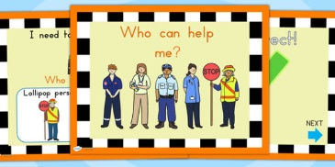 | Relationships  Growing Up | Living in the Wider World  Respecting Rights | Living in the Wider World  One World

