Long Term Planning
Upper Key Stage 2 Year 6
Cycle 1 2020-2021
English | Autumn 1 Unit 1  Ghost Stories  (RWP – Unit)  Reading, writing and performance unit based on the art of verbal story-telling. | Autumn 1 Unit 2  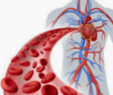  Red Blood Cells  Reading and writing based on science topic. | 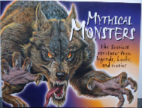  Spring 1 Unit 1  Mythical Monsters  Reading and writing based on mythical monsters | 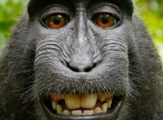  Spring 1 Unit 2  Changes  Reading and writing based on science topic | Summer 1 Unit 1  SATs Revision | Summer 1 Unit 2  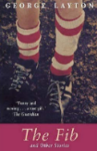  The Fib  Reading and writing based on ‘The Long Walk’ by George Layton.
 | Autumn 2 Unit 3  Macbeth Unit  Reading and writing based on Shakespeare’s Macbeth | 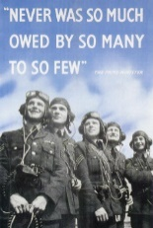  Autumn 2 Unit 4  The Battle of Britain  Narrative/non-narrative writing based on the Battle of Britain | Spring 2 Unit 3  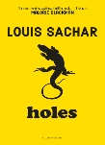  Holes  Reading and writing based on ‘Holes’ by Louis Sachar. | Spring 2 Unit 4  SATs Revision | Summer 2 Unit 3  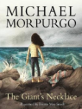  The Giant’s Necklace  Writing based on ‘The Giant’s Necklace’ by Michael Morpurgo | Summer 2 Unit 4  The Battle Cry  (RWP-Unit)  Speeches based on Gladiator and Braveheart.

Mathematics | Autumn 1 Unit 1  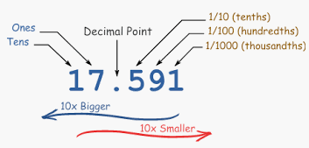  Number - Place Value  2 Weeks | Autumn 1 Unit 2  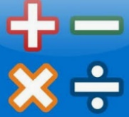  Number – Addition, Subtraction, Multiplication & Division  4 weeks | Spring 1 Unit 1  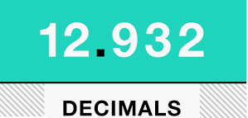  Number – Decimals  2 weeks | Spring 1 Unit 2  Number –Percentages 2 weeks  Spring 1 Unit 3  Number - Algebra 2 weeks | Summer 1 Unit 1  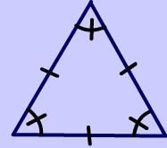  Geometry – Properties of Shape  (2 weeks) | Summer 1 Unit 2  Statistics  (2 weeks)
 | 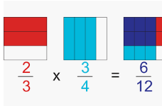  Autumn 2 Unit 3  Number – Fractions 4 weeks | Autumn 2 Unit 4  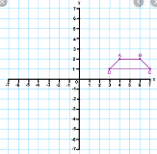  Geometry – Position and Direction  1 week  Consolidation learning 1 week | Spring 2 Unit 3  Measurement – Converting Units  1 Week  Perimeter, Area and Volume  2 weeks | 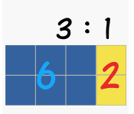  Spring 2 Unit 4  Number – Ratio 2 weeks  Consolidation learning 1 week | Summer 2 Unit 3  Problem Solving  3 weeks | Summer 2 Unit 4  Maths Investigations  3 weeks

Science |  | Autumn 1 Unit 1  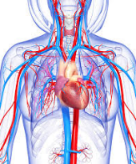  Animals including Humans  The circulation system |  | Autumn 2 Unit 2  Electricity  Circuits and Circuit diagrams |  | 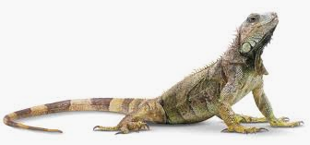  Spring 1 Unit 3  Living Things and their Habitats  Classification |  | 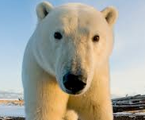  Spring 2 Unit 4  Inheritance and Adaptation  Evolution and Adaptation | 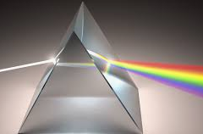  Summer 1 Unit 5  Light  Sources and movement of light | Summer 2 Unit 6  Scientists and Scientific Discovery  Stephen Hawking
Computing |  | 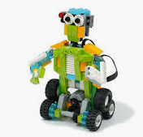  Autumn 1 Unit 1  Robot Controller- Lego We Do |  | Autumn 2 Unit 2  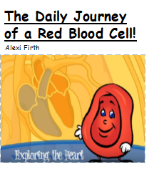  Presenting information- Word processing and Video Creation |  | 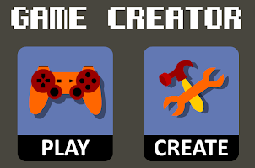  Spring 1 Unit 3  Game Creation |  | Spring 2 Unit 4  Game Design | Summer 1 Unit 5  Lights, Camera, Action! | Summer 1 Unit 6  Computer Networks
Digital Literacy |  | Managing online information |  | Copyright and ownership |  | Self-image and Identity  Online Relationships |  | Privacy and Security  Health, Wellbeing and Lifestyle | Online Bullying | Online Reputation
History & Geography |  | 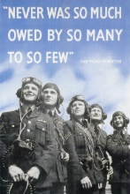  Autumn 1 Unit 1  History  The Battle of Britain |  | 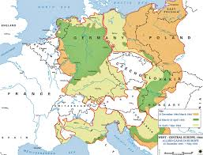  Autumn 2 Unit 2  Geography  Awareness of Place and Location WWII |  | Spring 1 Unit 2  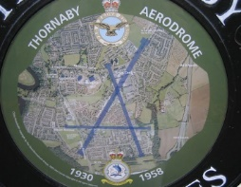  History  Local Study- Our Local Area During the WWII |  | 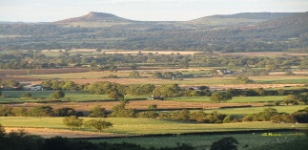  Spring 2 Unit 2  Geography  Awareness of Place and Location  Local Field Study | Summer 1 Unit 3  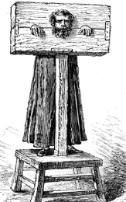  History  Crime and Punishment through the Ages | Summer 2 Unit 3  Geography – Awareness of Place and Location/Mapping Skills  Investigating Coasts
P.E. |  | Autumn 1 Unit 1  Invasion Games  Tag Rugby |  | 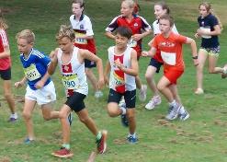  Autumn 1 Unit 2  Running and Jumping Cross Country |  | Spring 1 Unit 3  Balance, agility and coordination Gymnsastics |  | Spring 1 Unit 4  Attacking and Defending  Basketball | Summer 1 Unit 7  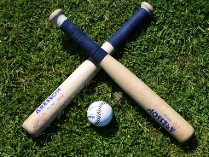Striking and Defending  Rounders | Summer 1 Unit 8  Attacking and Defending  Hockey
 |  | Autumn 2 Unit 3  Attacking and Defending  Dodgeball |  | Autumn 2 Unit 4  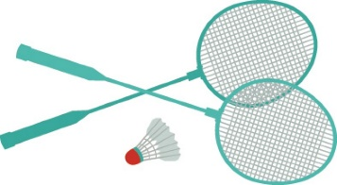  Net and Wall  Badminton |  | 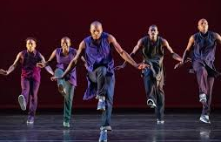  Spring 2 Unit 5  Dance  Dancefuzion |  | Spring 2 Unit 6  Running and Jumping  Athletics | Summer 2 Unit 9  Net and Wall  Volleyball | Summer 2 Unit 10  Health Related Fitness
MFL |  | 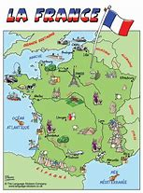  On y va  Learn to name Fracophone countries and towns in France. |  |  |  | L’argent de poche  Numbers to 100, likes and dislikes, the Euro, create a toy advert |  |  | Language around the world  Introduction to German, Mandarin and Spanish
Music | Autumn Unit 2  Pitch  Music of World War 2 |  |  |  | Spring Unit 4  Timbre & Texture  Composer Study  Mason Bates |  |  |  | Summer Unit 6  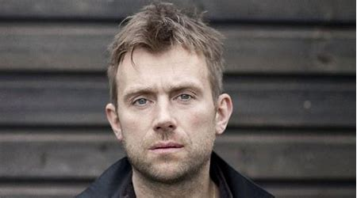  Structure  Artist Study  Damon Albarn
Art | 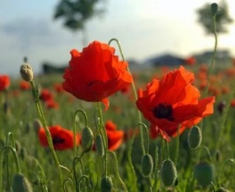  In Flanders Field –painting skills explored. |  |  |  | Street Art  Artist Study – Banksy |  |  |  | 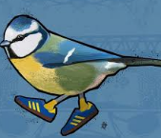  Artist Study -Local Street Art – Bobzilla
DT | Unit 1  Fashion and Textiles - Combining different fabric shapes |  |  |  | Unit 2  Frame Structures – Building Bridges |  |  |  | Unit 3  Celebrating culture and seasonality  (including cooking and nutrition requirements for KS2)  Great British Dishes
RE | Unit I  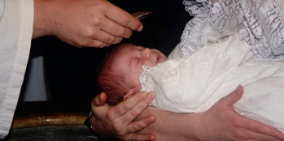  Rites of Passage  Thematic compare and contrast Christianity, Islam and Hinduism |  | Unit 2  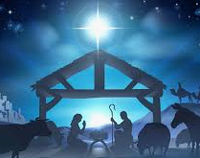  Festivals and Celebrations  What do the gospel stores tell us of Jesus’ birth? |  | Unit 3  Beliefs & Practices  Islam  What do we know about being a Muslim? |  | Unit 4  Beliefs & Practices  How far can the death of Jesus be seen as a victory? |  | Unit 5  Festivals  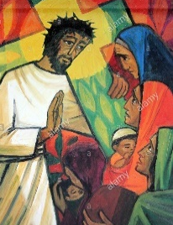  What festivals do other religions celebrate?  Judaism & Sikhism | Unit 6  Expressions of faith through Art:  Thematic compare and contrast Christianity, Islam and Hinduism
PSHE | 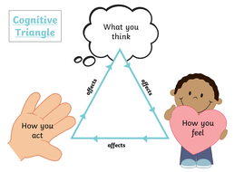  Think Positive |  | Safety First |  | VIPs |  | Growing Up |  | Respecting Rights | 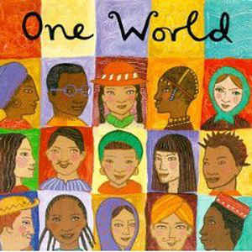One World

