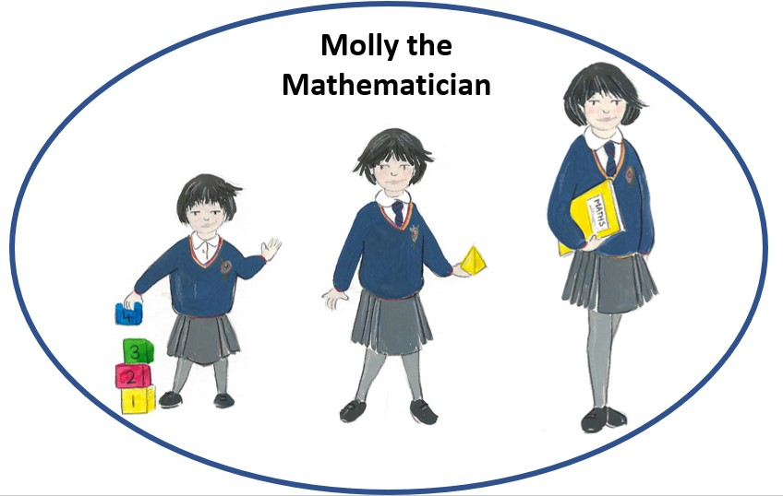
Mathematics

Long Term Curriculum Map
Whole School Scheme of Learning

Intent: This is what we want for your child.
At Barley Fields Primary we recognise that Mathematics is a universal language which helps us to understand the world around us. We aim to help our children understand that Mathematics has implications for important areas of employment such as; physics, architecture, medicine and business. It is also critical to technology and engineering, and necessary for financial literacy and most forms of employment.

We are committed to ensuring that our children become the problem solvers of the future. To do this, they need a solid grounding in Mathematical fluency and regular opportunities to apply these skills creatively to reasoning and problem solving. We want all children to enjoy Mathematics and to experience success in the subject whilst also developing their resilience, in line with our culture of growth mind-set.

We provide a high-quality mathematics curriculum so that all children:
- have fluency in their declarative knowledge;
- attain procedural fluency in a rigorous and progressive way across year groups and key stages;
- engage in regular opportunities to demonstrate conditional knowledge through problem solving activities which allow children to work systematically and logically, choosing the most appropriate method.

We aim for our Mathematics curriculum to be current and research informed. As such, it is regularly adapted to meet the needs of all learners and reviewed in response to best practice. We have worked with the EEF and the National College on adaptive teaching in the classroom which underpins all our teaching practice and pedagogy.

Our curriculum characters have been designed to represent the curriculum end points as children progress through school. Our children are regularly exposed to the core skills and knowledge needed to develop as a mathematician with the use of the school curriculum character – Molly the Mathematician. This character is regularly used to encourage children to reflect on the key skills and concept areas of Mathematics.

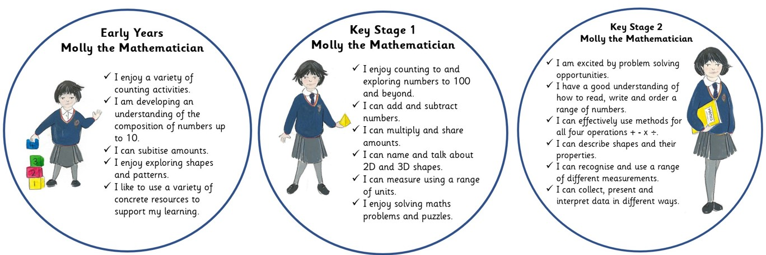

Implementation: This is what it will look like in the classroom
Our Mathematics curriculum has been designed to ensure children know more, remember more and can do more as they progress through our school. Our children follow a carefully structured, sequential and small step mathematics curriculum based on, but not exclusive to, that produced by White Rose (we also use ‘I see Maths’ pedagogy). We continually adapt this curriculum based on the needs of our learners. If we are to create the problem solvers of the future, first we must ensure that pupils become proficient in core knowledge and that learned facts and procedures become encoded into long term memory. As a school we have determined that our definition of learning is change to the long-term memory and the way we implement our curriculum map involves repetitive teaching of the key concepts in Mathematics.

To do this, our curriculum;

- breaks down knowledge into smaller components to avoid cognitive overload;
- has built in practise, retrieval and reinforcement of key concepts;
- is progressive so that all teachers know their responsibilities within the overarching development of mathematicians;
- is a promise from one teacher to the next on curriculum coverage;
- is built on research based adaptive teaching methodology;
- has formative assessment at its heart – at Barley Fields, assessment is planning.

Children engage in Mathematics daily and the structure of the curriculum promotes regular opportunities to embed declarative knowledge (facts/concepts) and develop procedural fluency (application of methods). We recognise that problem solving is not a generic skill that can be learned out of context. We believe that problem solving is an environment to be nurtured and as such, we provide regular opportunities for children to develop their conditional knowledge through the use of rich mathematical problems.

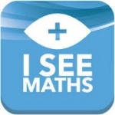
Our Teaching Approach – Mathematics Pedagogy
Our teaching approach incorporates three key aspects of Mathematics teaching designed to develop our children’s effective acquisition and application of skills and knowledge:

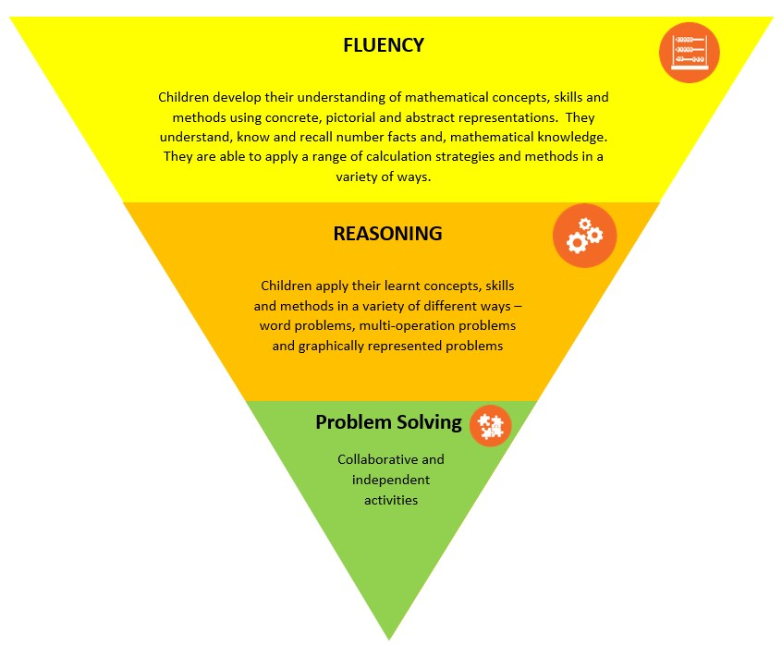
- Fluency
- Reasoning
- Problem Solving.

What do we mean by Fluency?
Fluency in mathematics (declarative knowledge) is the bedrock of effective teaching and learning. It encompasses a mixture of efficiency, accuracy and flexibility. Children will develop an understanding of all mathematical concepts through the CPA approach (concrete, pictorial, abstract). The use of manipulatives will be temporary and used as a ‘scaffold’ to aid understanding and skill development which can be removed once independence is achieved.
Within our planning structure fluency involves providing children with opportunities to:
- Become fluent in the fundamentals of mathematics through varied and frequent practice od skills;
- Recall facts and procedures quickly and efficiently;
- Develop the flexibility to move between different contexts and representations of mathematics;
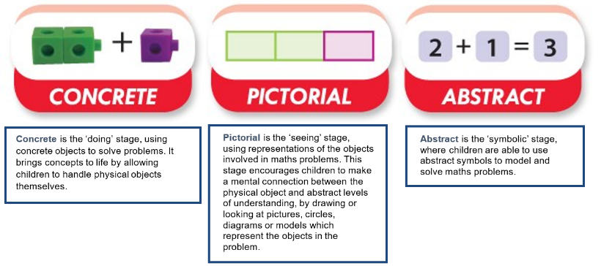
- Recognise relationships, make connections and make appropriate choices from a toolkit of methods, strategies and approaches.

What do we mean by Reasoning?
We recognise that the ability to reason mathematically is the most important factor in a pupil’s success in mathematics. Reasoning in Mathematics is the process of applying logical thinking to a situation to derive the correct strategies for a given question, and using known methods to develop and describe a solution.

Reasoning is seen as the glue that bonds pupils’ mathematical skills together; it is also seen as bridging the gap between fluency and problem solving, allowing pupils to use their fluency to accurately solve small step problems.

Reasoning activities allow children to apply their learnt skills and conceptual understanding in a variety of different contexts - word problems, multi-operational problems, graphically presented problems, SATs style reasoning problems etc.

What do we mean by Problem Solving?
Ensuring competency in collaborative and independent Problem Solving is at the heart of our mathematics teaching. We recognise that problem-solving cannot be taught - it is an environment, which must be nurtured. If a child already has a readily available method to solve a problem, problem-solving has not occurred.

Problem solving opportunities enable children to find a way to apply knowledge and skills they have to answer unfamiliar types of problems. children to apply their mathematical understanding to a variety of routine and non-routine problems with increasing sophistication and persevere in seeking solutions. In developing problem-solving skills and strategies children will be encouraged to:

- Use and compare different mathematical approaches.
- Independently break down problems into a series of simpler steps;
- Persevere in seeking solutions;
- Work in logical and structured steps;
- Work collaboratively with peers;
- Reflect on, and communicate their problem-solving ideas and strategies to others.

In their approach, teachers purposefully select problem-solving tasks for which children do not have ready-made solutions or to which there is more than one approach and answer. In promoting problem solving teachers use a variety of resources and support children with access to a range of practical equipment. Teachers will need to use effective questioning to enhance learning, acting as a guide on the side and redirect the learning as appropriate. Teachers may need to show and model to children how to interrogate and use their existing knowledge to solve problems.
Impact: This is what it will mean for our children
The impact of our mathematics curriculum is that children understand the significance and relevance of what they are learning in relation to wider world concepts. Children know that Mathematics is a vital life skill that they will rely on in many areas of their daily life both now and in the future. Children will have a positive view of Mathematics due to learning experiences in a classroom where growth mind-set is at the heart of learning.

Our mathematics curriculum and our teaching and learning pedagogy leads to children who:

- Are resilient mathematicians who don’t give up when they fail;
- Are active problem solvers who have the conditional knowledge to solve a range of mathematical problems;
- Are creative thinkers who work strategically and logically;
- Enjoy and are excited about mathematical challenges because they have firm foundations to build on;
- Understand the transferability of mathematics and the doors that mathematics can open for them in real life;
- Are proficient in Mathematics and achieve very well

We are proud of our children’s development of skills in Mathematics which in turn lead to excellent attainment outcomes. We continually observe and formatively assess children against age-related mathematics objectives and use this information to plan the next steps in their mathematical learning and to challenge and consolidate their skills. By the end of each key stage, pupils are expected to know, apply and understand the skills and techniques specified in the relevant curriculum plans.

Year – Reception Long Term Scheme of Learning – small steps
Autumn 1 | Autumn 2 | Spring 1 | Spring 2 | Summer 1 | Summer 2
Who are We?  Exploring the continuous provision inside and out.  Where do things belong? Positional language  Reception Baseline Assessment | Circles and Triangles  - Identify and name circles and triangles  - Compare circles and triangles  - Shapes in the environment  - Describe position  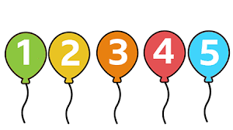  1 2 3 4 5  - Find 4 and 5  - Subitise 4 and 5  - Represent 4 and 5  - 1 more  - 1 less  - Composition of 4 and 5  - Composition of 1−5  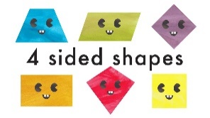  Shapes with 4 sides  - Identify and name shapes with 4 sides  - Combine shapes with 4 sides  - Shapes in the environment My day and night | 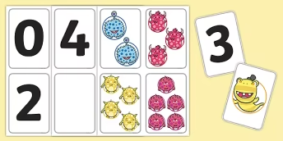Alive in 5!  Introduce zero  Find 0 to 5  Subitise 0 to 5  Represent 0 to 5  1 more  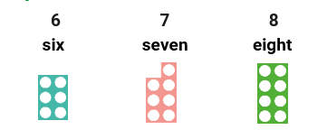  Growing 6, 7, 8  Find 6, 7 and 8  Represent 6, 7 and 8  1 more  1 less  Composition of 6, 7 and 8  Make pairs-odd and even  Double to 8 (find a double)  Double to 8 (make a double)  Combine 2 groups  Conceptual subitising  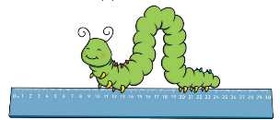  Length, Height and time  Explore length  Compare length  Explore height  Compare height  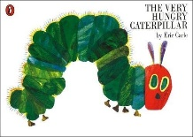  Talk about time | 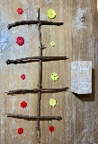  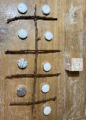  Building 9 and 10  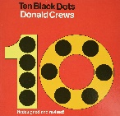  Find 9 and 10  Compare numbers to 10  Represent 9 and 10  Conceptual subitising to 10  1 more  1 less  Composition to 10  Bonds to 10 (2 parts)  Make arrangements of 10  Bonds to 10 (3 parts)  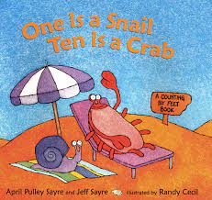  Doubles to 10 (find a double)  Doubles to 10 (make a double)  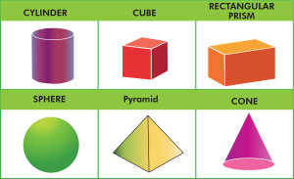  Explore 3D shapes  Recognise and name 3-D shapes  Find 2-D shapes within 3-D shapes  Use 3-D shapes for tasks  3-D shapes in the environment  Identify more complex patterns  Copy and continue patterns  Patterns in the environment  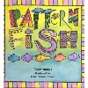 | To 20 and Beyond  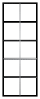  Build numbers beyond 10 (10 -13)  Continue patterns beyond 10 (10-13)  Build numbers beyond 10 (14-20)  Continue patterns beyond 10 (14-20)  Verbal counting beyond 20  Verbal counting patterns  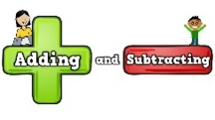  - How many now?  Add more  How many did I add?  Take away  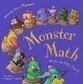  How many did I take away?  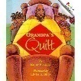  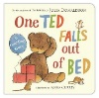  - Manipulate, compose and decompose  Select shapes for a purpose  Rotate shapes  Manipulate shapes  Explain shape arrangements  Compose shapes  Decompose shapes  Copy 2-D shape pictures  Find 2-D shapes within 3-D shape | Sharing and grouping  Explore sharing  Sharing  Explore grouping  Grouping  Even and odd sharing  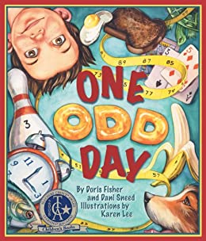  Play with and build doubles  Visualise, build and map  Identify units of repeating patterns  Create own pattern rules  Explore own pattern rules  Replicate and build scenes and constructions  Visualise from different position  Describe positions  Give instructions to build  Explore mapping  Represent maps with models  Create own maps from familiar places  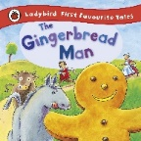  Create own maps and plans from story situations  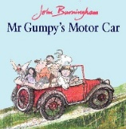  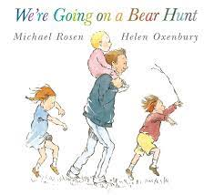  Making Connections  - Deepening Understanding  - Patterns and Relationships
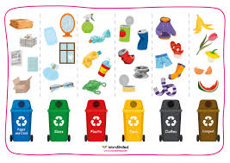 Match, Sort and Compare
- Match objects
- Match pictures and objects
- Identify a set
- Sort objects to a type
- Explore sorting techniques
- Create sorting rules
- Compare amounts

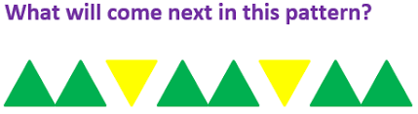 Talk about measure and Patterns
- Compare size
- Compare mass
- Compare capacity
- Explore simple patterns
- Copy and continue simple patterns
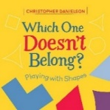
- Create simple patterns

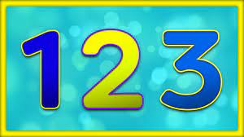
It’s me 1, 2, 3!
- Find 1, 2 and 3
- Subitise 1, 2 and 3
- Represent 1, 2 and 3
- 1 more Step 5 1 less
- Composition of 1, 2 and 3

Key Stage One
The principal focus of mathematics teaching in key stage 1 is to ensure that children develop confidence and mental fluency with whole numbers, counting and place value. This should involve working with numerals, words and the four operations, including with practical resources [for example, concrete objects and measuring tools].
At this stage, children should develop their ability to recognise, describe, draw, compare and sort different shapes and use the related vocabulary. Teaching should also involve using a range of measures to describe and compare different quantities such as length, mass, capacity/volume, time and money.

By the end of year 2, children should know the number bonds to 20 and be precise in using and understanding place value. An emphasis on practice at this early stage will aid fluency.

Children should read and spell mathematical vocabulary, at a level consistent with their increasing word reading and spelling knowledge at key stage 1.

Year 1 Long Term Scheme of Learning – small steps
Autumn 1 | Autumn 2 | Spring 1 | Spring 2 | Summer 1 | Summer 2
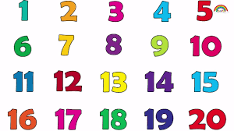Number: Place Value (within 20)  - Understanding 20  - Count, read and write numbers to 20  - Finding one more and one less  - Using a number line to 20  - Estimate on a number line to 20  - Compare numbers to 20  - Order numbers to 20  Number: Addition and Subtraction (within 10)  Addition  - Part whole models  - Writing number sentences  - Fact Families – Addition  - Number bonds to 10  - Addition  - Addition Problems  Subtraction  - Find a part  - Subtraction – Take away/cross out (How many left?)  - Subtraction on a number line  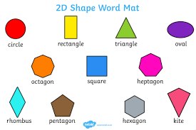  Geometry: Shape 2D and 3D  - Recognising and describing 2D Shapes  - Sorting and classifying 2D Shapes  - Recognising and describing 3D Shapes  - Sort and classify 3D shapes  - Creating Patterns with 2D and 3D shapes. | Number: Addition and Subtraction  (within 20)  Addition  - Addition within 20 (by counting on in ones)  - Adding ones (using number bonds)  - Find and make number bonds to 20  - Doubles and near doubles  Subtraction  - Subtract ones using number bonds  - Subtraction – counting back  - Subtraction – finding the difference  - Related Facts  - Missing number problems  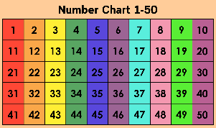Number: Place Value  (within 50)  - Counting from 20-50  - Counting in multiples of 10 – 10, 20, 30, 40 and 50  - Counting by making groups of 10  - Introduction to partitioning - Tens and Ones  - Partition into tens and ones  - Using the number line to 50  - 1 more 1 less than a number to 50 | Number: Addition and Subtraction  (within 50)  - Addition and subtraction within 50  - Addition Facts to 20  - Solve addition and subtraction reasoning problems  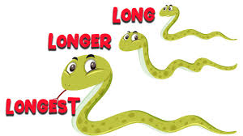  Measurement:  Length and Height  - Compare Length and Height  - Measuring Length – Using Non-standard units  - Measuring Length - Using Standard Units | 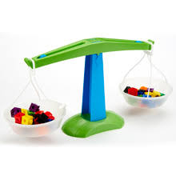  Measurement:  Mass and Weight,  - Heavier and Lighter - compare the weight of objects practically – heavier and lighter  - Use scales to measure Mass with non-standard units  - Compare and order the mass of objects  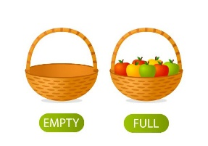Measurement:  Capacity and Volume  - Exploring Capacity and Volume - Full and empty  - Measure Capacity  - Compare Capacity  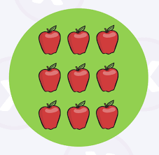  Number: Multiplication and Division  - Counting in multiples of 2, 5 and 10  - Making and counting in equal groups (multiples of 2, 5 and 10)  - Make arrays to represent multiples  - Introduction to doubling  - Exploring the concept of sharing into equal groups 2, 5 and 10  - Making equal groups – sharing  - Introduction to halving | 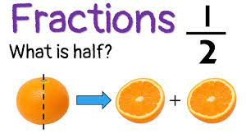  Number: Fractions  - Recognising and finding a half of whole objects and shapes  - Recognising half of a quantity  - Finding a half of a quantity  - Recognise and find a quarter of whole objects and shapes  - Recognise and find a quarter of a quantity  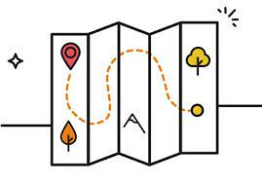  Geometry: Position and Direction  - Describing Turns  - Describing Position – left and right,  - Describing Position and Movement – forwards and backwards  - Describing Position Direction and Movement – above and below  - Using Ordinal Numbers to describe position  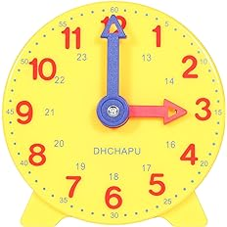  Measurement: Time  - Sequence familiar events in chronological order  - Know the days of the week  - Know the months of the year  - Understand units of time – hours, minutes and seconds  - Read and set the time to the Hour  - Read and set the time to the half hour | 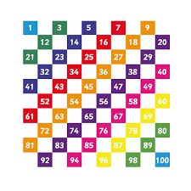Number and Place Value: (within 100)  - Count from 50-100  - Counting in tens to 100  - Partition numbers to 100 into tens and ones  - Placing numbers on a number line to 100  - Identify numbers one more and one less to 100  - Compare numbers with the same amount of tens  - Compare two numbers larger and smaller within 100  Measurement: Money  - Unitising – matching coins to their value  - Recognising the value of coins and notes  - Counting amounts of money with coins – 1p, 2p, 5p and 10p
 | Consolidation and assessment |  | Consolidation and assessment |  | Consolidation and assessment

Year 2 Long Term Scheme of Learning – small steps
Autumn 1 | Autumn 2 | Spring 1 | Spring 2 | Summer 1 | Summer 2
Number: Place Value (within 100)  - Count, read and write numbers to 100  - Represent Numbers to 100 in different ways  - Partition 2-digit Numbers in different ways  - Compare and order numbers to 100  - Count in multiples of 2, 5 and 10 to 100  Number: Addition  - Recall and use addition facts to 20  - Adding 2-digit numbers and ones  - Adding 2-digit numbers and tens  - Add two 2-digit numbers – not crossing 10  - Adding two 2-digit numbers – crossing 10  Subtraction  - Using and recalling subtraction facts to 20  - Subtracting – formal methods  - Subtracting two 2-digit numbers – no exchanging  - Subtracting 2 2-digit numbers – crossing ten - exchanging  - Subtracting 2 2-digit numbers – crossing ten – exchanging  Measurement: Money  - Recognise the value of coins and notes  - Recognising and using the symbols for money - £ and p  - Making amounts  - Making amounts in different ways  - comparing amounts of money  - Shopping – finding the total (using addition methods | Number: Multiplication  - Recognise Odd and Even Numbers  - Complete Repeated addition of equal groups  - Introducing the multiplication symbol and writing multiplication sentences  - Making and Using Arrays  - Recall and use multiplication facts for the 2x table  - Recall and use multiplication facts for the 5x table  - Recall and use multiplication facts for the 10x table  - Problem Solve using multiplication  Division  - Introduction to Division – making equal groups  - Introduction to Division – Division by sharing:  - Dividing by 2  - Doubling and Halving Numbers  - Dividing amounts by 10  - Dividing amounts by 5  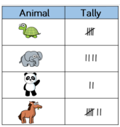  Statistics :Data Handling  - What is a Tally chart?  - What is a pictogram?  - Interpreting Information  - What is a block diagram?  Consolidation and assessment | Measurement: Time  - Minutes, seconds, hours  - Measuring amounts of time  - Telling Time to the Hour and Half Hour  - Telling the time to quarter to and quarter past  - Telling the time to 5-minute intervals  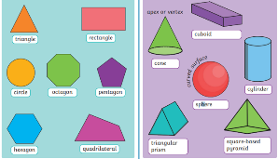  Geometry: Properties of Shape  - Recognise and name 2D and 3D shapes  - Exploring sides and vertices in 2D shapes  - Drawing 2D shapes  - What is symmetry?  - What are the properties of 3D shapes?  - Exploring edges and vertices in 3D shapes?  - Sorting 3D shapes  - Make patterns with shapes  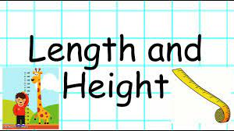  Measurement – length and height  - Measuring length in cm  - Measuring length in metres  - Comparing length and height  - Ordering length  - Problem solving with length | Number: Fractions  - Exploring parts and wholes  - What is a unit fraction?  - What is a non-unit fraction  - Recognising and finding half  - Recognising and finding quarters  - Recognising and finding three quarters of shapes and amounts  - Recognising and finding thirds  - Beginning to understand equivalence in fractions  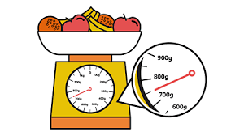  Measurement:  Weight and Mass  - Comparing the mass of objects  - Begin to measure mass in standard measures – grams  - Begin to measure mass in standard measures - kilograms  - Using the four operations in the context of Mass  Consolidation and assessment | Measurement : Capacity and Volume  - Comparing the capacity and volume of containers  - Using millilitres to measure volume and capacity  - Measuring capacity and volume using Litres  - Reasoning with Volume and Capacity  SATS revision and preparation. | KS1 SATS summative Teacher Assessments.  Geometry: Position and Direction  - Using the Language of Position  - Describing Movement  - Describing Turns  - Describe movements and turns  - Shape patterns with turns  Measurement: Temperature  - Measuring Temperature  Consolidation and assessment

Lower Key Stage Two
The principal focus of mathematics teaching in lower key stage 2 is to ensure that children become increasingly fluent with whole numbers and the four operations, including number facts and the concept of place value. This should ensure that children develop efficient written and mental methods and perform calculations accurately with increasingly large whole numbers.
At this stage, children should develop their ability to solve a range of problems, including with simple fractions and decimal place value.
Teaching should also ensure that children draw with increasing accuracy and develop mathematical reasoning so they can analyse shapes and their properties, and confidently describe the relationships between them. It should ensure that they can use measuring instruments with accuracy and make connections between measure and number.

By the end of year 4, children should have memorised their multiplication tables up to and including the 12-multiplication table and show precision and fluency in their work.

Children should read and spell mathematical vocabulary correctly and confidently, using their growing word reading knowledge and their knowledge of spelling.
Year 3 Long Term Scheme of Learning – small steps
Autumn 1 | Autumn 2 | Spring 1 | Spring 2 | Summer 1 | Summer 2
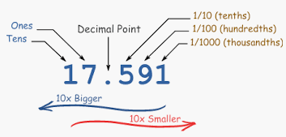  Number: Place Value  3 weeks  - Represent and Partition numbers to 100  - Number line to 100  - Hundreds  - Representing numbers to 1000  - Partitioning numbers to 1000  - Flexible partitioning to 1000  - Hundreds, tens and ones  - Find 1, 10 or 100 more or less  - Number line to 1000  - Estimate on a number line to 1000  - Compare numbers to 1000  - Order Numbers to 1000  - Count in 50s  Number – addition and subtraction  - Apply number bonds within 10  - Add and subtract 1s to a 3 digit number  - Add and subtract 10s  - Add and subtract 100s  - Spot the pattern  - Add 1s across a 10  - Add 10s across a 100  - Subtract 1s across a10  - Subtract 10s across a 100  - Make connections  - Add two numbers (no exchange)  - Subtract two numbers (no exchange)  - Add two numbers (across a 10)  Add two numbers (across a 100) | Number – addition and subtraction  2 weeks  - Subtract two numbers (across a 10)  - Subtract two numbers (across a 100)  - Add 2-digit and 3-digit numbers  - Subtract a 2-digit number from a 3-digit number  - Complements to 100  - Estimate answers  - Inverse operations  - Make decisions  Number  Multiplication and Division  3 weeks  - Multiplication – equal groups  - Use arrays  - Multiples of 2  - Multiples of 5 and 10  - Sharing and grouping  - Multiply by 3  - Divide by 3  - The 3 times-table  - Multiply by 4  - Divide by 4  - The 4 times-table  - Multiply by 8  - Divide by 8  - The 8 times-table  Consolidation and assessment | Multiplication and Division  2 weeks  - Multiples of 10  - Related calculations  - Reasoning about multiplication  - Multiply a 2-digit number by a 1-digit number – no exchange  - Multiply a 2-digit number by a 1-digit number – with exchange  - Link multiplication and division  - Divide a 2-digit number by a 1-digit number – no exchange  - Divide a 2-digit number by a 1-digit number – flexible partitioning  - Divide a 2-digit number by a 1-digit number – with remainders  - Scaling  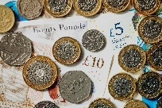  - How many ways?  Measures  Money  2 weeks  - Pounds and Pence - Recognise and use coins to make different amounts  - Convert Pounds and Pence  - Add and subtract amounts of money  - Subtract amounts of money  - Understand the concept of giving change in a practical context and using simple methods  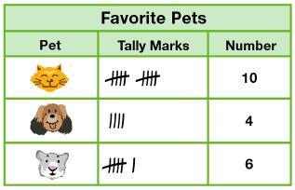  Statistics  Data  2 weeks  - Interpret pictograms  - Draw pictograms  - Interpret bar charts  - Draw bar charts  - Collect and represent data  - Two-way tables | 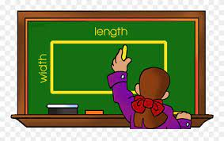  Measurement  Length and Perimeter  2 weeks  - Measure in metres and centimetres  - Measure in millimetres  - Measure in centimetres and millimetres  - Metres, centimetres and millimetres  - Equivalent lengths (metres and centimetres)  - Equivalent lengths (centimetres and millimetres)  - Compare lengths  - Add lengths  - Subtract lengths  - What is perimeter?  - Measure perimeter  - Calculate perimeter  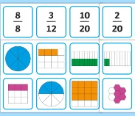  Number  Fractions  2 weeks  - Understand the denominators of unit fractions  - Compare and order unit fractions  - Understand the numerators of non-unit fractions  - Understand the whole  - Compare and order non-unit fractions  - Fractions and scales  - Fractions on a number line  - Count in fractions on a number line  - Equivalent fractions on a number line  - Equivalent fractions as bar models  Consolidation and assessment | 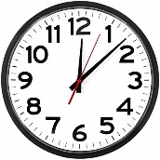  Measurement – Time  3 Weeks  - Recognising fractions as a link to telling the time  - Roman numerals to 12  - Tell the time to 5 minutes  - Tell the time to the minute  - Tell the time on a digital clock – 12hour  - Tell the time on a digital clock -24 hour  - Use am and pm  - Years, months and days  - Days and hours  - Hours and minutes – use start and end times  - Hours and minutes - use durations  - Minutes and seconds  - Units of time  - Solve problems with time  Fractions  3 weeks  - Recognising fractions of shapes  - Add fractions  - Subtract fractions  - Partition the whole  - Unit fractions of a set of objects  - Non-unit fractions of a set of objects  - Reasoning with fractions of an amount | 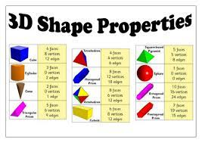Geometry Properties of Shape  2 weeks  - Turns and angles  - Right angles  - Compare angles  - Measure and draw accurately  - Horizontal and vertical  - Parallel and perpendicular  - Recognise and describe 2-D shapes  - Draw polygons  - Recognise and describe 3-D shapes  - Make 3-D shapes  Measurement  Mass  1 Week  - Use scales  - Measure mass in grams  - Measure mass in kilograms and grams  - Equivalent masses (kilograms and grams)  - Compare mass  - Add and subtract mass  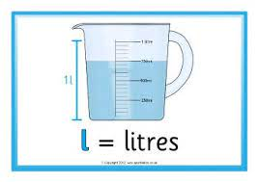  Measurement Capacity  1 Week  - Measure capacity and volume in millilitres  - Measure capacity and volume in litres and millilitres  - Equivalent capacities and volumes (litres and millilitres)  - Compare capacity and volume  - Add and subtract capacity and volume  Consolidation and assessment
Year 4 Long Term Scheme of Learning – small steps
Autumn 1 | Autumn 2 | Spring 1 | Spring 2 | Summer 1 | Summer 2
Number: Place Value  3 weeks  - Represent numbers to 1,000  - Partition numbers to 1,000  - Number line to 1,000  - Thousands  - Represent numbers to 10,000  - Partition numbers to 10,000  - Flexible partitioning of numbers to 10,000  - Find 1, 10, 100, 1,000 more or less  - Number line to 10,000  - Estimate on a number line to 10,000  - Compare numbers to 10,000  - Order numbers to 10,000  - Roman numerals  - Round to the nearest 10  - Round to the nearest 100  - Round to the nearest 1,000  - Round to the nearest 10, 100 or 1,000  Number:  Addition and Subtraction  3 weeks  - Add and subtract 1s, 10s, 100s and 1,000s  - Add up to two 4-digit numbers – no exchange  - Add two 4-digit numbers – one exchange  - Add two 4-digit numbers – more than one exchange  - Subtract two 4-digit numbers – no exchange  - Subtract two 4-digit numbers – one exchange  - Subtract two 4-digit numbers – more than one exchange  - Efficient subtraction  - Estimate answers  - Checking strategies | Number  Multiplication and Division Part A 3 weeks  - Multiples of 3  - Multiply and divide by 6  - 6 times-table and division facts  - Multiply and divide by 9  - 9 times-table and division facts  - The 3, 6 and 9 times-tables  - Multiply and divide by 7  - 7 times-table and division facts  - 11 times-table and division facts  - 12 times-table and division facts  - Multiply by 1 and 0  - Divide a number by 1 and itself  - Multiply three numbers  Measures Area  1 week  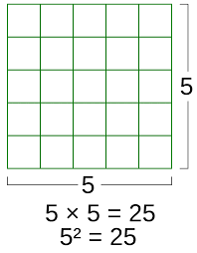  - What is Area?  - Counting Squares  - Making Shapes  - Comparing Area  Measurement Time  2 weeks  - Years, months, weeks and days  - Hours, minutes and seconds  - Convert between analogue and digital times  - Convert to the 24-hour clock  - Convert from the 24-hour clock  Consolidation and assessment | Multiplication and Division Part 2  3 weeks  - Factor pairs  - Use factor pairs  - Multiply by 10  - Multiply by 100  - Divide by 10  - Divide by 100  - Related facts – multiplication and division  - Informal written methods for multiplication  - Multiply a 2-digit number by a 1-digit number  - Multiply a 3-digit number by a 1-digit number  - Divide a 2-digit number by a 1-digit number (1)  - Divide a 2-digit number by a 1-digit number (2)  - Divide a 3-digit number by a 1-digit number  - Correspondence problems  - Efficient multiplication  Measurement: Length and Perimeter  2 weeks  - Measure in kilometres and metres  - Equivalent lengths (kilometres and metres)  - Perimeter on a grid  - Perimeter of a rectangle  - Perimeter of rectilinear shapes  - Find missing lengths in rectilinear shapes  - Calculate perimeter of rectilinear shapes  - Perimeter of regular polygons  - Perimeter of polygons  Fractions  1 weeks  - Understanding the whole  - Count beyond 1  - Partitioning a Mixed Numbers  - Number lines with mixed numbers | Statistics - Data  2 Weeks  - Interpreting data from charts, graphs and pictograms  - Comparison, Sum and Difference  - Interpret line graphs  - Draw line graphs  Fractions continued  2 weeks  - Comparing and Order mixed numbers  - Understand Improper Fractions  - Convert Mixed Numbers to Improper Fractions  - Covert Improper Fractions to Mixed Numbers  - Equivalent fractions on a number line  - Equivalent fraction families  - Add two or more fractions  - Add fractions and mixed numbers  - Subtract two fractions  - Subtract from whole amounts  - Subtract from mixed numbers  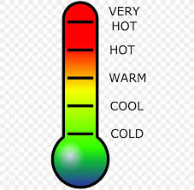  Measures  Temperature  1. What is temperature  2. Positive and Negative Numbers  3. Reading Temperature  4. Recording Temperature in a practical context  Consolidation and Assessment | 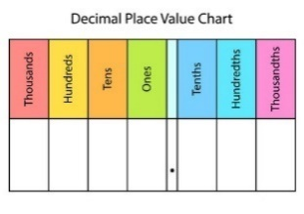  Decimals Part 1  3 weeks  - Tenths as fractions  - Tenths as decimals  - Tenths on a place value chart  - Tenths on a number line  - Divide a 1-digit number by 10  - Divide a 2-digit number by 10  - Hundredths as fractions  - Hundredths as decimals  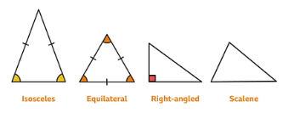  Geometry – Properties of Shape - Angles 3 weeks  - Understand Angles as turns  - Identify Angles  - Compare and Order Angles  - What are Triangles?  - What are Quadrilatrals?  - What are Polygons  - Lines of Symmetry  - Complete a Symmetrical Figure | Decimals Part 2  2 weeks  - Make a whole with tenths  - Make a whole with hundredths  - Partition decimals  - Flexibly partition decimals  - Compare decimals  - Order decimals  - Round to the nearest whole number  - Halves and quarters as decimals  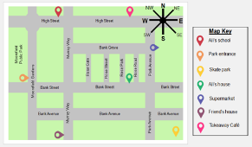  Geometry  Position and Direction  2 weeks  - Describe Position using Coordinates  - Plot Coordinates  - Draw 2D shapes on a grid  - Translate on a Grid  - Describe Translation on a Grid  Measurement – Money  1 Weeks  1. Write money using decimals  - Convert between pounds and pence  - Compare amounts of money  - Estimate with money  - Calculating with money  - Solve Problems with money  Consolidation and Assessment

Upper Key Stage Two
The principal focus of mathematics teaching in upper key stage 2 is to ensure that children extend their understanding of the number system and place value to include larger integers. This should develop the connections that children make between multiplication and division with fractions, decimals, percentages and ratio.
At this stage, children should develop their ability to solve a wider range of reasoning problems, including increasingly complex properties of numbers and arithmetic, and problems demanding efficient written and mental methods of calculation. With this foundation in arithmetic, children are introduced to the language of algebra as a means for solving a variety of problems.
Teaching in geometry and measures should consolidate and extend knowledge developed in number. Teaching should also ensure that children classify shapes with increasingly complex geometric properties and that they learn the vocabulary they need to describe them.
By the end of year 6, children should be fluent in written methods for all four operations, including long multiplication and division, and in working with fractions, decimals and percentages.
Children should read, spell and pronounce mathematical vocabulary correctly.
Year 5 Long Term Scheme of Learning – small steps
Autumn 1 | Autumn 2 |  | Spring 1 |  | Spring 2 |  | Summer 1 |  | Summer 2
Number: Place Value  3 weeks  - Roman Numerals to 1000  - Numbers up to 10,000  - Numbers up to 100,000  - Numbers up to 1,000,000  - Powers of 10  - 10/100/1000/10,000/100,000 more or less  - Partition numbers to 1,000,000  - Number line to 1,000,000  - Compare and order numbers to 100,000  - Compare and order numbers to 1,000,000  - Round to the nearest 10, 100 and 1000  - Round within 100,000  - Round within 1,000,000  Number: Addition and Subtraction  2 weeks  - Mental strategies  - Add whole numbers with more than four digits  - Subtract whole numbers with more than four digits  - Round to check answers  - Inverse operations (addition and subtraction)  - Multi-step addition and subtraction problems  - Compare calculations  - Find missing numbers  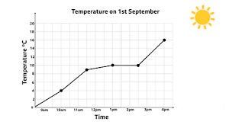Statistics  2 weeks  - Draw Line Graphs  - Read and Interpret Data in Line Graphs  - Read and Interpret tables  - Two way tables  - Read and Interpret Timetables | Number  Multiplication and Division  Part A  3 weeks  - Multiples  - Common multiples  - Factors  - Common factors  - Prime Numbers  - Square numbers  - Cube numbers  - Multiplying by 10, 100 and 1000  - Dividing by 10, 100 and 1000  - Multiples of 10, 100 and 1000  Measures Area and Perimeter  2 weeks  - Perimeter of Rectangles  - Perimeter of Rectilinear shapes  - Perimeter of Polygons  - Area of Rectangles  - Area of Compound shapes  - Estimate Area  Measurement  Negative numbers  1 week  - Understand Negative Numbers  - Count through zero in 1s  - Count through zero in multiples  - Compare and order negative numbers  - Find the difference  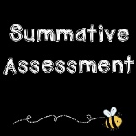 |  | Geometry  Properties of Shape  3 Weeks  - Understand and Use Degrees  - Classify Angles  - Estimate Angles  - Measure Angles up to 180  - Draw lines and angles accurately  - Calculate angles around a point  - Calculate angles on a straight line  - Lengths and angles in shapes  - Regular and irregular polygons  - 3D shapes  Number  Multiplication and Division  Part B  3 weeks  - Multiply up to a 4 digit number by a 1-digit number  - Multiply a 2-digit number by a 2-digit number (area model)  - Multiply a 2-digit number by a 2-digit number  - Multiply a 3-digit number by a 2-digit number  - Multiply a 4-digit number by a 2-digit number  - Solve Problems with Multiliplication  - Short Division  - Divide a 4-digit number by a 1-digit number  - Divide with remainders  - Efficient Division  - Solve Problems with Multiplication and Division |  | 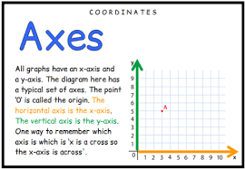  Geometry Position and Direction  2 weeks  - Read and Plot Coordinates  - Problem Solving with Coordinates  - Translation  - Translation with Coordinates  - Lines of Symmetry  - Reflection in horizonal and vertical lines  Number  Fractions  Part A  4 weeks  - Find Fractions equivelengt to a unit fraction  - Find Fractions Equivellent to a Non Unit Fraction  - Recognise Equivalent Fractions  - Convert improper fractions to mixed numbers  - Convert mixed numbers to improper fractions  - Compare fractions less than 1  - Order fractions less than 1  - Compare and order fractions greater than 1  - Add and subtract fractions with the same denominator  - Add fractions within 1  - Add fractions with a total greater than 1  - Add to a mixed number  - Add two mixed numbers  - Subtract fractions  - Subtract from a mixed number  - Subtract from a mixed number breaking the whole  - Subtract two mixed numbers  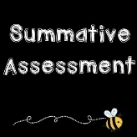 |  | Number Fractions  Part B  2 weeks  - Multiply a unit fraction by an integer  - Multiply a non unit fraction by an integer  - Multiply a mixed number by an integer  - Calculate a fraction of quantity  - Calculate the fractionof an amount  - Find the Whole  - Use Fractions as Operators  Number  Decimals and Percentages  3 weeks  - Decimals up to 2 decimal places  - Equivalent fractions and decimals (tenths)  - Equivalent fractions and decimals (hundredths)  - Equivellent fractions and decimals  - Thousandths as Fractions  - Thousandths as decimals  - Thousandths on a place value chart  - Order and compare decimals (with the same number of decimal places)  - Order and compare decimals with up to 3 decimal places  - Round to the nearest whole number  - Round to 1 decimal place  - Understand percentages  - Percentages as fractions  - Percentages as decimals  - Equivalent Fractions, decimals and percentages |  | 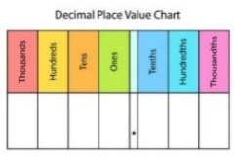  Number: Decimals  3 weeks  - Use known facts to add and subtract decimals within 1  - Complements to 1  - Add and subtract decimals across 1  - Add decimals with the same number of decimal places  - Subtract decimals with the same number of decimal places  - Add decimals with different numbers of decimal places  - Subtract decimals with different numbers of decimal places  - Efficient Strategies for adding and subtracting decimals  - Decimal Sequences  - Multiply by 10,100 and 1000  - Divide by 10, 100 and 1000  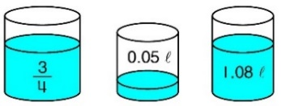  - Multiply and Divide Decimals – missing values  Measurement  Volume and Capacity  1 week  - Cubic centimetres  - Compare Volume  - Estimate Volume  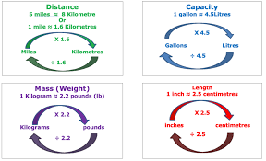  - Estimate Capacity  Measurement  Converting Units  2 weeks  - Kilograms and Kilometres  - Millimetres and Millilitres  - Convert Units of Length  - Convert between metric and imperial units  - Convert units of time  - Calculating with Timetables  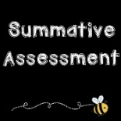
Year 6 Long Term Scheme of Learning – small steps
Autumn 1 |  | Autumn 2 |  | Spring 1 |  | Spring 2 |  | Summer 1 |  | Summer 2
Number: Place Value  2 weeks  - Read, Write and Order Numbers to 10,000,000  - Round whole numbers to the nearest 10, 100, 100, 10,000 and 100, 000  - Understand and use negative numbers in context  Number – Four Operations  1 week  - Add and subtract integers  Number – Four Operations  2 weeks  - Common factors  - Common multiples  - Rules of divisibility  - Primes to 100  - Square and cube numbers  - Multiply up to a 4-digit number by a 2-digit number  - Solve problems with multiplication  Number – Four Operations  2 weeks  - Short division  - Division using factors  - Introduction to long division  - Long division with remainders  - Solve problems with division  - Solve multi-step problems  - Order of operations  - Mental calculations and estimation |  | Number  Fractions A  2 weeks  - Equivalent fractions and simplifying  - Equivalent fractions on a number line  - Compare and order (denominator)  - Compare and order (numerator)  - Add and subtract simple fractions  - Add and subtract any two fractions  - Add mixed numbers  - Subtract mixed numbers  - Multistep Problems  Measurement  Converting Units  1 week  - Metric Measures  - Convert Metric Measures  - Calculate with metric measures  - Miles and kilometres  - Imperial measures  Number  Fractions B  2 weeks  - Multiply fractions by integers  - Multiply fractions by fractions  - Divide a fraction by an integer  - Mixed questions with fractions  - Find a Fraction of an amount  - Fraction of an amount – find the whole |  | 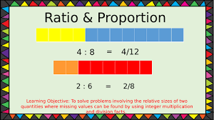  Ratio  1 week  - Add or multiply?  - Use ratio language  - Introduction to the ratio symbol  - Ratio and fractions  - Scale drawing  - Use scale factors  - Similar shapes  - Ratio problems  - Proportion problems  - Recipes  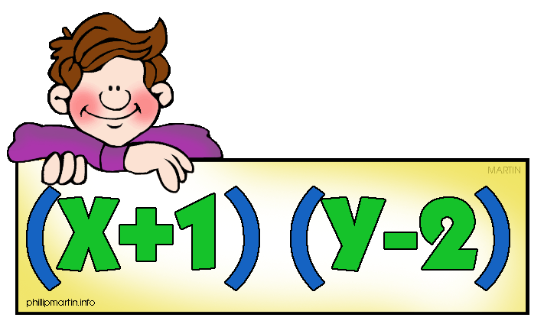Statistics – Algebra  2 weeks  - 1-step function machines  - 2-step function machines  - Form expressions  - Substitution  - Formulae  - Form equations  - Solve 1-step equations  - Solve 2-step equations  - Find pairs of values  - Solve problems with two unknowns  Number  Decimals  1 week  - Place value within 1  - Place value – integers and decimals  - Round decimals  - Add and subtract decimals Multiply decimals by 10, 100 and 1,000  - Divide decimals by 10, 100 and 1,000  - Multiply decimals by integers  - Divide decimals by integers  Measures  Area, Perimeter and Volume  2 weeks  - Shapes – same area  - Area and perimeter  - Area of a triangle – counting squares  - Area of a right-angled triangle  - Area of any triangle  - Area of a parallelogram  - Volume – counting cubes  - Volume of a cuboid |  | Number  Fractions, Decimals and Percentages  2 weeks  - Decimal and fraction equivalents  - Fractions as division  - Understand percentages  - Fractions to percentages  - Equivalent fractions, decimals and percentages  - Order fractions, decimals and percentages  - Percentage of an amount – one step  - Percentage of an amount – multi-step  Statistics  1 week  - Line graphs  - Dual bar charts  - Read and interpret pie charts  - Pie charts with percentages  - Draw pie charts  - Calculate the mean  Geometry –Angles  2weeks  - Measure and classify angles  - Calculate angles  - Vertically opposite angles  - Angles in a triangle  - Angles in a quadrilateral  - Angles in polygons  - Circles  - Drawing Shapes accurately  - Nets of 3D shapes  Geometry – position and direction  1 week  - Coodinates in the first quadrant  - Read and plot points in four quadrants  - Solve problems with coordinates  - Translations  - Reflections |  | SATS Revision and Statutory Testing  4 weeks |  | Themed Projects and Problem Solving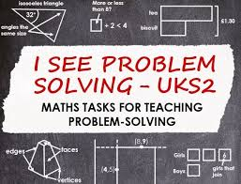  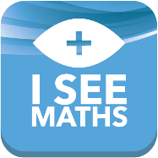  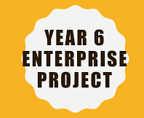
 |  | Consolidation and assessment |  |  |  | Consolidation and assessment |  | National Assessment  13th – 16th May 2024

